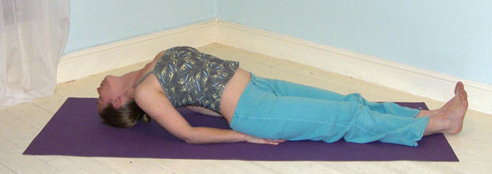**Matsyasana (fish pose)**

# *Pronounced muht-see-yaah-suh-nuh the word matsya means fish in Sanskrit.*

This pose is a supine backbend where we must be very mindful of the neck which can be very vulnerable in this pose. There are two main versions we can take that vary primarily according to the way we enter and leave the pose.

**Teaching Points:**

* 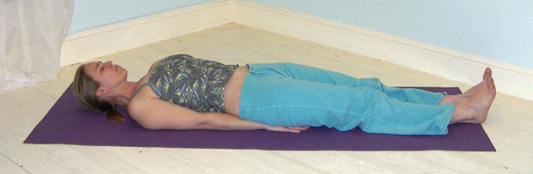Start by lying supine, place hands, palms down to the floor beneath the buttocks
* Make both legs active, pointing toes to the ceiling
* When ready gently press downwards into elbows, forearms and hands as you look behind, raising the chest and roll over onto the top of the head
* At no time does the head actually lift from the floor.
* Stay here lifting up out of the lower back, expanding and lifting the chest as the shoulders are drawn backwards, squeeze the shoulderblades together. Keep the buttocks to the floor and the legs actively contracted by pressing the inner edge of the legs together.
* To release from the pose simply slowly look downwards as you lower down, again keeping the head to the floor at all times

**Note:** This version is excellent as a way of being introduced to matsyasana because it will keep the neck supported throughout. It is interesting to note that initially students are likely to experience a significantly restricted breath and will be forced to breathe primarily within the abdominal region but as the back and shoulders become more flexible then they will find they can breathe more deeply into the diaphragmatic and thoracic regions.

**Drishti point**: Be aware of the heart centre or the third eye

**Benefits:**

Breaks up tension in the neck, shoulders and spine

Strengthens the back and neck

Frees ribcage, promoting deep breathing

Alleviates respiratory conditions

Stimulates blood flow to the neck and the brain

Aids digestion

Enlivens the abdominal organs

#### Good preparation:

Simple twists and backbends, shoulder mobilisers, chest openers, back strengtheners

**Cautions:**

* Prohibited for those who have suffered neck trauma or have ankylosis spondylitis
* Prohibited for those with severe back problems or kyphosis
* Prohibited for pregnancy
* Prohibited for unmedicated high blood pressure and heart conditions
* Take care for weak necks and backs

#### Simple versions and modifications

###### :::attachments_26_01_2010 Folder:fish_mod_1_resized.tiffLie over a bolster or rolled blankets/mats

This simple version really helps to open the chest and shoulders and if necessary some extra padding can be placed behind the head.

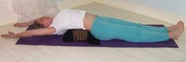**Lie over padding and raise arms overhead**

This version can accentuate the work done within the shoulders.

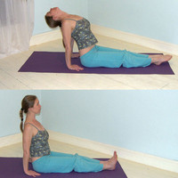***Working from dandasana***

We can simply start in staff pose and create a backbend by lifting up out of the lower back, raising the sternum. We will keep the head aligned in a neutral position and only hyperextend the neck when the neck is strong enough to do so with ease. Remember the head weighs heavy!

**Developments & Variations:**

***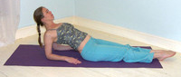Working on forearms***

Here we can begin on forearms positioning elbows beneath shoulders and work to lift and open the chest whilst keep the neck in a comfortable position. If possible we can lower the head with care!!

***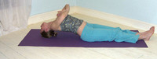Place hands in prayer position***

If working in version one as above, once comfortable in the pose we take hands from the floor and take them into prayer pose.

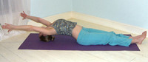***Hands reaching behind***

To go a little deeper it feels great to reach behind.

Note: for both of these developments we must return the hand to the floor and lower by rolling onto the back of the head as we look downwards

***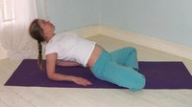Cross-legged***

We can work into matsyasana with crossed legs. Here as before we can if appropriate we can work with the crown of the head upon the ground or with the head hyperextended.

***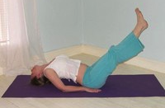Legs raised***

A much more challenging development we sometimes see is to lift both legs (and sometimes both arms) although we must always take great care performing double leg lifts and **generally they are to be avoided for the general public** . This is because the hip flexors for both legs insert close to the femur head and are therefore inefficient at lifting both heavy legs, they are also attached to the vertebrae of the lower back and so as legs lift these pull the vertebrae forwards, exerting pressure upon the lower back. In addition the pressure upon the abdominal wall is increased and the abdomen becomes distended, potentially stretching the lower attachments of the abdominal muscles.

#### Adjustments

In the first version some students get a little confused and attempt to lift the hips so if this happens you will need to instruct them to keep the buttocks to the floor. If a student has not lifted on to the very top of the head then we can instruct students to press more firmly down into the arms and create more lift in the back so the neck can become more extended. Finally if the ribcage has collapsed it is possible to place a hand beneath the shoulderblade area and instrct the student to more away from the hand or we could position a belt behind the students back at the level of the shoulderblades and standing astride the student at the hips we can very gently lift the student’s chest although care must be taken with this.