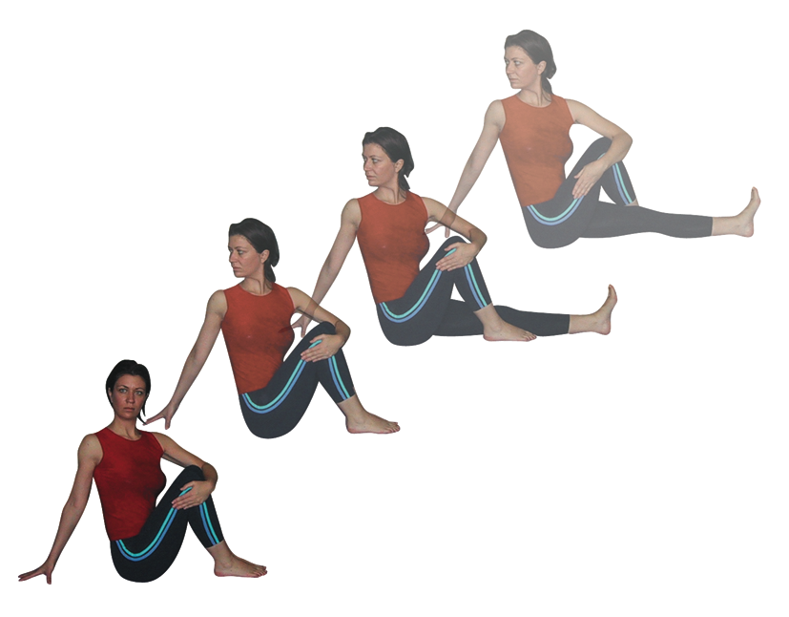**Marichyasana: Sage twist**

# Pronounced maar-ree-chee-yaah-suh-nuh the word marichi is the names of a great sage in Hindu mythology whose name means ‘way of light’ denoting his great power.

This pose is the basic seated twist from which all other variations follow. There are however several ways of working with this pose.

**Teaching Points:**

* In dandasana (staff pose) check to see that the lower back can retain it’s natural lumbar curve, if not then place a folded blanket or block beneath the buttocks.
* Extend the left leg forwards, foot actively dorsiflexed, and place the right hand to the ground behind.
* Stepping the right leg over the left leg, right foot pointing to the front, foot fully grounded.
* Wrap the left hand around the right knee.
* Check the back remains upright and shoulders are level, if necessary place a block beneath the palm.
* Head aligned with chest, chin parallel with the floor
* Inhaling lengthen the spine
* Exhaling contract the abdominals and rotate to the right using the muscles of the lower torso, mid torso and upper torso. Allowing the head to be the last part the body to twist.
* Avoid overuse of the arms to create the twist, rather primarily use the breath and muscles of the torso.
* Stay here noticing how the breath moves the body as you breathe.
* At some point if it is feels correct then twist a little more deeply.
* When you are ready to leave the pose, inhaling relase hands and move to the start position.

**Benefits:**

Tones both legs significantly

Tones spinal musculature

Opens chest and shoulder muscles

Mobilizes thoracic and cervical vertebrae

Increases circulation to lower back

#### Good preparation

Hamstring and adductor stretches, simpler twists and shoulder, chest and back mobilizers, hip mobilizers

**Contra-indications & possible modifications**

* For hip conditions, especially hip replacements do not cross the bent leg over the straight leg to help to diminish the work in the hips
* Lower back conditions & osteoporosis work cautiously using modifications perhaps keeping both knees bent if necessary
* For neck problems keep the head turned forwards or twist just as far as is comfortable
* For pregnancy & hiatus hernia work to the open side instead
* For kyphosis work with care, do not push into less mobile areas of the spine
* Note: some traditions place the elbow of the rear arm across the outside of the raised knee, this can work well to provide a lever against which to work but students should be asked to gauge if by placing the arm in this way the body becomes overly compressed reducing the opening action possible at the chest and shoulders.

**Simpler modified versions**

The simplest way to modify the pose is to either keep both legs bent or keep one leg straight without crossing the top leg over. We can also offer softer twists such as those shown beneath although they are rarely warranted and work best as preparatory poses.

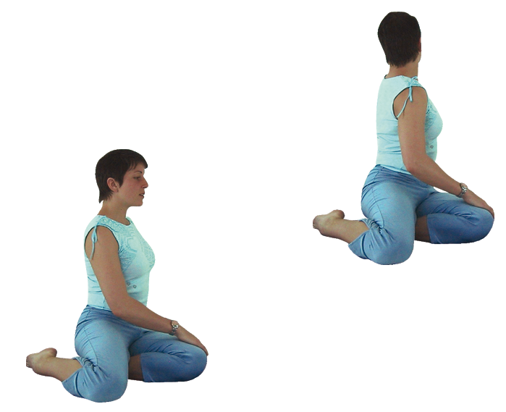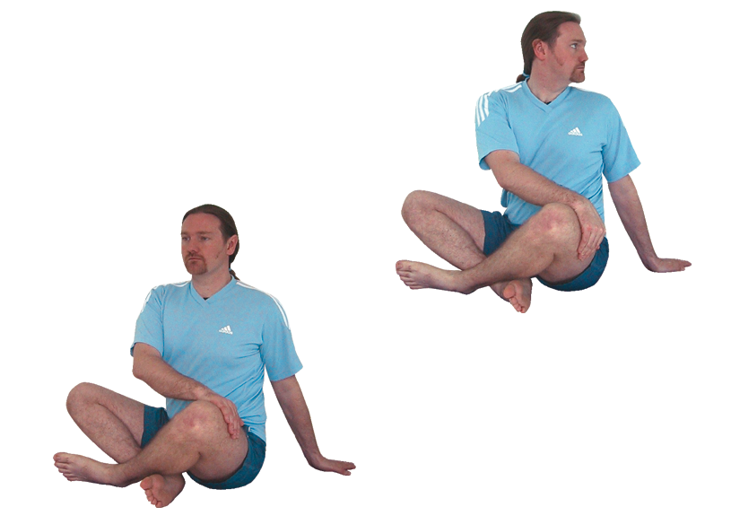

Bharadvajrasana

Bharad’s pose

Parivritta Sukhasana (reversed easy pose)

Pashasana (noose pose)

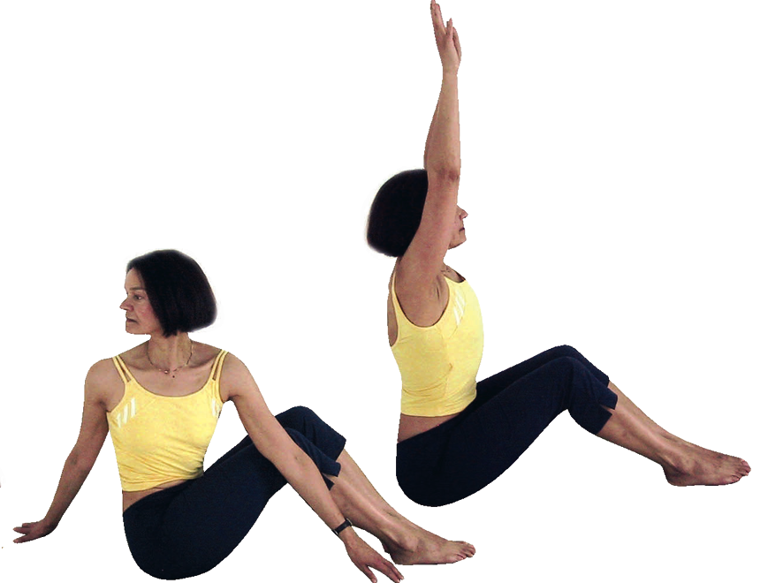This a nice way of working dynamically where from bent leg dandasana we inhale raising arms up through elevation then exhaling we lower arms through abduction to one side entering the twist. Inhale we lift arm up through abduction turning centrally then exhaling lower arms through abduction twisting to the other side. When we are ready we can stay statically on each side.

**Developments**

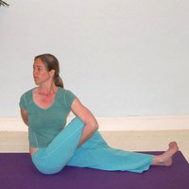

We can stay in a bound version as a development where the rear hand is threaded through the legs as the front arm reaches behind to hold hands. If students are ready for this development but cannot yet hold hands together they can hold a belt between hands to extend their reach. Some students will simply be unable to adopt this development due to bulky muscles

#### Adjustments

* For this pose we can lightly place a hand upon shoulders to remind students to keep them down from ears.
* If we feel they have not entered a deep enough twist we can gently place a hand upon the mid upper back and the other at the open lead shoulder, asking the student to breath in then as they exhale we can help them to rotate until the point of resistance is found.
* If the lower foot has lost interest, so to speak, then gently straighten the foot, toes pointing to the ceiling.