**Lung Cell Stimulation & Cleansing Breath.**

Stand in Tadasana (Mountain Pose). Take a few moments to connect to the breath becoming aware of how it feels. Notice the quality of the air as it passes through the nostrils, is it cooler on the inhale and a little warmer on the exhale? Is it a little smoother on the inhale and a little rougher on the exhale?…. see if you can sense how the breath is moving the body noticing if there are any subtle sensations of expansion and contraction being created as you gently breathe…..

**1. Lung Cell Stimulation**

Breathe in very slowly and as you inhale gently tap your chest with your fingertips, constantly changing position to cover the entire surface of the chest.

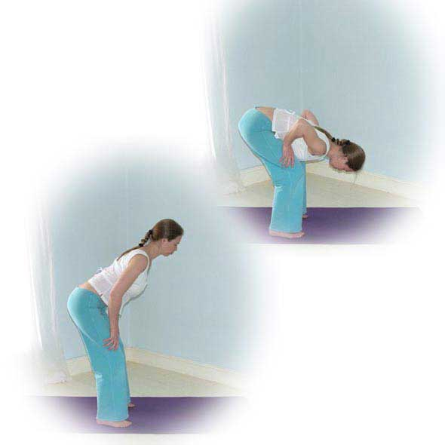When the lungs are full, hold your breath and begin to pat the chest with the palms of the hands, again constantly changing position to cover the surface of your chest.

**2. Cleansing Breath**

When you are ready to exhale begin the cleansing breath (shown opposite). Pucker up your lips and vigorously exhale a little air out, hold for a second and exhale a little more, hold for a second and exhale a little more. Continue until you have exhaled completely to begin again.

To make this exercise more effective you can place hands on thighs and fold forwards as you exhale in short bursts and at the last moment of the exhale contract your abdominal muscles to release all of the residual air within the lungs. Inhaling slowly straighten up and exhale beginning again on the next inhale.

If necessary you can take a few normal breaths between each round.

Repeat as many times as is comfortable for you, building the number of repetitions up over time. To start 3 to 5 repetitions would be good.

On completion stand in Tadasana and once again take a few moments to connect to the breath becoming aware of how it feels. Notice the quality of the air as it passes through the nostrils, is it cooler on the inhale and a little warmer on the exhale? Is it a little smoother on the inhale and a little rougher on the exhale?…. see if you can sense how the breath is moving the body noticing if there are any subtle sensations of expansion and contraction being created as you gently breathe….. Does anything feel a little different from when you began the practice?

**Cautions:**

Ensure you feel comfortable at all times, if you start to feel light-headed or faint stop and return to ordinary breathing

Caution for heart conditions, unmedicated high blood pressure, and pregnancy: we must not hold the breath so practice the cleansing breath in one exhale

Caution for low blood pressure: take care when moving through the levels if bending forward, can stay upright if needed

Benefits

This technique awakens the respiratory muscles and lungs and can remove tightness and congestion. It fully exchanges the air within the lungs, refreshing the air in the lower areas of the lungs. It brings new awareness to the use of the abdominals when exhaling and to the feeling of the body expanding as we fully inhale.