**Upavistha Konasana (Seated wide angle pose)**

**Kurmasana (Tortoise Pose)**

# *Pronounced oo-puh-vish-tuh kohn-aah-suh-nuh the word upavishta means seated and kona means angle in* :::attachments_16_01_2010 Folder:spread leg hold feet.tif*Sanskrit*

Here there is full adduction & flexion of the torso at the hips. Where there is tissue resistance we can certainly work to release this tightness however once the tissue resistance has been released for some students the **structure of the hip joints will disallow the full movement, for instance the hip cavity can be too shallow or the head of the femur can be more angled**. Therefore as for all asana, students need to be guided as to where they should experience the stretch and where they should not experience the pose.

For seated wide angle poses students **must not experience the stretch at the sitting bones or the inner knee** both of which indicates they have folded too deeply or the legs must be brought closer. They must also **ensure the sacroiliac joint and lumbar region remain comfortable** and this area can be safeguarded by working the spine, including the sacrum, as one long unit, flexing at the hip joints.

**Teaching Points:**

Stage one

* 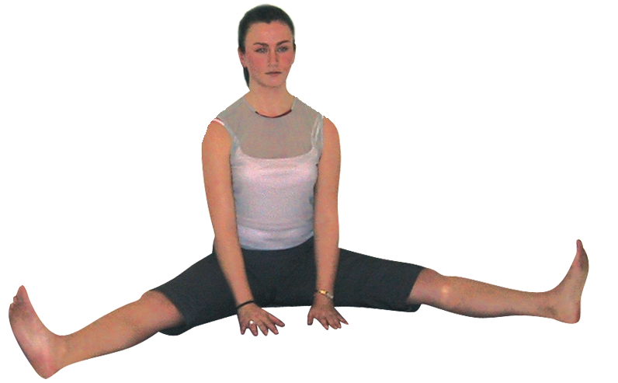Sitting in dandasana (staff pose) abduct the legs as far apart as possible.
* Using the arms lift the body up to nestle the sitting bones into the floor, creating a slight anterior pelvic tilt and a natural lumbar arch. Sit on block if needed.
* Let the torso sit upright with ease, creating space around the waist, the spine long, with the crown lifting upwards. Lift up through the upper front throat to engage the hyoid bone to engage the muscles at the front of the body.
* Gently roll the thighs backwards keeping knees and feet pointing to the ceiling.
* Stay here relaxing whilst maintaining the open erect body.

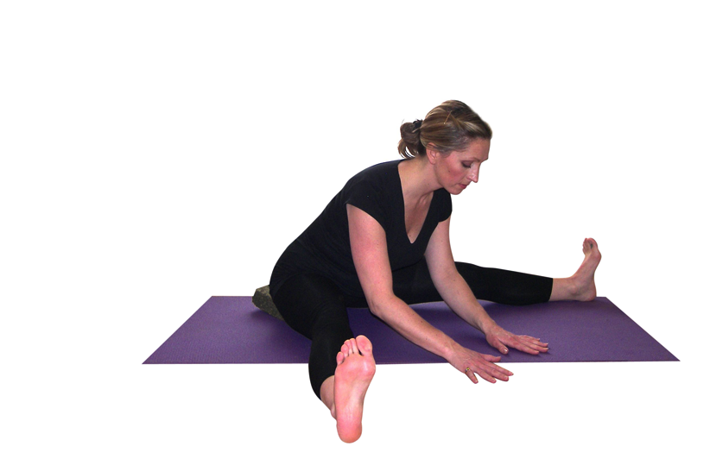Stage two

* Position the hands to the floor in front of the hips and begin to fold forwards from the hips keeping the legs aligned, knee to ceiling.
* Attempt to move forwards as if it is the pubis that would touch the floor first, keeping the spine elongated, neck long, looking down. If you are very flexible then feel the outer hips are firmed in towards the buttocks to stabilise the pelvis.
* Move to the point of resistance and stay breathing there until a ‘gate’ opens and it is possible to fold forwards a little more deeply. It may at first that a student only folds forward a few degrees but that is how it should be if there is enough work occurring at the back, hips and inner thigh muscles.

Stage three

* Once a student has become familiar with this pose it is possible to enter it by sitting upright and inhaling bring both arms out to sides and exhaling fold forwards taking the hands to wherever they naturally reach along the legs or feet. Here of course students no longer have the support of the arms to the ground in front of them and the weight of the arms being drawn forwards makes this a more challenging version.
* Stay here working as before.
* To exit simply lift hand to the knees and draw the torso upright.
* Closing legs find a good counterpose after experiencing the effects of the asana.

**Benefits:**

Quiets the mind and calms the nervous system

Stretches hamstrings and groin muscles

Tones leg muscles

Mobilizes hip joints

Stimulates blood flow to pelvic region

Regulate menstrual flow

Improve functioning of reproductive organs

#### Good preparation:

Simpler forward bends, hamstring, adductor and hip mobilisers

**Cautions:**

* Severe spinal disc conditions avoid this pose using an alternative pose instead
* Hip problems take care keeping legs closer together or omit the pose if recent hip replacement
* Groin or hamstring injury again take care keeping legs closer together and only fold forwards a few degrees, sitting upon block(s). If necessary omit the pose using an alternative instead
* General lower back problems and sciatica take care keeping legs closer together and only fold forwards a few degrees, using a support if available or if necessary omit the pose.

#### Simple versions and modifications

###### :::attachments_16_01_2010 Folder:stirring 1.tifWork dynamically into grinding the mill

###### :::attachments_16_01_2010 Folder:stirring 2.tifHere we sit spread leg, inhaling lifting the clasped hands to the heart, palms facing inwards, as we extend the spine and exhaling we fold forwards along the right leg and circle with palms facing outwards to the left leg. Now inhaling we lift the clapsed hands to the heart, palms facing inward, as we extend the spine, again folding forwards and sweeping from the right to the left leg. We can work in this way for a while then change direction. This technique is excellent for loosening the hip joints and adductor muscles.

###### Place blocks beneath the buttocks

This is always a good option as a modification for forward bends for general stiffness or specific conditions.

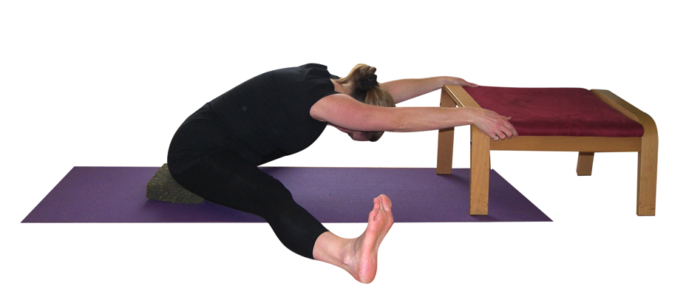***Lean upon a chair or over a bolster***

***Leg up the wall and spread apart***

A nice variation is to move to the wall, sliding buttocks to the wall, raising legs up the wall. We then allow the legs to open so gravity stretches the adductors and works into the hip joints.

#### Developments & Variations

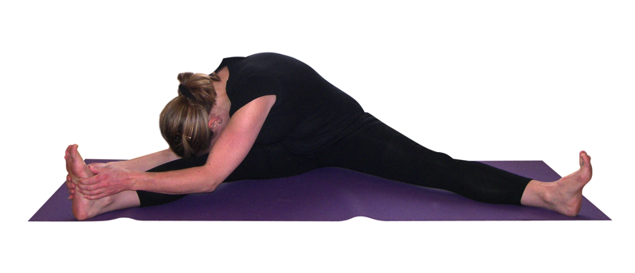***Work to each side, chest towards thigh***

We can stay working to each side. Of course we need to keep the spine extended and it may be we need to bend the knee of the leg we are moving towards or simply angle forwards a few degrees.

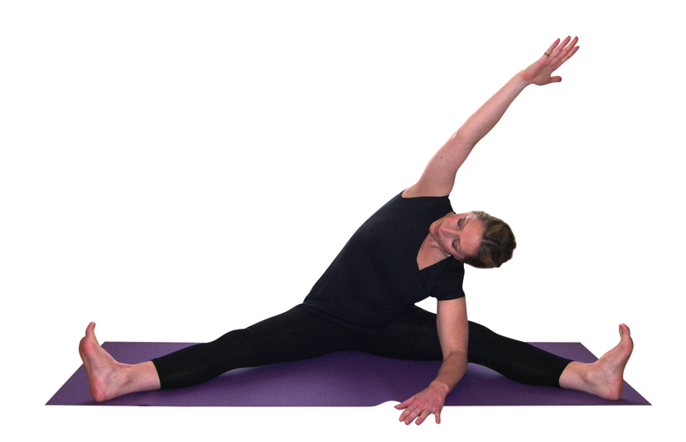

###### Work to each side, side bending spine

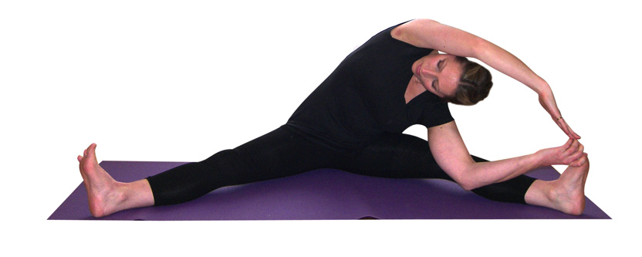We can work into a side bend where we can work more gently by placing the elbow and upper arm against the inner leg to aid the rotation of the upper body. To work more intensively we can lower the elbow to the floor and grasp the big toe of the lead foot. The upper arm can be lowered toward the lead foot, ensuring we maintain the side stretch without allowing the top shoulder to fall forwards. We can of course bend the leg we are stretching towards if necessary.

**Moving into tortoise pose, kurmasana**

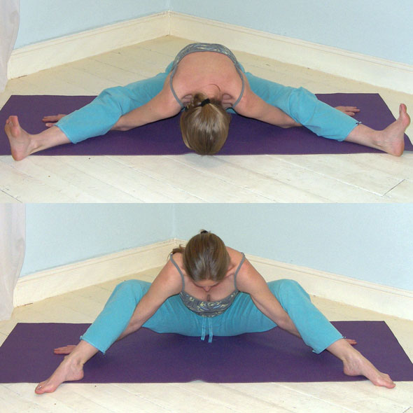

This pose is largely self-limiting but we must ensure we do not compress the structures of the body by moving into this pose forcefully; it should always be a pose of surrender and letting go.

We can only move into kurmasana once the full version of the previous pose of upavistha konasana is comfortable.

* From dandasana adduct legs a little further than shoulders and bend knees. Fold forwards from hips and slide arms beneath legs one by one.
* Slide palms slowly outwards, widening the chest and back, lengthening the spine and dropping shoulders to the floor, and away from ears.
* Keep knees and feet pointing upwards.
* Feel pelvis tilt forwards as sacrum and spine work as one unit
* When staying keep lengthening the spine, reaching out through heels, opening the back and chest. Keep relaxed.
* To release bend knees and lift the upper body, moving into a suitable counterpose.

**Adjustments for Upavistha Konasana**

Check student’s thighs are aligned and if the knee has rolled inwards then it is possible to kneel behind the student and gently rotate the thighs backwards i.e. assist the external rotation of the hips. If feet have collapsed then a light touch to the feet is enough to point toes to the ceiling. Check that knees have not bent if so, give blocks beneath buttocks and perhaps advise that legs need to be closer together. Where backs are rounded a hand placed upon the lower back and at the upper chest can help to guide the student into lengthening the spine, if it is not possible then we must request students do not flex so far forwards.

**Remember for all forward bends:**

Check there is an anterior tilt of the pelvis so there are natural spinal curves before starting to flex. Use padding beneath buttocks if needed.

Flex forwards from the hips.

Move the sacrum and spinal column as one.

Keep the spine lengthened in full extension.

Check there is not pain or excessive tension experienced at the sits bones or inner knees.

Be aware that the placement of arms will have an immediate effect upon the intensity of the pose.

Use the breath, waiting for the relaxation response to occur to go more deeply.

© S Beck November 2014