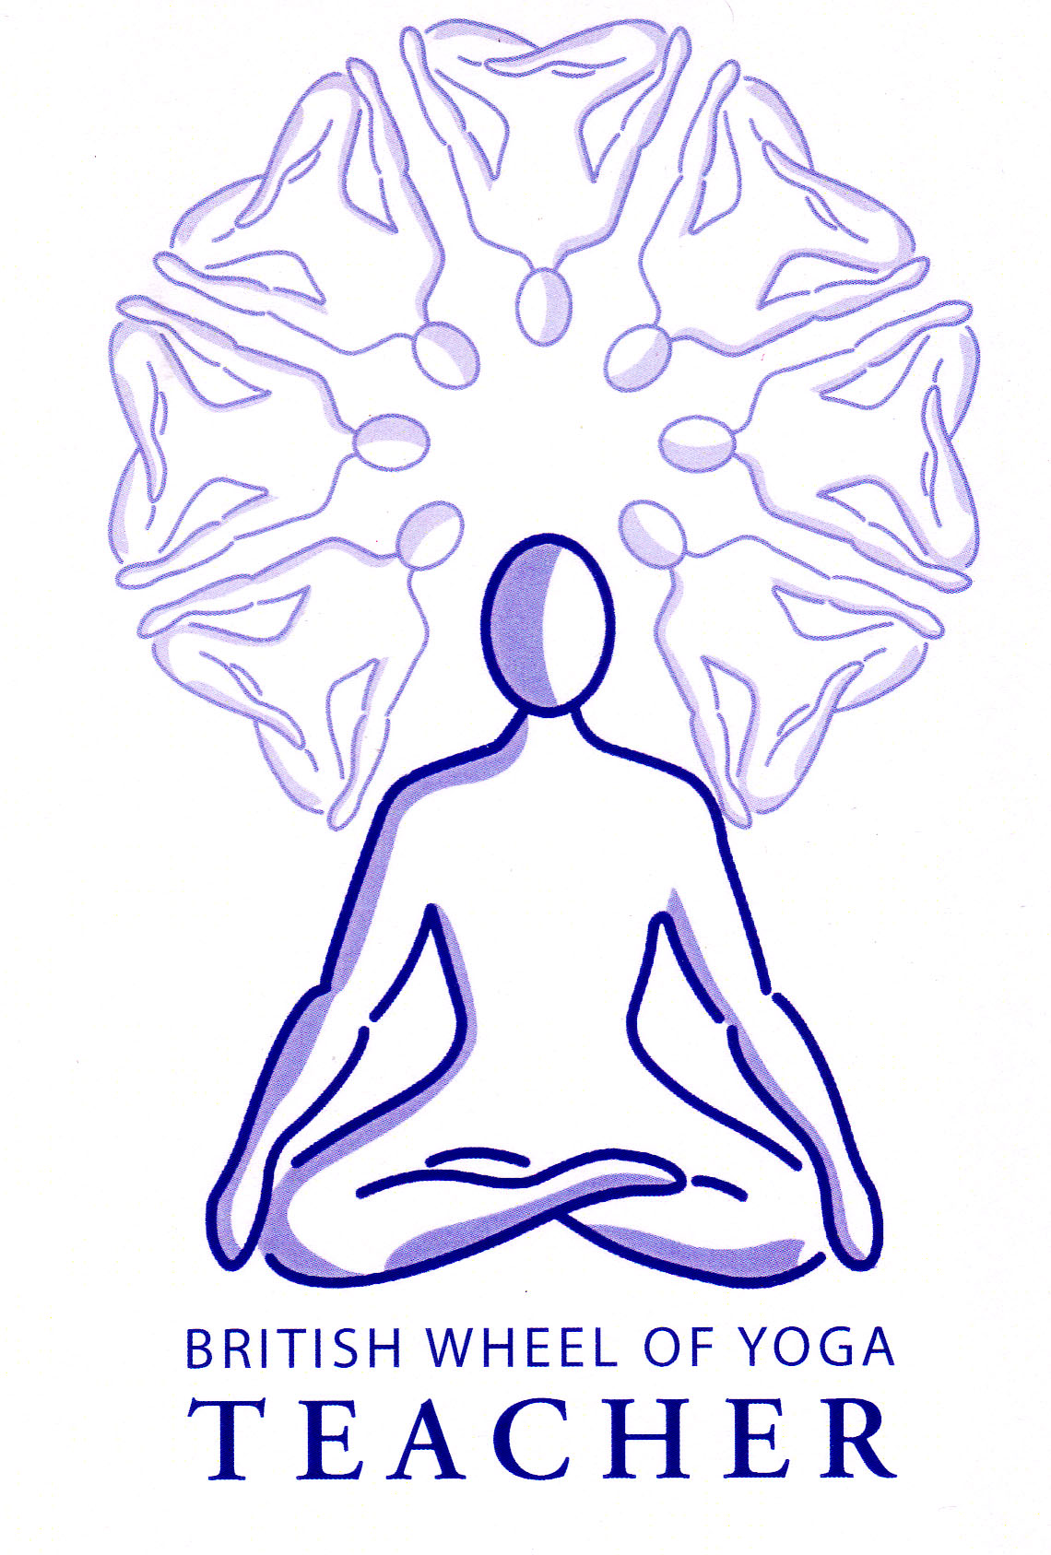Hatha Yoga comes from the Tantric Tradition where after the proliferation of Buddhismin India in around 6th CE there was a movement by yogis such as Goraknath and Matsyendranath to establish a new system of self-realization based soley upon the purification of the body. Unlike previous paths here the body was seen as divine, a manifestation of the One. They refined previous tantric practices, removing the aspects of meditation and ritual, so that the **expansion of consciousness became a physiological possibility**, although, like all yogic paths, hatha yoga leads us to raja yoga where the mind becomes one-pointed and samadhi becomes possible. Hatha Yoga works directly with our subtle pranic energies, bringing them into balance, so that our innate store of Kundalini Shakti can be awakened and consciousness can be expanded beyond it’s usual limitations. In it’s entirety is a very intensive, **forceful path** requiring special guidance however there is much to be learnt from it’s study especially with regards to our subtle pranic anatomy & physiology and we can most certainly benefit from it’s most accessible practices.

**Kundalini: The Serpent of Fire**

**The Cosmology behind Hatha Yoga: Evolutionary Principles**

The path of Hatha Yoga is the involution where we re-trace the evolutionary path of Shakti, to re-unite Shakti wth Shiva, i.e. to realize our true Self, beyond the mind and body and senses. Hatha Yoga, unlike other paths such as the meditative path of Raja Yoga, is primarily an ecstatic path where rather than slowing down our mind and pranic energies (enstasy) they are instead stimulated; indeed Hatha Yoga is sometimes known as forceful or violent yoga. (see the handout on ecstacy v enstacy).

Remember for the Hatha Yogi Realization of the Self is primarily a physiological possibility where s/he works directly upon pranic energies to refine and balance the pranic body, pranamayakosha, knowing that this will ultimately lead to a chain reaction leading to the expansion of consciousness into the transcendental state. As Swami Muktibodhananda Saraswati says in the HYP (1993: Ch4 v2) “Through yogic and tantric practices this process is accelerated. Just as scientists have developed the means to release nuclear energy from the uranium atom, similarly the yogis found a scientific system to release the energy and consciousness from the bindu within the body.” Let us now look at the different aspects of our pranic body so we can begin to better understand this process.

**Aspects of our subtle anatomy & phsyiology**

Sushumna Nadi

We have already encountered ida and pingala nadis, the currents of mind (intelligence, thinking, emotions, memories) and life energy (vitality, activity, will power) respectively (HYP:Ch 2 v4 & Ch3 v4), but now to look in more detail at the central channel of sushumna nadi which lies along the central spinal axis. The sushumna nadi emanates from the ‘kanda’, meaning ‘root’ which is the location from which all nadis emerge. In the HYP the kanda is said to be located just above the anus, being one hand span high and four fingers wide (Ch3 v113) although modern commentators often describe it’s location to be around or just above the muladhara chakra, starting just above the perineum and reaching up to the sacral chakra, swadisthana chakra. We may imagine that the cauda equina, meaning horses’ tail, which emerges from the spinal cord at L1 on the spine, corresponds to the kanda, although the kanda exists in the subtle pranic body rather than the physical body.

There are three layers to sushumna where the innermost is the channel of fire, usually called the ‘Brahma Nadi’ since when energy moves along this nadi it leads us to an experience of Brahman, the Self. The next level is Citrini Nadi meaning ‘giver of immortality or shining’ which is said to be an extension of ida nadi, being the channel of the moon. Whilst the outermost layer is the Vajrini Nadi meaning ‘thunderbolt’ being the channel of the sun and an extension of pingala nadi.

[Interestingly it is the level of the citrini nadi which contains the chakras and that if we remember each chakra operates at a different vibratory frequency this is indicated by the bija sounds to be found upon the petals of each chakra symbol. The matrikas or sanskrit letters are truly the vibratory sounds of the uinverse creating all of prakriti]

The sushumna nadi which emerges from the ‘kanda’ travels up though the middle of the spine from the muladahara chakra to the ajna chakra. Muladhara is the negative pole where the three nadis meet at what is known as the yukta triveni (combined three streams) and ajna is the positive pole where the three nadis travel up the spine, crossing at each chakra, climbing over the head to converge at what is known as the mukta triveni (liberated three streams); pingala and ida contining beyond this point until they culminate at the two nostrils. Sushumna nadi is sometimes described as the place between the two extremes, known as the ‘path of the void’ or great pathway.

The granthis

Placed along the sushumna are three Granthis or psychic knots (Ch3 v106 to 107) and each must be pierced as Kundalini Shakti within the central sushumna nadi rises. Each knot ordinarily keeps us tied to a certain level of attachment.

The first psychic knot is Brahma Granthi located at the base chakra, this ties us to the world or Bhur Loka, the world of matter, sexuality and sensuality where we are identified with the physical body and senses, seeking pleasure and avoiding pain. It is related to being attached to desires.

The second psychic knot is Vishnu Granthi located at the heart chakra which denotes our attachment to action and the the world of I-ness or Mahar Loka.

The third psychic lock, Rudra Granthi, is located at ajna chakra, relating to Tapas Loka, linking us to our attachment to thought.

Figure 1

Finally as part of our pranic system to examine the concept of bindu and nada.

The bindu

Bindu is a nucelus or point containing concentrated potential consciousness & creative energy, it is the point of both Shiva & Shakti from which nothing has yet been manifested. There are several bindus within the subtle body. The first is that of bindu visarga or Maha Bindu located at the top back of the head. It is the white bindu represented as the crescent moon and dot in a moonlit sky (remember the symbol of OM, where this is the symbol for the transcendental state). Physiologically amrita (nectar), also sometimes known as Soma, is the secretion arising from the bindu visarga (meaning falling of the drop) located at the back of the head. Normally the secretion flows downwards, is held in a reservoir called lalana chaka, located at the rear of the naso-pharynx, continuing downwards to be consumed by manipura chakra. However when vishuddhi chakra is awoken the secretions are able to travel throughout the body bringing great vitality, regeneration, removing the need for food & providing protection from all poison. Metaphorically protection from poison means that the world cannot bring negativity, there is no good or bad. The existence of this tiny amount of fluid has not been proven by modern science but like the pineal gland perhaps it will be one day. (Ch3 v77)

The other significant bindu known as Sthula Bindu is the red bindu located in the muladhara chakra as the subtle energy of the reproductive fluids, i.e. sperm and ova. Interestingly we can see how this concentrated point of consciousness and energy or the creative energy of the universe, maha shakti, is so potent that it can become another human! However for the evolution of consciousness we can then also see how celibacy aids this process because pranically there must be the union of these two bindus where the sun i.e. the red bindu at muladhara chakra, the negative pole (Shakti) must meet the white bindu in the head, the positive pole (Shiva). When these two poles meet there is an explosion creating pure light, transcendental consciousness, now the whole brain is alight.

In other words as we progress through the practice of Hatha Yoga and our kundlini shakti moves beyond ajna chakra we reach Raja Yoga where the mind is one pointed. Here at the last stage of Raja Yoga we will spontaneously collapse back into the maha bindu as we move beyond the mind & body & senses into universal consciousness.

During the rising of the kundalini energy we can say that ida (mind) and pingala (prana) nadis are drawn together at successive chakras, the bindu rising upwards through the lower chakras, once however it reaches manipura chakra, the sun at the solar plexus, it is said to be stabilised there; i.e. bindu is now withdrawn from muladahara & swadisthana chakras. There is now transformed sensuality as will (iccha Shakti) and transformed passion as compassion. Physiologically it is said that now the hormones secreted from the pituitary gland flow continually, modifying the instinctive functioning of the lower two chakras and reducing the usual aging, degenerating effects of hormones being turned off and on to retain homeostasis according to the body’s needs.

Nada

One quality of vibration is that it can create sound, some of these sounds we can hear audibly through our senses and others are beyond our normal auditory capacity. However nada is subtle sound vibration experienced inwardly as kundalini moves. When the two polarites pierce the granthis there will be an internal sounds, varying from the sound of tinkling bells to thunder, the sounds becoming sharper and subtler as we move upwards. We are told in the earlier stages to keep our attention upon the subtler sounds from which the sound emanates, and indeed our mind will naturally converge upon it’s source.

Kundalini Shakti

‘Kundalini’ meaning ‘she who is coiled’ is the latent primordial power we all possess for evolution. It is located at the base chakra where it sleeps in a dormant state, being usually conceptualised as a serpent coiled three and a half times around the kanda, the muladhara chakra. In our everday lives sleeping kundalini provides the source of energy for all of our body and minds activities but when awoken it can expand our consciousness, awakening our full potential. The three and half coils represent the three states of consciousness i.e. waking, dreaming and sleeping, the final half coil represents the fourth state of transcendental awareness. Throughout time and within different cultures kundalini shakti has been portrayed as a serpent, in part this is no doubt due to the fact that when it first begins to rise usually a kind of hissing sound is heard and also that it is said to sit coiled, waiting to be awoken. Within each of us this is considered to be the place of the Goddess, Shakti, the force or Being which is the energy of consciousness which can be united with the God, Shiva, Pure Consciousness itself.

Figure 2

The path to awakening

The awakening of kundalini follows a four fold path where:

1. first we must purify, strengthen & balance the nadis, balancing ida & pingala
2. then the chakras are awakened
3. then sushumna nadi is awakened
4. and finally kundalini can be awoken

1. The practices of hatha yoga help to purify, strengthen & balance the nadis, especially asana and pranayama. Normally ida conducting consciousness, and pingala conducting the life force, fluctutate in dominance influencing all the body’s activities. At first there are only seconds when both ida and pingala operate simultaneously causing sushumna to flow, as the flow changes from ida to pingala and vice versa but over time this period lengthens. When both ida and pingala are balanced then it becomes possible for sushumna, the central nadi, to become activated.

2. There should be a gentle awakening of the chakras through asana, pranayama, mantra, bandha etc. Sometimes the lower two chakras are already awakened i.e. purified and purification is required in the remaining chakras. If this is done gently then we are unlikely to experience explosive emotions.

*In terms of electricity now the wiring (nadis) and junctions (chakras) are ready.*

3. When both ida & pingala nadis are balanced, sushumna nadi becomes active and initially movements of energy can be experienced within sushumna but these are not the full force of Kundalini, rather a preliminary clearing of sushumna nadi. At ths point all of the chakras are said to face downwards.

*Now it is as if the +ve and –ve channels are linked to an earth or neutral channel (+ve & –ve)*

4. When all is in balance it becomes possible for Kundalini Shakti herself to stir awake and if the proceding steps have been taken she can rise, as if by a powerful magnetic force, to the ajna uninhibited, breaking through the granthis as she rises through the sushumna. As Maha Shakti awakens and travels through sushumna nadi the Void or state of Shoonya will be experienced as the experience of no-thingness. Then with grace upon reaching sahasrara chakra we may merge with maha bindu. If however we attempt to lift kundalini before the intital three steps are taken then an obstruction along sushumna may force kundalini shakti into a particular chakra where it can cause physical & psychological problems, even madness! That said to the greatest degree there are inbuilt safety features and if kundalini rises and is obstructed it will simply fall again and become latent once again.

For ourselves, as householders, it is often recommended that as well as practicing some Hatha Yoga, we also practice some Bhakti Yoga, Karma Yoga and Raja Yoga to help us find psychological balance. This is especially helpful because it is said that to awaken the three lowest chakras can give rise to many difficult issues, as they relate to areas of the brain where samskaras are held, i.e. hold latent memories, tendencies etc. and these will bubble up into consciousness.

The is is especially true for swadisthasana chakra which can be seen to be the storehouse of our unconscious karma, from this life and others, meaning unless this area is ‘purified’ kundalini may rise from muladhara repeatedly to be met by this obstacle in swadisthasana and descend again. When swadisthana is awakened we must be prepared to experience the mental confusion it brings, and for this traditionally the Guru was a necessary guide.

It is often said that ideally ajna chakra is awoken first so that we will then have the insight and necessary detachment to more easily experience what the lower chakras bring forth as they awaken.

Hatha yoga to Raja Yoga to Self-Realization

Hatha yoga has been achieved when we have achieved physical, mental, emotional and psychic equilibrium, where the body has become refined and strong enough to become a vehicle for higher forces of energy (Ch1 v1). It creates the unification of chitta and prana (ida & pingala) so that now sushumna can be activated and kundalini can be awoken. Hatha Yoga is the ‘ladder’ to Raja Yoga where through its practices, especially that of kumbhaka, the mind becomes one pointed so that Raja Yoga has been achieved where there are no mental fluctuations and there is the experience of ‘Thatness’ and Bliss. Along the way as we see in chapter 4 of the HYP there will be Laya Yoga or the ever increasing absorption of the mind into nada, the auditory manifestation of Shakti. Eventually the Ishwara Tattva is reached, the sattvic state of Shakti or creative potential of Shakti. Finally our consciousness must merge back into the Maha Bindu wherein there is Liberation as we become part of Universal Consciousness. This is the journey of involution back to the Source. (See four stages in HYP Ch4 v69 to 76).

Note that the force of kundalini is intimately tied to the brain where normally of the ten regions, nine of them located in the frontal brain are dormant. These dormant areas of the brain only receive pingala, i.e. prana, but not consciousness i.e. ida nadi. When a chakra awakens as previously stated the corresponding part of the brain is then connected to both ida and pingala nadis and will bring consciousness to these areas of the brain. And when finally kundalini reaches ajna chakra and travels into sushumna chakra the whole brain becomes alight, and as Maha Bindu explodes Shakti has reached her destination to be reunited with Shiva at the crown and we are connected to Universal Consciousness. There is now liberation from all karma, vasana (unconscious desire) and ego. (Ch4 v11 &12)

**Signs of Kundalini Awakening**

It can be a gradual awakening over an extended period of time so that there is a partial ascent only and as long we are in a state of balance this can be quite mild in nature. But it can also rise up as an explosive electric charge, like lightening, and so we need to be prepared.

Experiences can be highly individualistic but generally:

* Spine becomes rigid
* A feeling of explosive energy or strong vibrations within the spine
* Tremendous heat where the Shakti has touched us then a cold lifelessness as it passes through.
* Inner sounds, known as manifestations of Nada, becoming sharper & subtler as higher energy frequencies are experienced.
* Experience of light within, such as seeing inner visions of the nadis
* There can also be:
  + Very intense emotions, memories resurfacing
  + Disconnection from the external world
  + Headaches as new areas of the brain become active
  + Insomnia
  + Inexplicable illness
  + Fear or Terror especially as we face annihilation of the mind

[Note: when chakras awaken the experience tends to be blissful with fantastic images arising & images of goddesses etc. these may also be purely our own samskaras (psychic imprints)]

The Descent of Kundalini

During Samadhi when Kundalini Shakti has been united with Shiva, Uinversal Consciousness, we are unaware of our individual self, we have entered The One, there is only ‘being’ beyond all time and space, and importantly beyond thought. Thus it is very significant that during the ascent of kundalini we are able to surrender our thinking and much of our preparation will enable us to this, especially through the experience of kumbhaka, or the cessation of the breath. This state of merger will last for some time and then Shiva and Shakti will separate returning to the state of duality but now Shiva will descend with Shakti to muladhara chakra. The practitioner remains connected to the new cosmic wisdom and knowledge but truly recognises that all of duality is Lila, the cosmic dance, and that s/he can fully particpate in life but at the same time is filled with the joy of being. S/he as a Realised Being is of this world and also not of this world. This is a jivamukti.

The question of the necessity Guru

Classical texts generally highlight the necessity of a Guru who already trodden the path and has the ability to perceive what each student requires to develop and evolve. Here in the west this is rarely possible so what can be done? One of the best ways is to practice hatha yoga with great sensitivity to your own capacities, monitoring your own experience, keeping it gentle and balanced. Develop an attitude of surrender so that your own higher intelligence leads you and can grace you with change when the right time arises. It is good to also practice karma yoga and bhakti yoga to aid the development of selflessness and purify the chakras. Another powerful possibility is to develop a relationship with the Goddess or Devatas which can be done very directly through mantra.

Whilst this journey through to sahasrara chakra may remain purely theoretical (for this lifetime at least!) but we must always remember that the practices of hatha yoga can be extremely beneficial for us regardless. They will help us in the many ways giving us physical, emotional, mental and spiritual balance; through working dircetly with prana we will all benefit.

Bibliography

Images:

*Figure 1 soonyata.home (accessed December 2013)*

*Figure 2* [*http://www.galaksija.info*](http://www.galaksija.info) *(accessed December 2013)*

Texts:

Georg Feuerstein, Tantra, The Path of Ecstasy, (1998), Shambala Publications:Boston

Swami Muktibodhananda Saraswati, Hatha Yoga Pradipka, (2nd edition), Bihar School of Yoga: Bihar

Swami Satyananda Saraswati, Kundalini Tantra, (2012), Bihar School of Yoga:Bihar

*Useful references from the HYP:*

*Ch3 v4 The nature of sushumna nadi*

*Ch3 v64 Bindu*

*Ch3 v54 The experience of the union of Shakti & Shiva*

*Ch3 v68 to 69 Kundalini awakes*

*Ch3 v73 to 75 Employing the bandhas activates sushumna*

*Ch3 v106 to 107 The granthis*

*Ch3 v108 Kundalini asleep within muladhara chakra*

*Ch 3 v113 The kanda Ch 3 v124 Sushuma being purified and awakening*

© S. Beck January 2014