**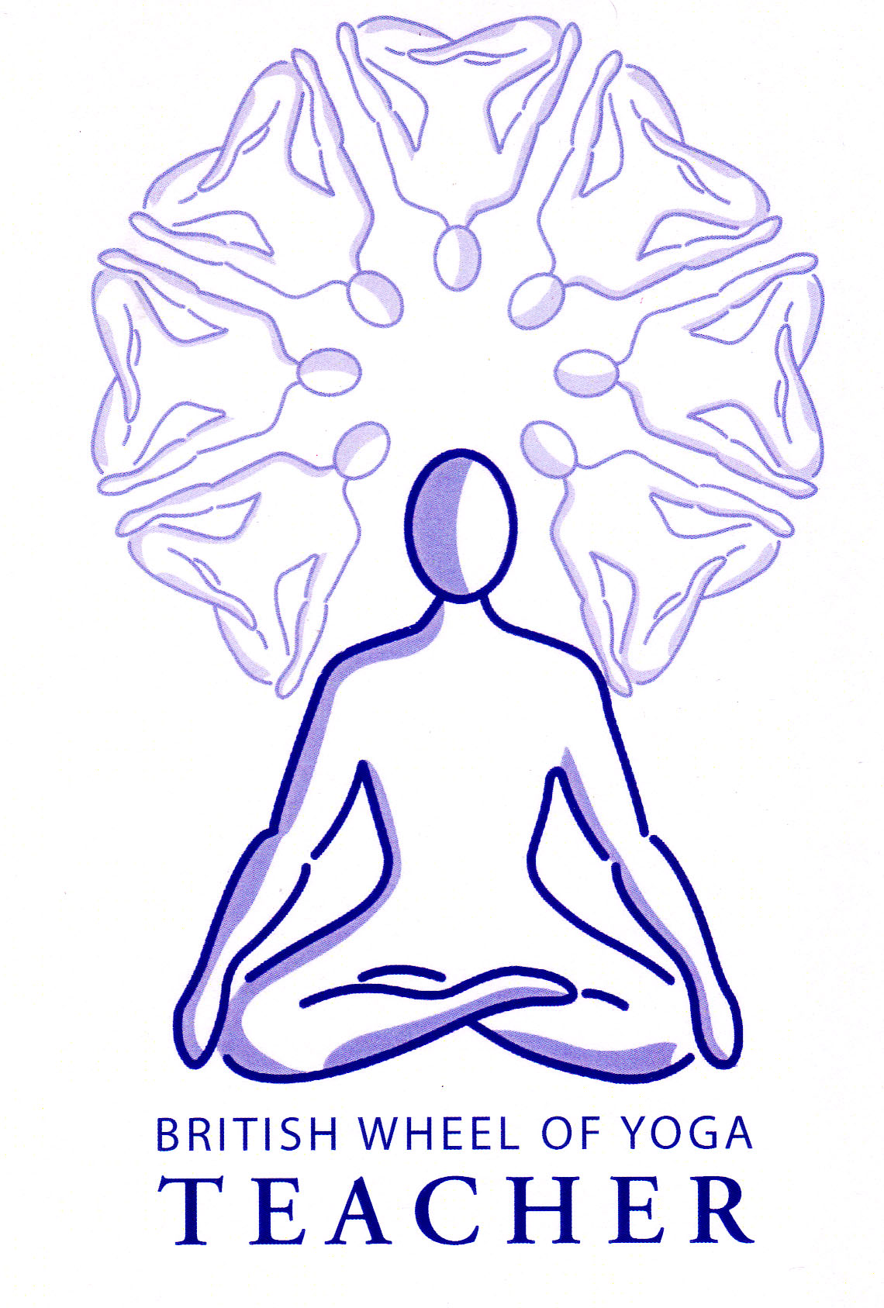Janusirsasana (Head to knee pose)**

# :attachments_11_12_2009-1 Folder:janu5.tif*Pronounced jaah-noo-sheer-shaah-suh-nuh the word janu means knee and sirsa means head in Sanskrit*

This is an asymmetrical seated pose which unfortunately due to its name sometimes causes students to force the head to or beyond the knee at the expense of the mechanical integrity of the body. This pose requires very open hips, adductors and hamstrings. This means it is sometimes better to simply call this asana the seated asymmetrical forward bend! It is an introspective position where the breath can gently move us into a more released state; within this position we can adopt soft, easy breathing to calm and soothe the body into quietness.

**Teaching Points:**

* Sitting in dandasana (staff pose), bend the right knee, placing the right sole against the left inner thigh. Press gently against the left thigh to help keep the hips aligned square to the front.
* Ensure the spine is upright with a slight anterior tilt of the pelvis, check the chest faces forwards towards the end of the mat.
* Inhaling lift both arms vertically (flexion through elevation) keeping the shoulder blades tucked in and down against the back, shoulders down away from ears. Create space within the waist as the ribcage lifts away from the pelvis creating a very slight backbend.
* Exhaling lifting the tailbone, to lengthen the lower back and slightly arch the back, fold forwards from the hips reaching outwards through the fingertips and crown of the head as you lower both arms, folding forwards.
* Only fold forwards as far as the back can remain long, as soon as the back rounds you have moved far enough. Try to close the gap between the navel and thigh rather than trying to take the head to knee!
* Place the hands lightly upon the leg or foot, ensuring the straight leg remains active with the left foot dorsiflexed (toes pointing to ceiling), knee pointing upwards to ceiling.
* Stay at this first point of resistance inhaling lifting and lengthening the spine, taking the ribcage away from the pelvis and exhaling lowering the chest to the thigh. After working in this way using the breath and subtle movement simply stay still and encourage release through the breath. If at any point the upper body feels to have shortened again lift and lengthen on an inhalation and then exhale to release once again into the pose.
* To exit, inhaling reach outwards and upwards through the fingertips and crown of head raising arms back to the vertical and exhaling lower arms to sides.

**Caution:**

* Ensure the bent leg hip is open so the **rotation of the bent leg is occurring within the hip joint and does not create rotation and compresion within the knee joint**.
* We can direct the primary work into the legs or the upper body. If we wish to work with the legs then we can hinge forwards as far as the back remains straight and either hold the straight leg foot if we can reach or use a belt wrapped around the ball of the foot if we need to extend the length of arms. If however we wish to work with the upper body into a more complete pose then we must always ensure the chest can rest along the thigh and as shown above this may mean bending the straight leg to accomplish this with integrity. So when primarily working the upper body aim to first close the space between the navel and the thigh and then slowly allow the outstretched leg muscles relax over time or alternatively focus primarily on the leg muscles and hinge the upper body carefully forward at the hips without rounding the back. **We must choose which alternative we choose to teach and it is good to teach one for a while then the other.**
* We must also ensure we keep the neck long so it is best to look down as we lift and lower arms.
* **Avoid overly using the arms to pull the body forwards**, it is best to primarily rely upon the abdominal and iliopsoas muscles instead.
* Take care to **maintain symmetry so there is an even stretch in the back and hamstrings by keeping the chest and hips forwards facing.**

**Benefits:**

Quiets the mind and calms the nervous system

Rejuvenates the spine (stretching & strengthening)

Stretches hamstrings and groin muscles

Massages the heart and alleviates symptoms of high blood pressure

Massages the abdominal organs, especially the liver, spleen and kidneys

Improves digestion

Tonifies the sexual and reproductive organs

#### Good preparation

Simpler forward bends, hamstring, groin and hip openers. Ankle mobilisers & back strengtheners.

**Contra-indications & possible modifications**

* Hamstring problems or low back conditions, sacroiliac problems and sciatica bend front knee and focus upon tilting the pelvis rather than stretching the spine
* Severe spinal disc conditions avoid this pose using an alternative instead
* Hip conditions can keep bent leg straight out to side or work with both legs straight in front instead if necessary
* Knee conditions can again keep bent leg straight out to side or work with both legs straight in front instead if necessary

#### Simple versions and modifications

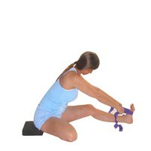

###### Use a block and a belt

Here we can assist the pelvic tilt using a block beneath buttocks or extend the reach of the arms by using a belt

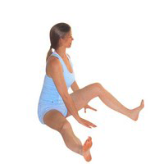

#### *Bent leg straight out to side & blocks beneath bent leg*

Here we can avoid excessive pressure into the hip or knee joint by working with the bent leg straight out to sides. Alternatively we can place padding beneath the bent leg thigh to enable students to relax the inner thigh and hips muscles. If students keep the bent leg raised in the air then there is little chance the muscles will relax enabling the knee to lower to the floor.

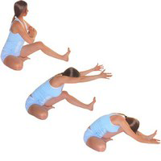***Reach out at shoulder height***

Here we can avoid excessive work within the back by reducing the weight of the arms so rather than lifting the arms vertically instead we reach out as we lengthen the spine. This is a great modification for students with back conditions and can be also used as the first version to be taught to beginner students and where we are teaching a mixed class we can teach this version first and then the second time through work in the versions where arms are raised as we enter and leave.

**Developments & Variations**

*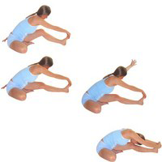Initial upper back & shoulder stretch*

This is a great way of working into the pose where we start by taking the right hand to the left foot, keeping the left leg aligned, and place the left hand behind the left buttock. We press down into the left hand to help us fold forwards as we feel the area of the right upper back being stretched. Once we have stayed here for several breaths then we inhale lifting the left hand up and exhaling taking the left hand to the front foot, holding the foot in both hands. This is performed to both sides and can really help students move into a deeper pose.

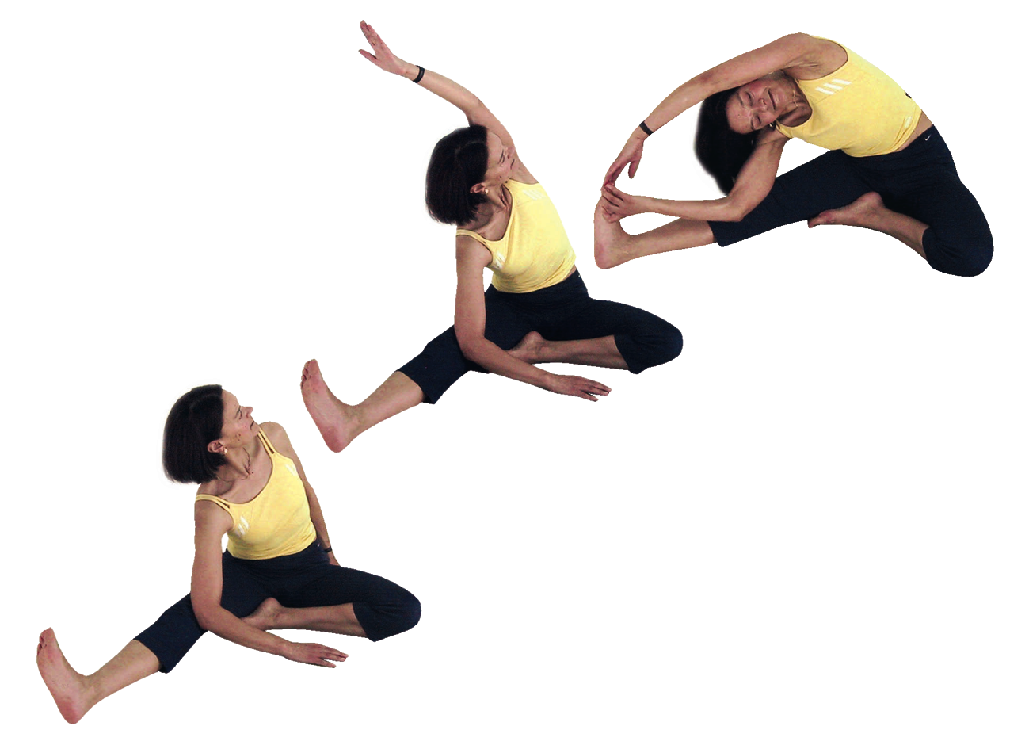*Revolving head to knee stretch*

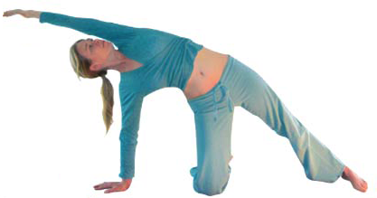Here we can work first or afterwards with revolving head to knee stretch where we begin by rotating the torso by pressing gently against the straight leg inner thigh. This can be done with a bent leg instead if needed. Once the rotation is found we can then if we wish arc the rear hand up against the left ear or go further by taking the upper arm to the outstretched leg. We must however be able to maintain the rotation of the torso, rolling the chest upwards as we look past the armpit. As for all poses we can stay at the level where the body maintains openness.

*Revolving head to knee stretch to circle pose to head to knee pose*

A very good sequence of movements to lead us into head to knee pose is to work as above in revolving head to knee pose then lowering the upper arm we place it just behind the left buttock, finger pointing away at 45º, lifting the buttocks from the floor, shoulder above wrist as we reach over head drawing the hips forwards into circle pose as illustrated opposite. Then lowering the buttocks to the floor we arc the lower hand forwards entering head to knee pose working with an initial upper back and shoulder stretch, finally moving into the full pose.

*Hold wrist beyond the outstretched foot*

To develop we can hold the wrist beyond the outstretched foot, lengthening the calf of the outstretched leg along the floor.

*Place the bent leg heel beneath the perineum*

This is the version often used with maha mudra.

#### Adjustments

Here we gently encourage students to face the chest towards the front by placing hands either side of the ribcage and gently direct the torso. We can also realign the straight leg if needed by pointing the toes upwards and directing the leg so the knee is facing the ceiling. If students have tension within the neck we can also lightly brush the neck or head asking that they release the neck. The same is true for shoulders which have been unconsciously raised. Generally if a student has not entered the pose well then it is best to sit next to the student and demonstrate how to enter, stay and leave the pose working one to one.