Unconsciously many of us restrict our breathing in some way and if this is the case significantly we are locked into a cycle where the body, breath and mind are all adversely affected. This is a closed loop leading to pain or dukha as it is known in Sanskrit. We can take dukha to refer to pain in the widest sense of being an actual physical pain as well as the experience of psychological pain, or it can be a feeling of more generalized discomfort or being ill at ease. Dukha is the opposite of sukha meaning ‘easy’ or ‘comfortable’.

The closed loop leading to either Sukha or Dukha:

Mind

Breath

Body

However we can create favourable change, creating sukha, by changing one aspect of the loop, so for example beneficially altering the functioning of the mind will beneficially transform the functioning of the body and breath, and the same is true if we make positive changes to the body, this too will benefit the mind and breath. **However in yoga great value is placed upon the transformation of the breath to break the cycle of duhkha, it being considered to be much harder to break the cycle through changes within the mind or body.**

The breath is perhaps the most easily transformed aspect of our being as it is under our conscious control and only requires the patient application of our attention to make positive changes. When we make any changes to the characteristics of the breath such as its depth, speed, smoothness etc. we will quickly alter the way in which the mind functions and how the body is experienced. These positive changes are primarily because the breath directly relates to both our energy levels and the distribution of our energy, a change in the functioning of the breath literally changing our inner rhythm. Here in yogic terminology we can see that the pranamayakosha (pranic sheath) is the bridge between annamayakosha (body sheath) and manomayakosha (mental sheath) and by altering the quality of pranamayakosha we are directly affecting change in body and mind.

Indeed the famous yogi Osho once said that for him all breath work, including pranayama, should be the conscious awareness of the rhythm of the perfect breath which brings a feeling of peace to each individual.

There are several common breathing patterns we can investigate to help us decide if we are restricting the natural flow of our breath or if our students are doing so. We will explore:

Reverse breathing

Paradoxical breathing

Collapsed breathing

Throat holding

Breath grabbing

Frozen breathing

As you read through the list of breathing patterns try emulating each situation, seeing how it makes you feel physically, energetically and psychologically. See if any of the patterns feels familiar to you or if you know of anyone who fits the pattern.

**1. Reverse Breathing**

Normally as we inhale the diaphragm moves downwards causing the abdomen to expand outwards then as we exhale the diaphragm moves upwards causing the abdomen to move inwards.

A reverse breather does just the opposite, when they inhale they contract the abdomen and as they exhale the abdomen expands. Although it may be the case the abdomen is never fully released at any stage of breathing.

*How to check for reverse breathing?* Sit comfortably or lie in a semi supine position and place your hands lightly over the abdomen. Begin to notice if your belly is expanding into your hands as you inhale and contracting a little as you exhale. Try not to exaggerate your breathing let it be natural and begin to notice if this is the case, if not then you are a reverse breather!

*Why does this happen?* Reverse breathing often results from habitually wearing tight clothing or wishing to look very trim. It can also result from feeling chaotic or at odds with your self.

*What are the main effects?* Reverse breathing leads to tension in the upper body, particularly in the jaw, neck, shoulders and upper back. It means energy is not being collected down in the belly region where it grounds us and gives us a feeling of mental and physical strength. This type of breathing often leads to a confused state of mind and difficulty coordinating movement. Usually there is confusion about when to breathe in and out and which muscles to use.

*How can I rectify reverse breathing?* We need to spend time initially working as above, breathing into our hands. We may also benefit from lying down and placing a small weight on our abdomen to help us feel how the abdomen gently contracts on the exhalation, then feeling the weight being lifted upwards a little as we inhale. The yogic breath will helps us greatly as it is the primary foundational practice where we can learn how to breathe deeply and smoothly.

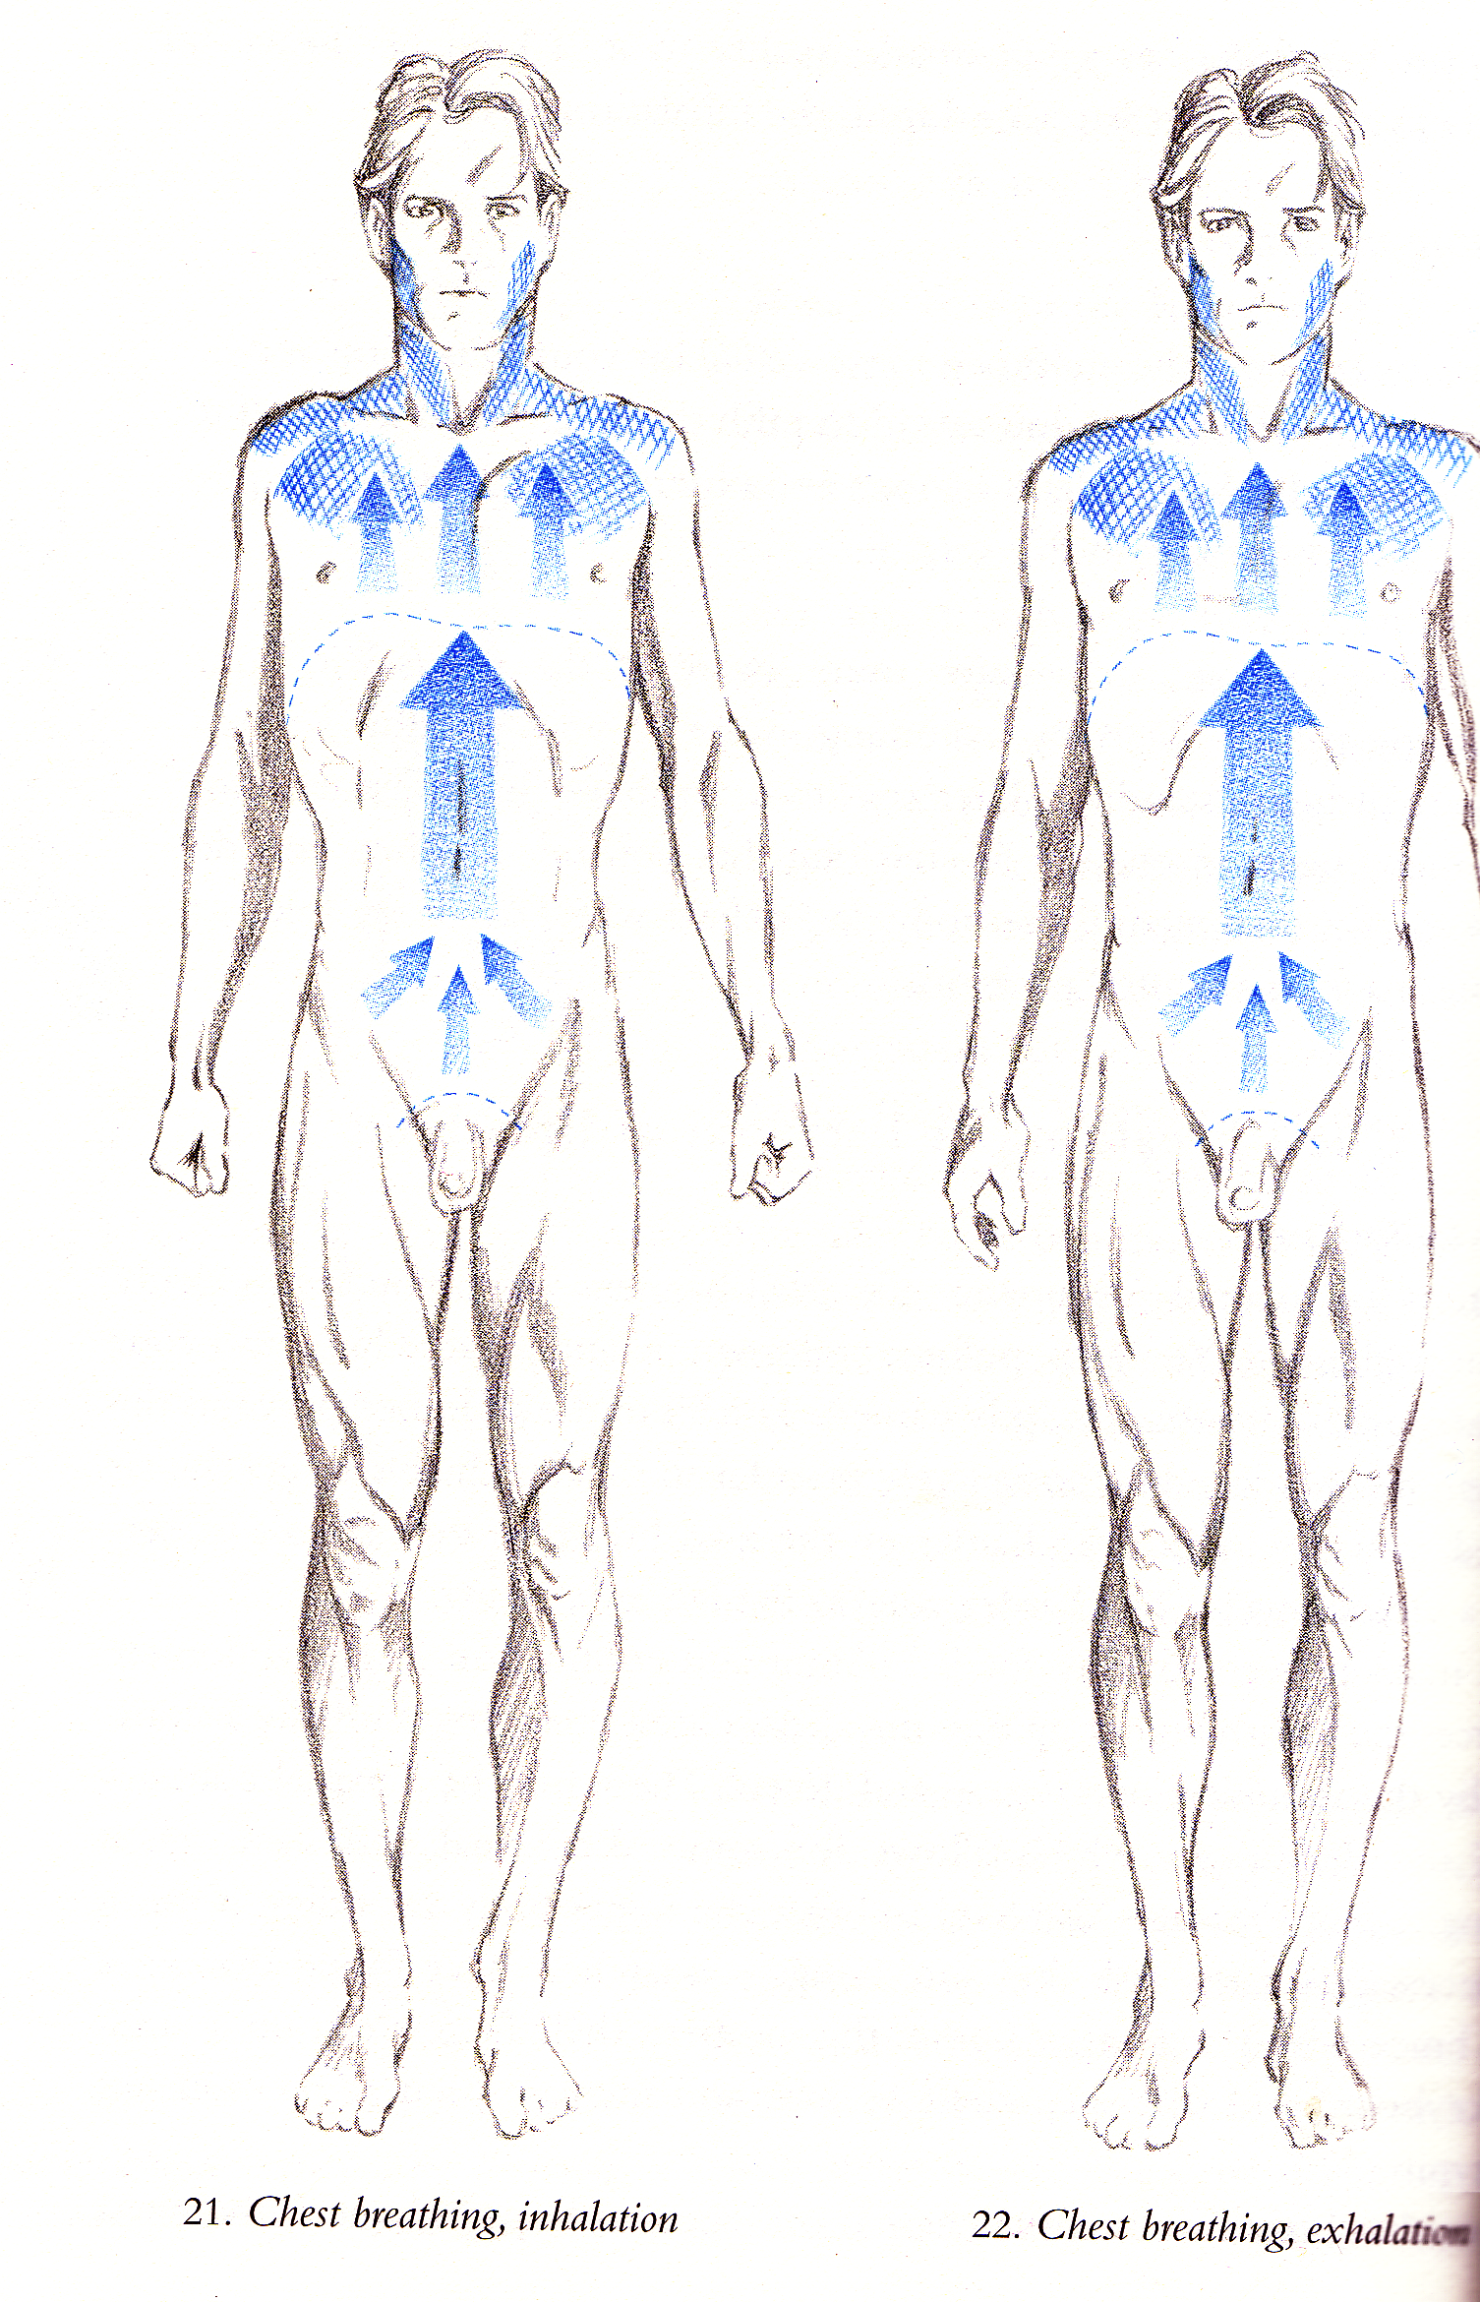**2. Paradoxical Breathing**

This is sometimes known as chest breathing where we hold the abdomen still forcing breathing to occur in the chest area. The upper body is generally braced often with the shoulders moving up and down with each breath. In this case the diaphragm never fully descends and our breathing usually becomes faster. This is the type of breathing we may all experience when startled where as we gasp the abdomen is sucked inwards and we breathe high in the chest area.

*How to check for chest breathing?* Sit or stand and place one hand upon the sternum and the other on the abdomen. Breathe naturally and notice where there is more movement occurring. If there is more movement at the chest then you are breathing in a paradoxical manner.

*Why does this happen?* Paradoxical breathing often occurs when someone feels as though they are not ideal physically, perhaps believing they are overweight or when we habitually holds the abdomen it may be a result of habitual stress or excessive ‘busyness’.

*What are the main effects?* Breathing high in the chest region creates tension in the upper body, especially in the neck, chest and shoulders and because we are using the secondary respiratory muscles, which are not designed for prolonged use, they quickly become fatigued meaning a cycle of tight and tired muscles results.

Without the proper descent of the diaphragm we find visceral organs do not function as efficiently without the massaging effect of the movement of the diaphragm. Digestion, assimilation and elimination are all impaired. Also because the diaphragm is not fully descending the blood flow to the heart is reduced leading to a quickened breath and possibly even to hyperventilation.

We find this breath leads to a general state of anxiety and a feeling of nervousness. Energy is directed high up in the body and the individual is likely to feel ungrounded and may find it is difficult to focus, be organized and get things done. A person habitually suffering from paradoxical breathing can often be seen sitting on the edge of their chair!

*How can I rectify paradoxical breathing?* We need to consciously spend time relaxing the upper back and shoulders. We must allow the abdomen to expand and contract enabling the movement of the diaphragm. The yogic breath is great for learning to breathe properly into the three areas of the abdomen, ribcage and upper chest.

Most importantly over time we must learn to relax the mind, learning to stay present rather than allowing the mind to rush ahead of us. We must also learn to release any unrealistic expectations particularly in relationship to our body.

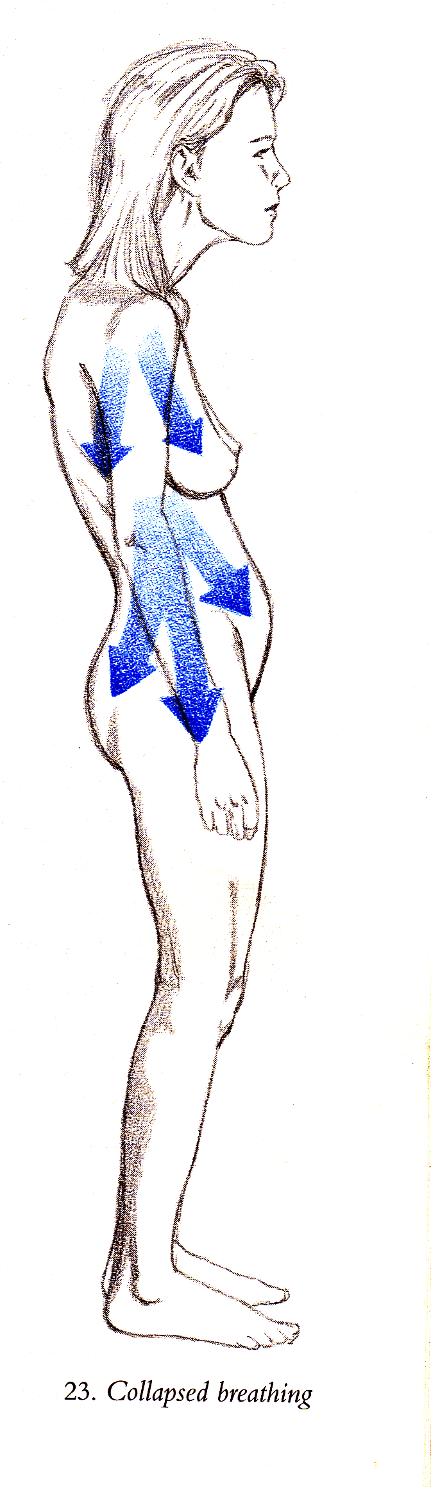**3. Collapsed Breathing**

Here the abdomen is also held and breathing is also restricted being directed to the upper chest but the body collapses downwards and inwards rather than being lifted upwards as we find in the case of paradoxical breathing. The shoulders and upper back collapse inwards and downwards and the abdomen often protrudes like a dead weight. When breathing the upper shoulders and upper chest may lift a little and the exhalation is often like a sigh.

*How to check for collapsed breathing?* In a standing position allow your shoulders and chest to collapse downwards and inwards, then begin to straighten up drawing the shoulders back and down, lifting and opening the chest and notice which of these two situations feels the most familiar to you.

*Why does this happen?* This type of breathing often occurs when a person is feeling depressed and does not relate well to the body, living more in the head than the body. An individual may be feeling life is too difficult so they literally have shrunken back from life. It can also occur when a person is overweight.

*What are the main effects?* The greatest effect is stagnancy and this will be echoed in the fact that the inner organs will also be stagnant. Vitality will be greatly diminished.

*How can I rectify collapsed breathing?* Here several things can done, asana will greatly help by creating a straightening lifting effect, toning and strengthening the body and therefore also the mind. Simple basic breathing techniques such as yogic breathing will help to break the pattern by exercising the respiratory muscles and creating a free flow of breath and energy. Both asana and basic breathing techniques will draw focus inwardly into the body altering the propensity to be in the head, breaking the cycle of habitual negative thinking. Although it may also be the case that these individuals will need also to spend time working through psychological issues keeping them in a state of depression and/or disassociation.

**4. Throat holding**

Here the muscles of the throat are tightened so a downwards pressure through the body is created meaning the diaphragm cannot fully lift or lower as we breathe. Throat breathers often make a ‘humph’ sound especially when exercising and there may be a good deal of tension within their voice making them sound hurried or high pitched when speaking.

*How to check for throat holding?* To check we need to simply observe our breathing noticing if indeed the throat is held tight and the signs are present.

*Why does this happen?* This may occur when the relationship between the mind and body is disrupted and is therefore most evident for us all when we are concentrating their mind with little or no awareness of the body. It is most likely to be present as a habitual breathing pattern when there is a chronic psychological inner tension or contradiction where that individual cannot for some reason speak their own truth. We can see that people who smoke or must always have something in their mouths are prone to this type of breathing.

*What are the main effects?* We often see a pinched type of face, tension in the jaw and teeth and a reduced ability to fulfill potential. The body and mind are not working optimally and there will be a background of tension within each.

*How can I rectify throat holding?* We can concentrate upon making complete exhalations and it is very helpful to make a long ‘aah’ sound whilst exhaling to release tension in the throat. We must consciously learn to relax the tongue, throat and jaw whilst softening facial tissues. We can also consciously learn to lower the tone of the voice and notice if there is anything we wish to say but cannot. Singing is excellent!

**5. Breath Grabbing**

We all create natural pauses as we breathe but breath grabbers cannot allow the natural pause to occur creating an internal feeling of being rushed.

*How to check for breath grabbing?* To check we need to simply observe our breathing noticing if indeed we are not allowing natural pauses to occur.

*Why does this happen?* Breath grabbing occurs when we continually feel rushed so there is not enough time for everything to be done.

*What are the main effects?* The main effect of grabbing at the breath is an internal feeling of battling against the clock creating excessive movement in the mind and body, this creates a pressurized tension within all of the systems of the body, a feeling of being strung out like the string on a violin or guitar.

*How can I rectify breath grabbing?* To counteract this tendency we can become used to the natural pauses at the end of each inhalation and each exhalation during our basic breathing techniques. We can consciously practice enjoying the respite the pause offers us, the moment of stillness inside. We must learn to exhale completely and allow the new inhalation to arise of its own volition. In addition in general life we must start to cultivate the feeling of allowing everything to unfold in its own time, avoiding the need to finish other’s sentences! Learning to create space and relax mind and body are essential.

**6. Frozen Breathing**

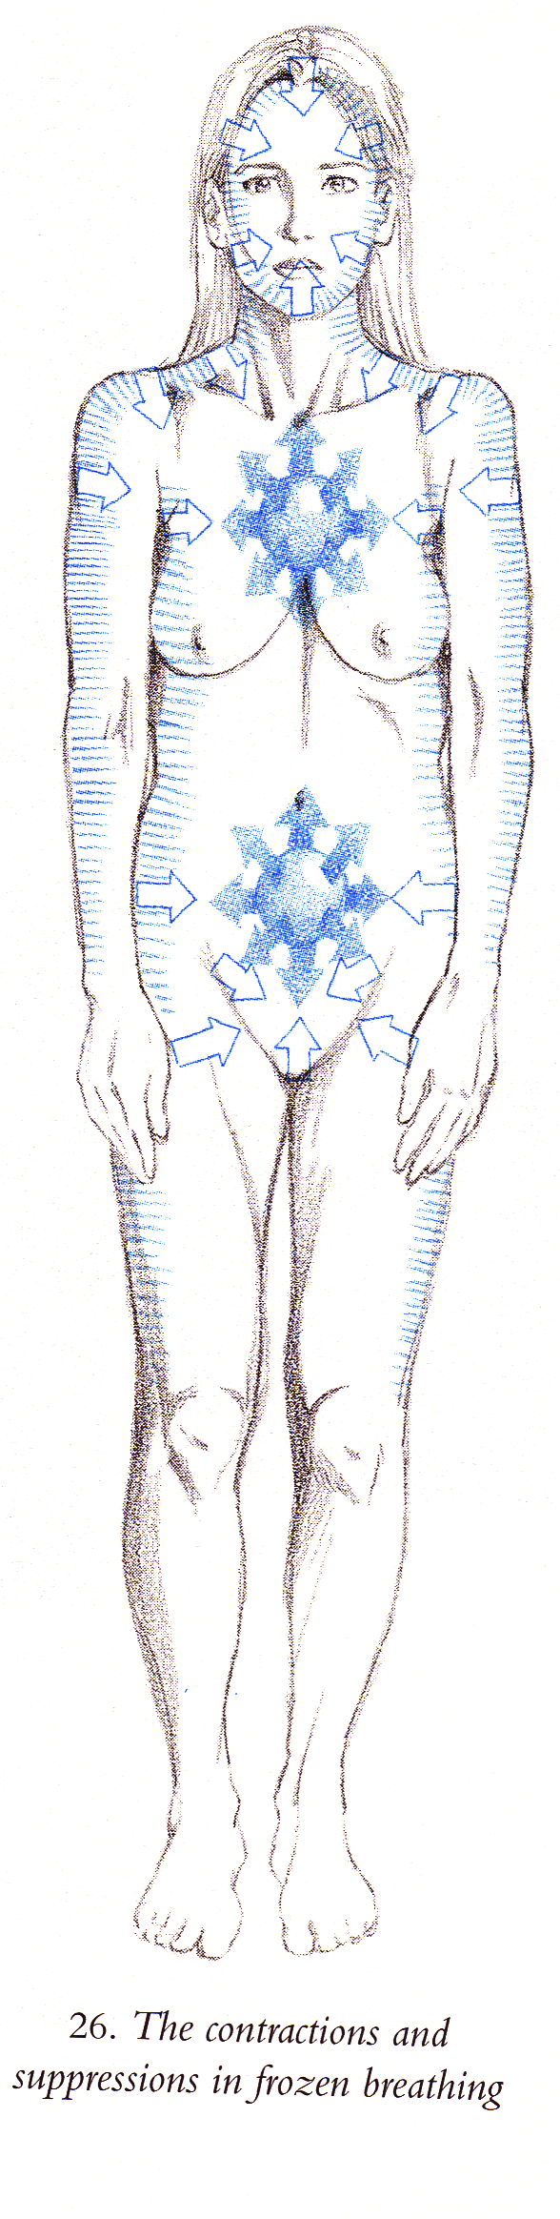Here the outer body contracts and suppresses the movement of the breath. Normally when the inner body expands and contracts the outer body also expands and contracts but in the case of frozen breathing the outer body remains rigid.

*How can I check to see if I have frozen breathing?* There will be a physically rigidity and a sense of always waiting for something.

*Why does this happen?* This usually occurs when we are overly goal orientated meaning there is always the feeling we can only relax when something has been completed but of course since another ‘project’ or ‘problem’ will always arise we are perpetually held in this state. It can also occur when there is chronic fear and an individual is unconsciously waiting for this fear to be realized.

*What are the main effects?* The body and mind are held tight leading to all types of physical and psychological tensions.

*How can I rectify frozen breathing?* We can bring release through allowing the free flow of the breath through the body in different basic breathing techniques. We can also utilize yoga asana to aid the movement of energy within the body. It may be an individual will also need to talk through unresolved emotional issues but the breathing and asana will greatly assist in this process.

**Summary**

Whilst this section only covers the most common dysfunctional breathing patterns we can see how the way in which we habitually breathe affects us on all levels, having great implications for the mind and body.

These different breathing patterns show how our breathing so intimately reflects our habitual patterns of thinking. Also in yoga if you can recall the koshas or sheaths of the body it is considered the mind creates the energy creating the physical body, that is causality usually works from the finest vibrations into the grossest vibrations. Hence physical disease often occurs due to a disturbance in the mind and emotions which has led to an energetic disruption. If we look at some of the examples listed above then it becomes easy to see how this can happen!

However by working directly with creating a free flowing breath we can help break this cycle. And even where psychological help is required yoga says that actually by working with the breath and simple asana this may not be required and if it is then these practices will greatly support this work and bring transformation more quickly.

When we are working with basic breathing techniques we can:

* alleviate tension in body and mind
* increase self-knowledge
* promote proper use of respiratory muscles, dismantling habitual dysfunctional breathing patterns
* create a free flowing natural breath
* help us to be able to watch the breath in a relaxed effortless manner

It is very important to realise that here we are not working with traditional pranayama techniques where the breath is controlled. In fact to teach pranayama or traditional breath techniques where there is breath control can actually create more internal tension for students where they have not already established mechanical integrity and the ability to watch the breath in an objective and effortless way.

Basic breathing must be first taught to all students before we consider moving on to pranayama techniques.

For more advanced students time spent returning to these basic techniques is also well spent and should be done every once in a while.

**Bibliography:**

Based on information from Farhi, Donna (1996) The Breathing Book, Henry Holt & Co: New York

© S.Beck August 2021