**Intercostal Stretching & Cleansing Breath.**

**1) Intercostals stretching**

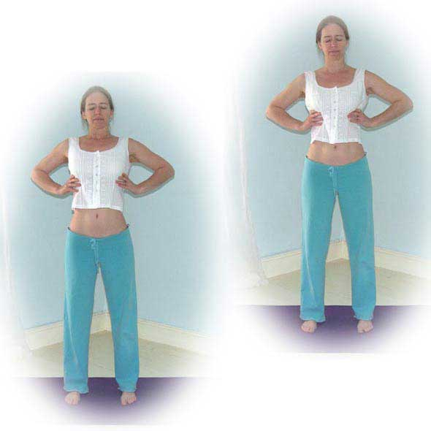Stand in Tadasana (mountain pose) taking your time to talk students into establishing the pose of tadasana, ideally with feet hip width apart so there is a solid base. Attune to natural breathing for a while, noticing the quality of your breathing, for instance can you feel how deep or shallow it is? How fast or slow? Can you feel where the body is being moved by the breath? Then place your palms either side of your ribcage. Place the hands as close to the armpits as you can whilst keeping your shoulders broad and relaxed. Ideally palms against the ribcage but if that is impossible then backs of fingers will do.

Gradually begin to deepen the breath. Inhaling deeply, pause for a few seconds, then exhaling gently squeeze your palms inwards against the rib cage noticing just how far the ribcage can move inwards, then inhaling keeping palms to the side of ribs allow the ribcage to expand into your hands. Do note that the lower abdomen can remain in a state of partial contraction even when inhaling to direct the breath into the ribcage, try this and notice the difference if any as you do this.

Continue in this way feeling just how much your ribcage can expand and relax. Work for around twelve long breaths inhaling breathing deeply into your palms with a long complete exhalation.

Afterwards release hands to sides, and take a few moments to be aware of your breathing. Is the breath any different from before? Or perhaps it is very similar? Just noticing what is true for you.

**Benefits:**

We learn to appreciate just how much movement is possible at the ribcage whilst increasing strength and flexibility of the intercostals muscles. Also helps with establishing a relaxed awareness of the breath.

**2) Cleansing Breath**

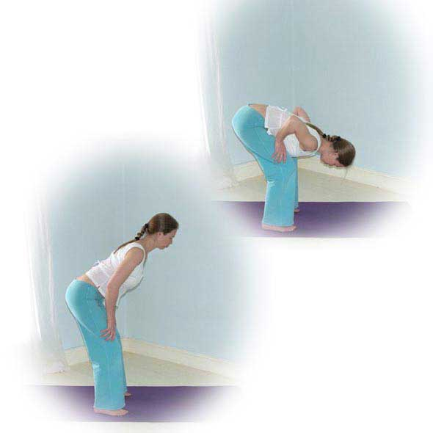

Inhale and when lungs are full, hold your breath and begin to pat the chest with the palms of the hands, again constantly changing position to cover the surface of your chest.

When you are ready to exhale begin the cleansing breath (shown opposite). Pucker up your lips and vigorously exhale a little air out, hold for a second and exhale a little more, hold for a second and exhale a little more. Continue until you have exhaled completely to begin again.

To make this exercise more effective you can place hands on thighs and fold forwards as you exhale in short bursts and at the last moment of the exhale contract your abdominal muscles to release all of the residual air within the lungs. Inhaling slowly straighten up and exhale beginning again on the next inhale.

If necessary you can take a few normal breaths between each round.

Repeat as many times as is comfortable for you, building the number of repetitions up over time. To start 3 to 5 repetitions would be good.

On completion stand in Tadasana and once again take a few moments to connect to the breath becoming aware of how it feels. Notice the quality of the air as it passes through the nostrils, is it cooler on the inhale and a little warmer on the exhale? Is it a little smoother on the inhale and a little rougher on the exhale?…. see if you can sense how the breath is moving the body noticing if there are any subtle sensations of expansion and contraction being created as you gently breathe….. Does anything feel a little different from when you began the practice?

**Cautions:**

Ensure you feel comfortable at all times, if you start to feel light-headed or faint stop and return to ordinary breathing

Caution for heart conditions, unmedicated high blood pressure, and pregnancy: we must not hold the breath so practice the cleansing breath in one exhale

Caution for low blood pressure: take care when moving through the levels if bending forward, can stay upright if needed

**Benefits:**

This technique awakens the respiratory muscles and lungs and can remove tightness and congestion. It fully exchanges the air within the lungs, refreshing the air in the lower areas of the lungs. It brings new awareness to the use of the abdominals when exhaling and to the feeling of the body expanding as we fully inhale.