***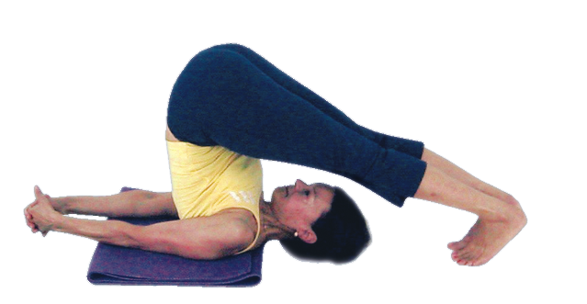*Halasana (plough)**

# *Pronounced huhl-aah-suh-nuh the word hala means ‘plough' ' in Sanskrit.*

The plough can be taught once a student feels familiar with the half shoulderstand. But like the shoulderstand it is also a pose requiring good preparation over time and has many associated contraindications, indeed many of the teaching points and contraindications are shared with those for the shoulderstand.

**Teaching Points:**

* To alleviate excessive pressure on the neck start in a semi-supine position with a folded blanket beneath the upper back, the top aligned with the top of the shoulders
* When ready, roll up onto the upper back using the momentum of your legs and your arms by pressing the arms downwards against the floor.
* Place hands either side of the lower back, thumbs pointing towards the belly and fingers pointing towards the buttocks. Gradually adjust the position if necessary drawing the elbows in line with the shoulders, the shoulders externally rotating. This is half shoulderstand. **Can stay here.**
* Now draw hips above shoulders, lengthening the torso as lift into full shouldersatnd. **Could stay here.**
* Keep the torso extended (not rounded) as the legs are lowered overhead to rest upon blocks or the floor. **Could stay here with hands supporting the back.**
* Once the feet are supported by the floor can release hands and clasp hands laying arms along the ground. As we do so, drawing the chest open, as the spine straightens drawing hips above the shoulders. Press both heels down towards the floor as you keep straightening the back and pressing both arms into the floor. Do not release the hands from the back until the feet touch the floo**r. Can stay here**
* To exit the pose bend the knees so the centre of gravity is low then straighten one arm along the ground then the other arm along the ground. Gradually curl the spine to the floor whilst pressing down with both arms and hands to curl down with absolute control.
* After releasing down take a few moments of stillness in a position which feels right, this could be savasana (corpse pose), supta baddha konasana (supine cobblers pose) or whatever feels the right thing to do.

**Benefits:**

* Promotes proper functioning of the thyroid and parathyroid glands and therefore the functioning of the hormonal system
* Aids the venous return to the heart promoting the circulation of blood to the chest and head
* Promotes the functioning of the parasympathetic nervous system so calming our mind and nervous system and releasing tension, being very good for all ailments where stress is a central factor
* Reactivates the proper functioning of the abdominal organs
* Increases the blood supply to the spinal column
* Mobilises the back and provides a good stretch to the shoulders
* Releases chronic neck and shoulder tension
* Increases energy levels
* Invigorates the brain

#### Good preparation

Abdominal and back strengtheners, shoulder and wrist mobilisers. Ideally students will be able to perform salamba setu bandhasana (supported bridge pose) where the neck is relaxed and does not touch the ground. This tells us a student is ready to perform shoulderstand and the plough i.e. they are able to produce a firm foundation for the pose. In addition we need to develop strong abdominal and back strength so students can lift and lower with control.

**Cautions & possible modifications**

There are different contraindications given by various authorities and this may be a little confusing, especially when one authority states we must avoid the halasana if we have a particular condition whereas another authority states the same pose will actually help that same condition. So as always we must note the available advice and then apply this to ourselves with great sensitivity, meaning we must teach our students to observe their inner reaction to a pose both during the asana and afterwards.

It is also very helpful to practice softer modified versions of halasana and over time make our way to the stronger versions of halasana staying at first for a few seconds only then gradually building up the time spent. In this way we can monitor our responses to the pose.

This pose is prohibited if a student is suffers from:

* heart conditions or un-medicated high blood pressure, mature diabetes
* severe eye conditions such as detached retina or glaucoma
* ear or nose problems
* an overactive thyroid
* un-medicated epilepsy
* severe kyphosis

Also avoid this pose if you are currently experiencing:

* migraine or headache
* high temperature
* flu or cold symptoms
* excessive gas or mucous
* pregnancy
* menstruation

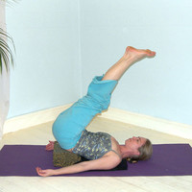

For most of these conditions we can adopt a version of **viparita karani** (reversed position pose) as shown opposite where a student lies supine and lifts the hips, sliding two blocks beneath the sacrum. The legs are then lifted one by one until they are straightened. This pose gives a soft inversion ideal for those for whom halasana is contraindicated. If blocks are unavailable we can adopt the modification by lying supine and placing hands, palms facing downwards, beneath buttocks. Alternatively we can place legs up against a wall if a wall is available to be used.

We also need to take care if suffering from the following conditions:

* diabetes
* lower back conditions
* sciatica
* osteoporosis
* neck problems
* mild kyphosis
* wrist problems
* vertigo

For all of these conditions we must monitor how a student responds and they can if necessary adopt viparita karani as shown above or only stay within the pose for a few moments.

#### Simple versions and modifications

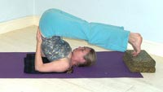***Blocks beneath feet***

A good modification is to place feet upon a stack of blocks or upon the seat of a chair, which provides support for the weight of the legs but diminishes the intensity within the back. It is good for many conditions where we have to take care in halasana and is also great when there is general stiffness in the hips or back muscles.

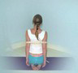

**Belt around upper arms**

We can also place a belt measured at shoulder width around the upper arms to help to keep arms together although it is not good to rely upon the belt as we need to strengthen the muscles involved.

Ideally we will teach halasana in a progressive manner:

1. First we can work with setu bandha (bridge) where hands are clasped beneath the body so a good foundation is established and we can learn how to draw arms together as we laterally rotate shoulders, lifting the chest.
2. We need to have worked with shoulderstand becoming at least familiar and comfortable with half shoulderstand, if not then we will stay working with that or if necessary take a suitable modification.
3. We can introduce the plough from half shoulderstand by demonstrating how we can move onto a plough where feet are supported by blocks or chairs. Then students can move into this position and if possible go further by removing one or all blocks.

Note: Please remember we should always treat this posture with respect particularly in relation to the safety of the neck.

**Developments & Variations**

There are many different developments we can practice.

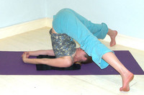

***Spread leg plough***

Once feet touch the floor we can walk feet apart, drawing them together again before exiting from the pose.

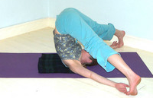***Spread leg plough ~ hands to toes***

Here we move into spread leg pose and then take hands to toes, drawing legs together and arms back to the floor before exiting from this pose.

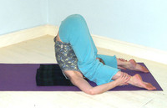

***Knees to ears***

Once in plough we can bend both knees placing knees to ears, straightening legs once again before exiting from the pose.

Another way to subtly alter the experience of the plough is to point toes away from the head rather than towards the head.

**Adjustments**

Always check that students do not have a block or padding beneath the head, remember the padding is for the upper back and back of shoulders.

Students need to prevent the chest from collapsing so ensure those students with a collapsed chest and rounded upper back are using modifications and have made use of the padding beneath the upper back and shoulders to help them to extend and straighten the back so hips are positioned above the shoulders.

If students continue to work in this way then in the longer term it will compromise the neck. We can if necessary gentle press inwards and upwards at the mid to upper back so students can feel the direction in which they must move; as always however we must never push!