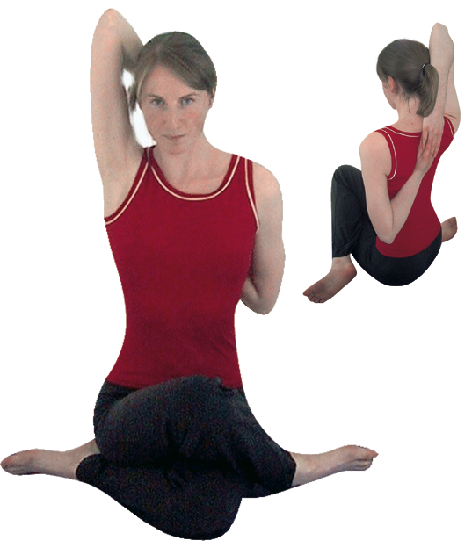**Gomukhasana – Cows Head Pose**

*Pronounced go-mook-aah-suh-nuh go means cow and mukha means face in Sanskrit.*

This pose is said to resemble a cow’s head where the arms are the ears and the legs the mouth! There is also another translation of this pose however where the word go means ‘light’ and mukha means ‘freeing’ which is said to relate to how this pose places pressure upon the carotid artery within the neck inhibiting the flow of blood to the brain so when the pose is completed and the arms are released a rush of new blood to the brain provides new energy!

**Teaching Points:**

* From dandasana (staff pose) sit to the left side of both feet, both knees bent
* Draw the right leg over the left leg aligning both knees, one stacked upon the other
* Move both heels apart creating space between the heels for **both buttocks to sit square to the floor, both sitting bones to the ground**
* Now raise the right arm to the ceiling, bending the right elbow as the lower arm drop towards the left shoulder. Then externally rotating the left shoulder draw the leg arm behind, clasp both hands together so the forearms make a 45º line from elbow to elbow with elbows aligned with shoulders.
* If the hands do not meet hold a belt between the hands to extend the reach of the arms **or if the neck is pushed to one side when hands are clasped then again we must use a belt between hands.**
* Allow the weight of the upper body to ground down between the heels, finding symmetry at the pelvis, create space around the waist as the shoulders are drawn back, the chest open. Keep the neck relaxed as you rise up through the crown of the head.
* To exit, release the lower hand and lift the upper arm vertically, stretching it out, lowering the arm down to sides, then un-crossing the legs work to the other side.

**Benefits:**

Mobilizes hips, especially external rotation

Can alleviate sciatica

Opens chest and mobilizes shoulder muscles

Renews circulation to arms and hands

Alleviates headaches

#### Good preparation

Shoulder and hip mobilizers.

**Contra-indications & possible modifications**

* For severe hip conditions such as hip replacements only work with the upper body, keeping legs aligned in kneeling or crosslegged-pose, this could actually even be performed from standing.
* For shoulder injuries such as rotator cuff tears be cautious especially with the lower arm, using a belt where this helps.
* When hips are stiff students can sit upon a block working the hips open little by little

#### Simpler alternatives

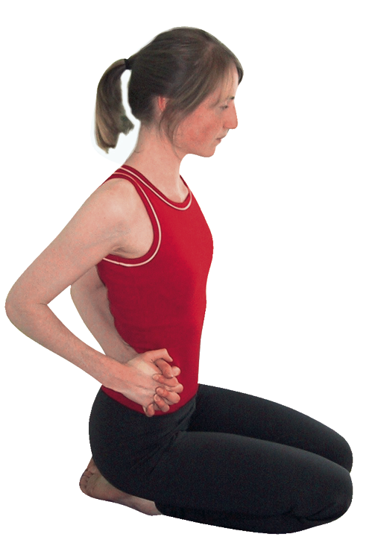**Work arms only**

We can leave students working with a preparatory stretch such as the one illustrated here.

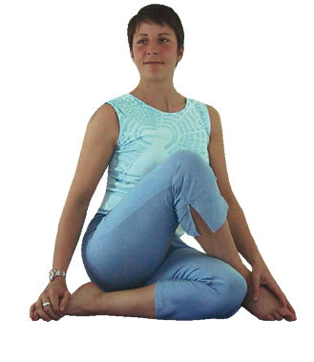**Work the lower body only**

We can work with the legs allowing students to work into the external rotation of the hips before they also work with the upper body. Here sitting on a block initially can be very helpful.

**Developments**

#### ::gm3.tifFlexing forwards

To make this pose more intense we can allow the upper body to fold forwards. Here this is shown with hands to floor but we can also practice the full pose and flex forwards where the weight of the arms will make this forwards actions much stronger!

**Variations**

Once students are familiar with the pose a nice way of working is to adopt kapotasana (pigeon pose) then step the back leg forwards into gomukhasana. There are also several other ways to enter and leave the pose such as from cat pose.

#### Adjustments

To individually assist students it is best to verbally instruct and use mirroring. We can scan the room to check necks are aligned offering belts to those who appear compressed in this area and if needed we can place a hand lightly upon the lower arm shoulder or upper back to remind students to open and lengthen. Never push or pull!