**Garudasana (Eagle pose)**

# :::attachments_16_01_2010 Folder:garduasana full.tif*Pronounced guh-rood-aah-suh-nuh the word garuda means eagle in Sanskrit.*

This standing balance in named the eagle because it requires intense concentration to perform and we are seen to be perched still ready for action! For all of the following stages leading to the full asana keep the eyes softly gazing at a fixed spot 45º away to help maintain balance.

**Teaching Points:**

###### Stage one

* 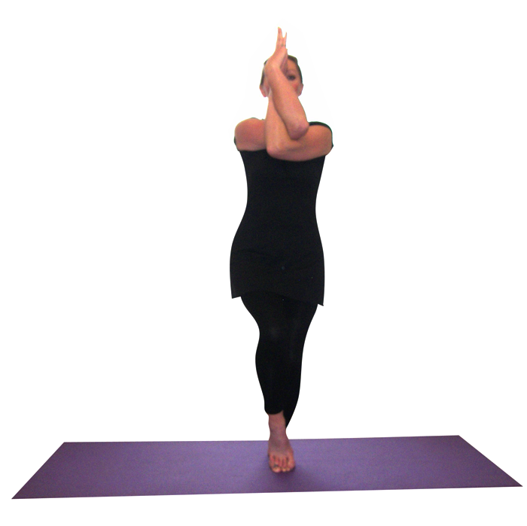Start in tadasana (mountain pose), creating a good pada banda with the left foot. Bending the right knee take the right foot onto the left foot, slightly bending the standing left leg as needed.
* Take both arms out in front positioning them at right angles palms facing, draw the right arm under the left arm so elbows are interlocked, backs of arms and hands touching, then draw the right hand around the left hand so the right hand fingers or palms are touching the left palm. Fingers pointing upwards.
* Lift both elbows so the upper arms are aligned with the shoulders.
* Keep the neck long and open, shoulders down away from ears and stay here breathing into the back of the heart area as the eyes are fixed on a spot 45º away.
* Then releasing arms and legs work to the other side. Could stay working at this level.

*Stage two*

* To go deeper into the pose this time bend both knees and cross the right leg over the left leg, working to draw both legs together.
* Keep the spine upright, the tailbone dropping to the floor.
* 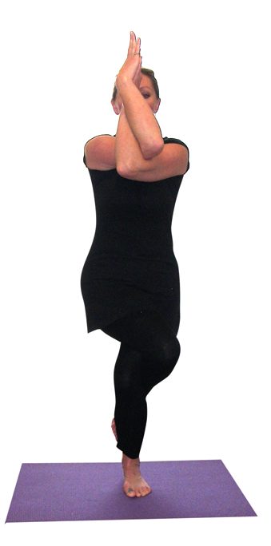Bring both arms in front of the body, wrists crossing.
* Inhaling swoop arms out to sides keeping elbows soft and exhaling as before draw the right arm under the left arm and wrap the arms until palms touch.

Stay here and if possible the top leg can be wrapped more completely by weaving the ankle around the lower leg.

* To release inhaling draw arms back out to sides and exhaling lower arms as the legs are unwrapped returning to tadasana.
* We can then work to the other side in the same way.
* Each time arms are drawn out to sides let the arms be gentle but powerful like two eagle wings.

*Stage three*

* 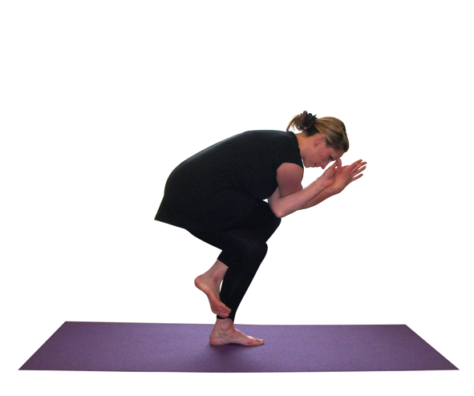For the final stage it is possible to squat more deeply so the back is now angled at around 45º as is the lower shin.
* We can work in just the same way as for stage two but now the pose is more intense.

**Note:**

It is always important to keep length within the spine and so students need to simultaneously lift upwards through the crown of the head as they allow the tailbone to drop to the floor, with a neutral pelvic tilt. We must ensure there is not a pronounced lumbar curve and where this occurs it may be necessary to slightly create a posterior pelvic tilt so the lower back remains lengthened.

The standing leg knee must also always be aligned with the foot so the knee is not twisting or rolling to either side. Finally students must keep their shoulders down away from the ears.

**Caution:**

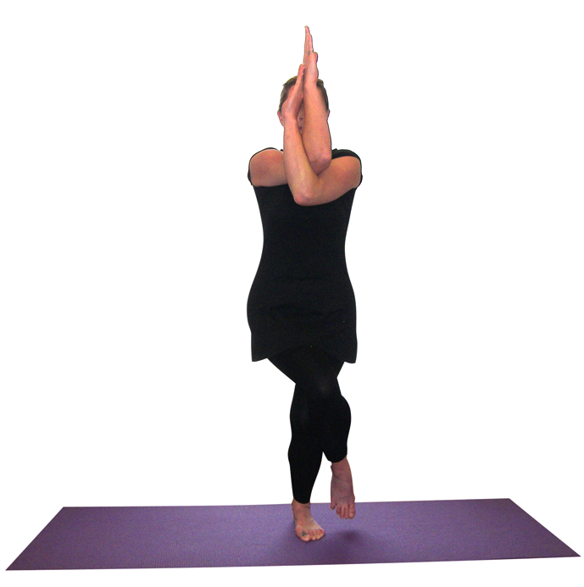Sometimes a student may be structurally unable to wrap the arms fully around one another in which case it is possible to simple rest one elbow against the other and just press the back of arms together. Also some students may be unable to fully wrap legs so they can stay at stage two where the legs are crossed and they can work to draw the outsides of the legs together. This is often the case when a student has bulky muscles or excess fat.

**Drishti point**: Be aware of tip of fingers of upper hand

**Benefits:**

Develops concentration

Stretches upper back muscles, especially between the shoulder blades

Intensely tones and strengthens legs

Stretches the hips

#### Good preparation

Simpler balances, standing poses in general

**Contra-indications & possible modifications**

* Hip conditions take care working with simpler stages as a modification. Hip replacements do not cross legs across the body so work with the first stage only.
* Balance problems can keep the top foot to the floor as for stage one and if helpful it is possible to work with the back to the wall.

#### Simple versions and modifications

Working with stage one is a modified version that will suit most conditions.

**Developments & Variations**

***Alter the hand position***

With fingers closed down it is often known as eagle sleeping and if we point both sets of fingers upwards then it is known as eagle awakes.

***Working dynamically form side to side***

Using the swooping outwards of arms to lead us into the pose as we cross legs and fold arms we can work from side to side, staying for a few breaths in each pose. This can work well as we build up the pose through the stages with students staying working with the correct level for them.

#### Adjustments

If hips are twisted we can stand behind the student placing hands lightly at the hips and extremely carefully re-position them so they are square to the front. We can also carefully lift the elbows if the elbows are lower than shoulder height. If shoulders are raised we can also gently place a hand upon the shoulders to remind students to relax them. Much of this however is best done verbally to avoid unbalancing students.