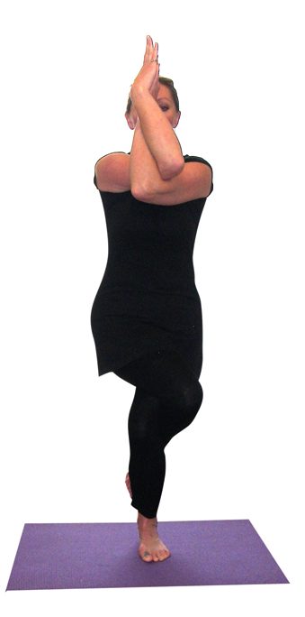**Garudasana (Eagle pose)**

# *Pronounced guh-rood-aah-suh-nuh the word garuda means eagle in Sanskrit.*

This standing balance is named the eagle because it requires intense concentration/focus to perform and we are seen to be perched still ready for action! For all of the following stages leading to the full asana keep the eyes softly gazing at a fixed spot 45º away to help maintain balance.

**Teaching Points:**

Initially can practice upper body movements and then lower body movements separately

###### Stage one upper body

* 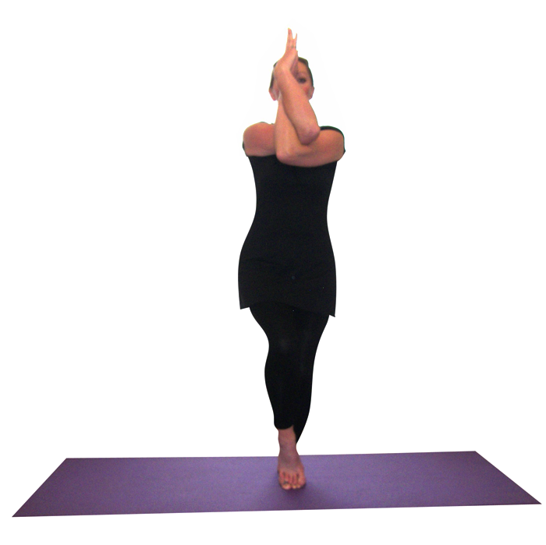Start in tadasana (mountain pose)
* Take both arms out in front positioning them at right angles palms facing, draw the right arm under the left arm so elbows are interlocked, backs of arms and hands touching, can stay here…
* If possible draw the right hand around the left hand so the right hand fingers or palms are touching the left palm. Fingers pointing upwards.
* Slightly lift the upper arms until they are horizontal to the ground
* **Shoulders facing forwards and down away from ears, neck central & relaxed, face soft**
* Breath into the back of the heart area as the eyes are fixed on a spot 45º away.

*Stage two lower body*

* Start in tadasana (mountain pose), creating a good pada banda with the left foot
* Bending the right knee take the **right foot onto the left foot**, slightly bending the standing left leg as needed, could stay here, placing hand against support needed
* **Hips facing forwards, lower knee aligned with lower foot, ensuring the knee does not feel twisted or overly pressured and is not extended forwards of the foot (as for intense squat)……**
* Keeping the torso upright, i.e. perpendicular to the ground, if possible bend the standing leg knee more deeply and the top leg can be wrapped around the lower leg, squeezing both legs together
* If possible can wrap the upper leg foot around the back of the lower leg
* **Hips facing forwards, lower knee aligned with lower foot, ensuring the knee does not feel twisted or overly pressured and is not extended forwards of the foot (as for intense squat)**



*Stage three*

* Practice with upper and lower body simultaneously
* Here opposite sides of the body support the pose so if left leg is standing leg then the right arm is the lower arm
* All teaching points as above

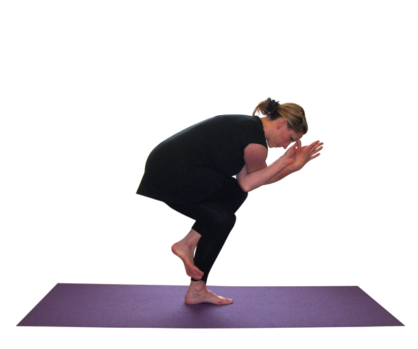*Stage four*

* For the final stage it is possible to squat more deeply so the **back is now angled at around 45º as is the lower shin**.
* We can work in just the same way as for stage two but now the pose is more intense.

**Note:**

It is always important to keep length within the spine and so students need to simultaneously lift upwards through the crown of the head as they allow the tailbone to drop to the floor, with a neutral pelvic tilt. We must ensure there is not a pronounced lumbar curve and where this occurs it may be necessary to tuck the tailbone slightly under to create a posterior pelvic tilt so the lower back remains lengthened.

**Vulnerable Area:** The standing leg knee must be aligned with the foot so the knee is not twisting or rolling to either side, avoiding uneven pressure within the kneecap and stress to lateral collateral ligaments either side of the knee.

**Caution:**

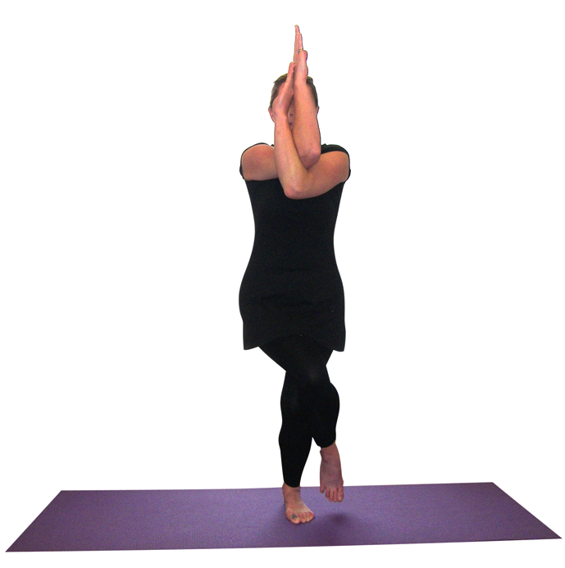Sometimes a student may be structurally unable to wrap the arms fully around one another in which case it is possible to simply rest one elbow against the other and just press the back of arms together. Also some students may be unable to fully wrap legs as is often the case when a student has bulky muscles or similar, and again they can simply press legs together without fully wrapping the legs around one another.

**Drishti point**: Be aware of tip of fingers of upper hand/ floor 45º

**Benefits:**

Develops concentration

Stretches upper back muscles, especially between the shoulder blades

Intensely tones and strengthens legs

Stretches the hips

#### Good preparation

Simpler balances, squats, standing poses in general to strengthen thighs in longer term; raise awareness of pada bandha; activate core; ankle mobilisers; calf stretches; external hip releasers/hip mobilisers; shoulder joint mobilisers; raise awareness of adduction of legs/abduction; activate serratus anterior to help stabilise shoulder blades; raise awareness/tone humerus flexors (pectorialis major & anterior deltoid) & extensors (rhomboids, upper & mid trapezius & posterior deltoid); wrist & forearm mobilisers

**Cautions & possible modifications**

* Hip conditions take care working with simpler stages as a modification. Hip replacements do not cross legs across the body so work with the first stage only.
* Balance problems can keep the top foot to the floor as for stage one and if helpful it is possible to work with the back to the wall.

#### Simple versions and modifications

Practicing earlier stages will suit most conditions.

**Developments & Variations**

***Alter the hand position***

With fingers closed down it is often known as eagle sleeping and if we point both sets of fingers upwards then it is known as eagle awakes.

***Working dynamically form side to side***

Using the swooping outwards of arms to lead us into the pose as we cross legs and fold arms we can work from side to side, staying for a few breaths in each pose. This can work well as we build up the pose through the stages with students staying working with the correct level for them.

© S Beck June 2022