The shoulder joint is composed of the humerus, the clavicle and the scapula, with the clavicle and scapula formed like a horse shoe and always working together where for example if one lift the other lifts.

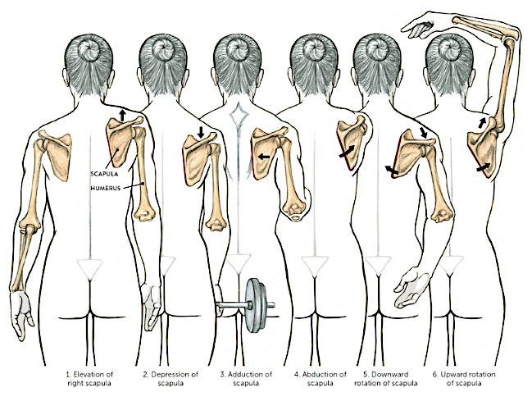

Image 1

There are six different movements of the scapula as shown above, although we could add a special seventh movement where there is a backward tilt of the scapula towards the ribcage as we use the head of the humerus like a lever drawing the arm overhead (as if moving into a backbend).

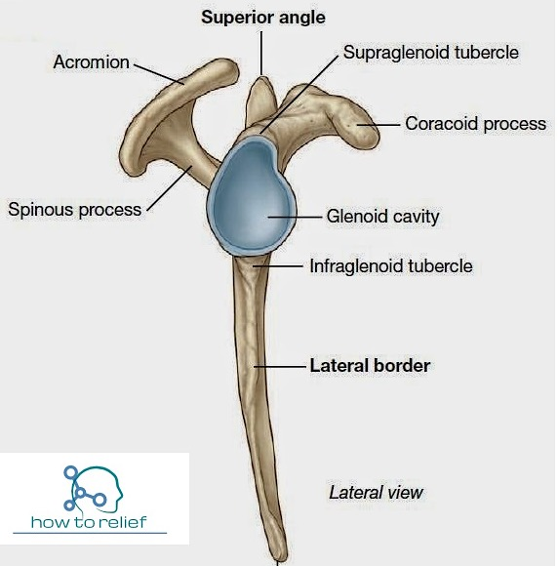As we also know there are six possible movements of the humeral head within the glenoid cavity to include flexion, (hyper)extension, adduction, abduction, internal rotation & external rotation.

Now it is also worth noting that the glenoid cavity is a little pear shaped with the upper portion being a little smaller than the lower portion (imagine the shape of a snowman). This means the head of the humerus can make larger more stable movements when it drops down into the lower portion meaning the most stable positions for the humeral head are hyperextension, adduction and internal rotation of the humerus.

However in the positions of arm flexion, abduction and external rotation the head of the humerus is less stable as it lifts into the upper smaller portion of the cavity so here we often rely on good stabilization; for instance in asana such as chataranga dandasana (four limbs pose) and adho muhka vrksasana (hand stand) we need to keep the scapulae against the ribcage in a neutral position by retracting and depressing them.

Image 1

**The question of flexing the arm overhead?**

However for full flexion through elevation (where arms are lifted forwards to raise them overhead) and full flexion through abduction(where arms are lifted out to the side to raise them overhead) there are several issues involved.



If soft tissues have been released so there are no restrictions to movement from tight muscles we may still find that when we flex the arm at the gleno-humeral joint there will come a point when bone meets bone and we cannot flex any further. Here the head of the humerus **meets the acromion process of the scapula** creating an impassable compression – this occurs at **different degrees of flexion for different individuals depending upon the shape of their bone structure.**

If the humerus meets the acromion process of the scapula at this point to flex more deeply we would also need to **slightly abduct the arm** **to move around the acromion process** - which will involve **some external rotation** and for some students slightly **bending the elbows** will help.

Image 2

So rather than just flexing through the gleno-humeral joint, i.e. where the humerus simply moves in the glenoid fossa the remaining degrees of flexion will now come from another two set of joints which are 1) where the sternum meets the clavicle (SC Joint) and 2) where the acromion process of the shoulderblade meets the clavicle (AC Joint). So now to flex the arm up we will be lifting the clavicles, and there will also be protraction and upward rotation of the shoulderblades. This is done largely through the action of the serratus anterior muscle, a finger like muscle located at the side of the ribs.

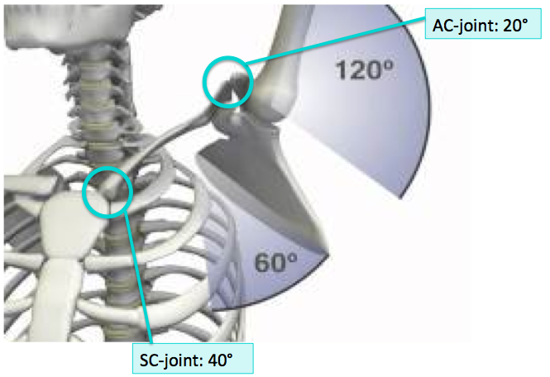

Image 3

So can you see how when we ask students to keep their shoulders down away from their ears this may not always be possible because to flex arms overhead if they do not have enough natural movement of the humerus within the glenoid fossa they can either:

1) try abducting the arms i.e. taking them wider, externally rotating the arms at the shoulders and bending the arms at the elbows – all help to keep shoulders level

and/or

2) lift the arm higher by raising the shoulder to use the degrees of flexion possible at the SC and AC joints, thereby lifting the angle of the shoulderblades and clavicles so shoulders are not level.

**Inquiry 1.** Try holding the top of the shoulder down so the scapula and clavicle cannot lift and see how much flexion through elevation can come directly from the gleno-humeral joint. Now release you hand and allow the collarbones and scapulae to move as well. Which is preferable for you?

The same need to utilise the scapulae and clavicles will also arise when practicing flexion through abduction where again the head of the humerus will eventually compress against the acromion process of the scapula, there will be a need to abduct and externally rotate the arm and lift the shoulder as the scapulae & clavicles are utilised

**Inquiry 2.** Try holding the top of the shoulder down so the scapula and clavicle cannot lift and see how much flexion through abduction can come directly from the gleno-humeral joint. Now release you hand and allow the collarbones and shoulderblades to move as well. Which is preferable for you?

There are very few people who do not need to also engage these second joints so there is movement of the shoulderblades and collarbones !

Anatomically speaking this is called the **gleno-humeral rhythm** whereby there is a subtle sequence of events for both flexion and abduction:

1. first the glenohumeral joint flexes

2. and then externally rotates taking arms wider into slight abduction

3. scapulae protract & upwardly rotate

4. and the clavicles rotate in towards the chest.

**So what implications does this have for our teaching?**

Note that this will mean that our teaching points when flexing the arms overhead either through elevation or through abduction are somewhat controversial i.e. is it benefical for all students to ask them to keep the shoulders down away from ears? Is it helpful to say that the arms should be externally rotated at the shoulders? Indeed if you research this subject you will find many differences of opinion!

**The Solution:**

The best route perhaps is to lead students into an exploration and to give options to try with the primary emphasis being that they must find the place where there is no pain or discomfort, especially around the shoulders, neck and jaw.

So for example in Vrksasana Tree Pose –

*Does it feel better to take the arms a little further apart and draw the shoulders into external rotation? Or does slight internal rotation feel better?*

*Does it feel more comfortable around the neck and shoulders to bend the elbows?*

*Is it helpful to draw shoulderblades downwards, lowering shoulders down away from ears?*

As the teacher we can simply help students to explore their own experience and highlight what to check for.

In many asana, we tend to overlook the positioning of arms, for instance in Down Facing Dog or Tree, where we can often focus upon the lower body instead. But it is important to do this over time as we do not want to strain the muscles or impinge nerves.

Grilley, Paul, (2004) Anatomy for Yoga DVD, Pranamaya Inc

Image 1 from: www. detiina.com/winged-scapula-skeleton-pictured/winged-scapula-skeleton-pictured-image-result-for-elevation-of-scapula-anatomy-upper-body/accessed 10.07.18

Image 2 from: [www.howtorelief.com/scapula-anatomy-bony-landmarks-muscle-attachment/](http://www.howtorelief.com/scapula-anatomy-bony-landmarks-muscle-attachment/) accessed 10.07.18

Image 3 from: http://ihanayoga.com.au/ accessed 10.07.18

© S Beck August 2021