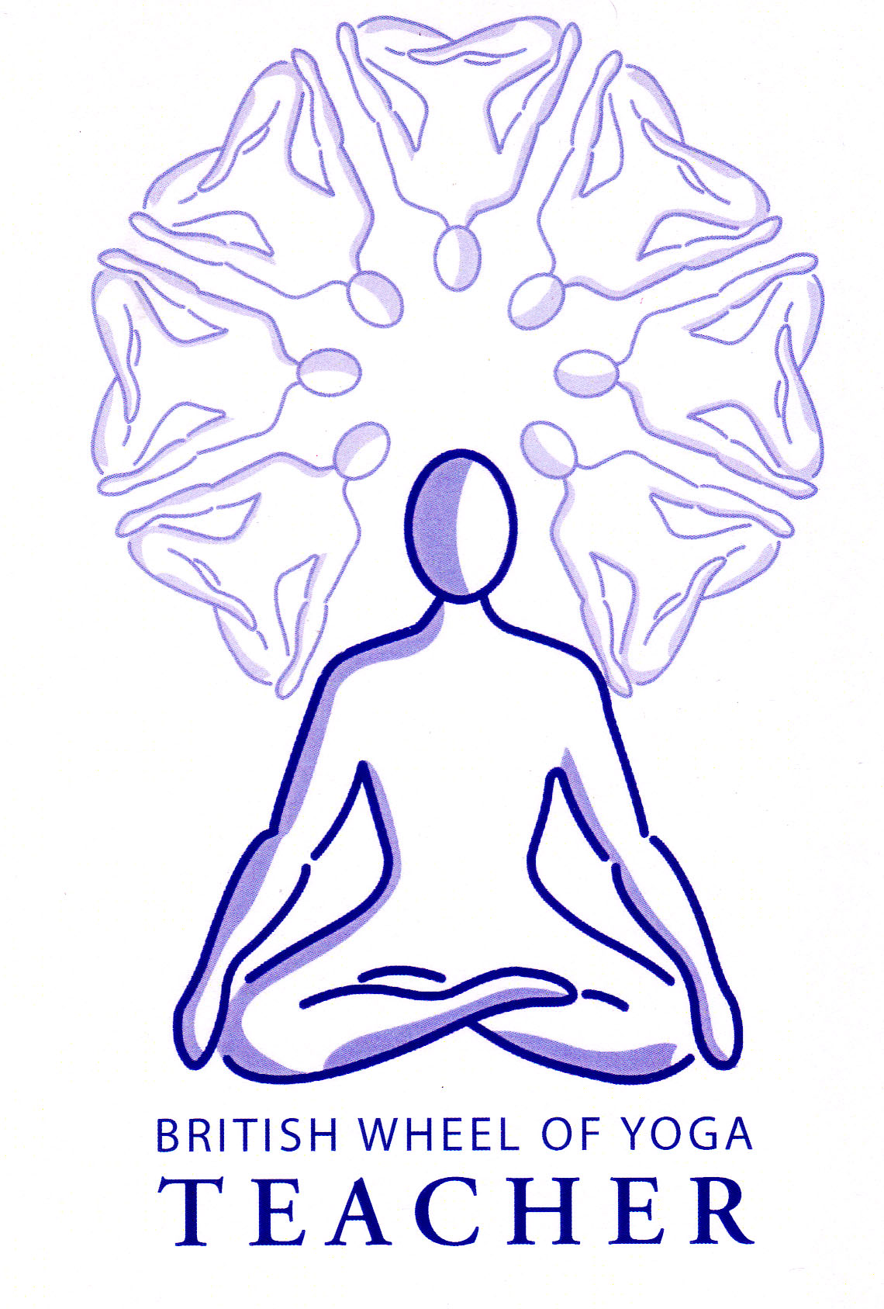
Dirga Swasam: The Dynamic Three Part Yogic Breath

This is a variation on the Complete Yogic Breath which can taught after students are familiar with the breath. A variation introduces new elements which help to keep students focused and enables new pathways to continue to be created with the body/mind.

Cautions: Please stop the practice if you feel any dizziness, and never strain the breath or try to breathe too deeply, keeping breathing easy and smooth at all times.
The Technique:
Adopt a comfortable semi-supine position placing a block behind the head if needed. Arms positioned on the ground either side of the body.

Start to connect with your breathing, becoming aware of the inhalation and the exhalation, allowing the breath to gradually lengthen and deepen, slowing the breath little by little.

Abdominal Breathing

Now inhaling lift both arms upwards so your fingers are pointing to the ceiling and then exhaling lower both arms back to your sides. Continue in this way in time with your own breathing. Each time you inhale feel your abdomen gently expanding and as you exhale your abdomen gently contracting. Allow the natural pause to occur at the end of the inhalation and at the end of the exhalation. Let the breath be smooth and long, do not hurry. Continue to practice in this way until you are advised to make this the final one.

Rib cage Breathing

Now on the inhale lift both arms upwards and just a little overhead so your arms are 45º from the floor behind and then exhaling lower both arms back to your sides. Continue in this way in time with your own breathing. Each time you inhale feel your abdomen expanding then the ribcage expanding and each time you exhale allow them to release. Allow the natural pause to occur at the end of the inhalation and at the end of the exhalation. Let the breath be smooth and long, do not hurry. Again, continue to practice in this way until you are advised to make this the final one.

Clavicular Breathing

Now on the inhale lift both arms upwards and all the way overhead so they are lying along the ground behind you and then exhaling lower both arms back to your sides. Continue in this way in time in your own rhythm of breathing. Each time you inhale feel your abdomen expanding, then the ribcage expanding and finally the upper chest broadening and each time you exhale allow them to release. Allow the natural pause to occur at the end of the inhalation and at the end of the exhalation. Let the breath be smooth and long, do not hurry. Continue to practice in this way until you are advised to make this the final one.

Benefits: Breathing more completely has countless benefits for us such revitalizing the entire body with prana (i.e. the essential life force). It benefits the vital organs, which can easily become stagnant, constricted, or fraught with emotional and physical tension. The complete breath refreshes the mind, and activates the parasympathetic nervous system, encouraging a calmer, more balanced state of being overall. Significantly it also helps to correct unhealthy breathing patterns.
This technique can be engaged at any time, but it is especially beneficial when practiced intently for five to fifteen minutes every day—preferably on an empty stomach. It is also very useful as the initial technique for our daily practice, helping us to settle and connect with the breath prior to asana.

