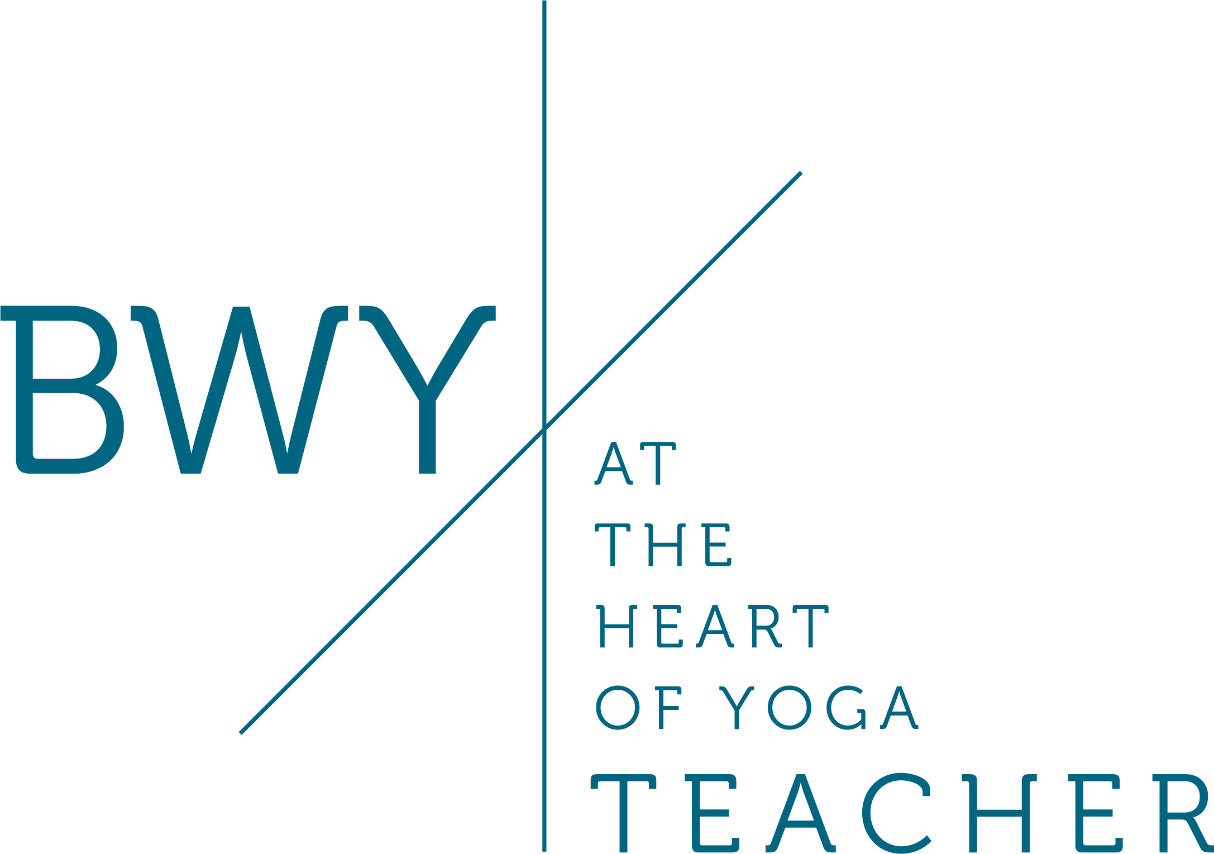
Roles and Responsibilities of a Yoga Teacher: Teaching Children
A person is formally designated to be a child if under 18yrs old, even if the child is living alone, working and so forth.

The BWY has a ‘Safeguarding Children Policy’and ‘Safeguarding Children’s Policy Statement’ to be found in the website under Resources, then Safeguarding Guidance Documents. You will need to carefully read these through (links below).

You will also find all of the other forms you may need on the same Safeguarding Guidance Documents web page.

Guidance for including children within your own private adult yoga classes

Although you are training to teach adults you can incorporate unders 18 year olds within your adult classes. There are however several things to consider.

As stated above carefully read the ‘Safeguarding Children Policy’ and the ‘Safeguarding Children’s Policy Statement’ which can be found on the BWY website under Resources: Safeguarding Guidance Documents

https://www.bwy.org.uk/pdf/1611933964BWY%20Safeguarding%20Children%20Policy%202020.pdf

https://www.bwy.org.uk/pdf/1588062625BWY%20Safeguarding%20Children%20Policy%20Statement%202020.pdf

If children under 18 years attend your class then you must do the Safeguarding Children Training (SCT): This can be done face to face or online:

1. The NSPCC Child Protection in Sport Course is a good online course costing £20.

2. The Local Safeguarding Children Boards are another online option and may be free; details of this course in your locality can be found on the BWY website under Safeguarding Guidance Documents under ‘Local Safeguarding Children Boards’.

https://www.bwy.org.uk/pdf/1499422859Local%20Safeguarding%20Children%20Board%20Information%202017.pdf

It is also possible to do face to face training with the Local Safeguarding Children Boards or Sportscoach hold three hour workshops for approximately £35.

And once the course has been completed details must be uploaded on to your Safeguarding Record in the Members Area, to be updated every three years.

For children aged 16 and 17 they are able to come to classes alone and you will only need to have done SCT. | For children under 16 if they are accompanied by a parent or guardian then you only need to have done SCT.
For childen under 16 if unaccompanied you would need to have done SCT and also have an enhanced disclosure DBS. | However it is recommended that you do not allow under 16 year olds to come to your class unaccompanied.
To get an Enclosed Disclosure DBS see the BWY document Enhanced disclosure certificates from the Disclosure & Barring Service (DBS) which can be found on the BWY website under Safeguarding Guidance Documents. Here you will also find information on the portabilty of an existing DBS certificate.

https://www.bwy.org.uk/pdf/14909676021474297957DBS%20applications%202016.pdf

For all class where under 18 year olds are present you will also need to use the following forms as relevant, all of which are found in the Safeguarding Guidance Documents in the Resources section of the BWY website:

- Have an Agreement Form for Under 16’s in an adult Class where the teacher does not hold a DBS Enhanced Disclosure Certificate
- Have a completed BWY Essential Contacts Details for Teachers Form to hand
- Have a specialised Incident Record Form for children available (Form F)
- Decide if a hands on adjustment form needs to be used (Form G)
- Decide if a photograph consent form is needed (Form H or K)

- Note that only a guardian/parent can partner a child in class.

Other Important Considerations:

- Be aware of the number of adults to children ratio in classes, for instance will you decide that 2 or more under 18 year olds would be a reasonable addition to class without changing the overall dynamics of the class?

- Consider the character of the practices being taught, and decide whether they are suitable for all under 18 year olds or if there is a minimum age that you are willing to teach, e.g. 14 year olds?

- Will you choose to state that no under 18 year olds can come to the class, i.e. it is an adult yoga class? And will you need to advertise this fact?

- Will you consider finding a BWY Inservice Training Day (IST) on incorporating under 18s into adult classes to help you with suitable modifications & practices?

It is recommended that you establish your own written policy for each class such as: two children can present, must be 14 years or older, and if under 16 yrs then must be accompanied by a parent/guardian. This can be kept in your teaching file.

By deciding upon a policy of your own then you can ensure that you are always being fair to all students!

See: General Guidance for Adult Classes and Under 18’s in Private Classes
https://www.bwy.org.uk/pdf/1620642765Adult%20Classes%20Gen%20Guidance%20Private%202021.pdf

Giving taster sessions for under 18 year olds

If you wish to give a taster session please see the handout on the BWY website ‘Offering a Taster Yoga Class for under 18 year olds’ but essentially you can go ahead with a one-off taster session without an enhanced DBS but the teacher, leader or helper of the group must be present throughout. Safeguarding Training is advised.

See: https://www.bwy.org.uk/pdf/1499424010Taster%20Sessions%202017.pdf

Teaching Children Only Yoga Classes

If you wish to teach a children’s yoga class specifically for children then you will need to hold a specialist qualification in teaching children and follow the guidelines found in the ‘Safeguarding Children Policy’ which includes:

- Completion of BWY Application Form A
- Completion of Self-declaration Form B
- Both forms to be sent to Safeguarding & Diversity Manager
- Completion of Safeguarding Training & register this on the BWY website
- A minimum of 2 written references will be taken up and, if possible, one to be associated with former work with children/young people. Written references will be followed up and confirmed by telephone if it is considered necessary
- Holding a current Enhanced Disclosure Certificate DBS

Also we would need to be aware of the following documents, all of which are available in the Safeguarding section of the BWY website:

- Hands on Adjustment Consent Form if needed (Form G)
- Photograph Consent Form (Form H)
- Essential Contact Details form to hand
- The recommended teacher/child supervision ratios (handout available on website)
- The BWY procedures for reporting suspected abuse – in the Safeguarding Children Policy & Procedure handout.

See: ‘BWY Child Protection Policy- General Guidance for Teaching Private Dedicated Classes to Under 18s’ on BWY website where you will find a useful checklist:

https://www.bwy.org.uk/pdf/1581582197Private%20Dedicated%20Childrens'%20Classes%20General%20Guidance%202020.pdf

Post-Natal Yoga

As babies attending yoga classes with their mothers are not in the care of the teacher, the BWY does not require teachers of such classes to be DBS checked. However, in keeping with best practice, teachers should undergo Safeguarding Training.

Regular Teaching of under 18 year olds in a School Environment

Any teacher teaching for another organisation, for example a school, health club, gym, must follow that organisation’s own Safeguarding Policy and Procedures. The teacher is required to:
- ask for a copy of the organisation’s Safeguarding Policy and Procedures
- ask for the name and contact details of the “referral” person within the
organisation
- know the organisation’s procedures with reference to Hands-On
Adjustment, use of Photographic Images and of Photographic Filming Equipment,

See: the BWY handout ‘BWY Child Protection Policy- General Guidance for Teaching Children in Schools’ at:

https://www.bwy.org.uk/pdf/1581582217Teaching%20In%20Schools%202020.pdf

Regular Teaching of Adult Yoga Classes and under 18 year olds when working as an employee or contractor for an organization such as a Gym, Health Centre or FE College

Here the main concerns are checking that you are told if any under 18’s are coming to your class. You must ask the organization for a copy of their Child Protection Policy, in particular noting what their policy is regarding physical adjusting. You need to ask who you should speak to if you have any concerns about a child. Also check they do not require you to have an enhanced disclosure, being aware that the BWY do not require one if the child is accompanied by a parent or guardian. Please note that if children under 18 years old are in your classes you will required to undertake the Safeguarding Training for Teaching Children Course.

BWY Safeguarding Checklist

https://www.bwy.org.uk/pdf/1620642848Checklist%20BWY%20safeguarding%20procedures%202021%20.pdf

Assignment S1: Roles & Responsiblities of a Yoga Teacher
Question 4: One of your students wishes to bring their eleven-year-old child to the class. What do you consider in deciding whether or not to agree? Would it make a difference if the child was unaccompanied? Refer to the current BWY Safeguarding Children Policy on the BWY website.

© Sarah Beck August 2021

