
Sandbag breathing: Diaphragmatic Strengthening

This basic breathing exercise will help to strengthen your diaphragm whilst you simultaneously relax your upper body where we find the secondary respiratory muscles. Donna Farhi describes it as “weight lifting for your breathing muscles”.

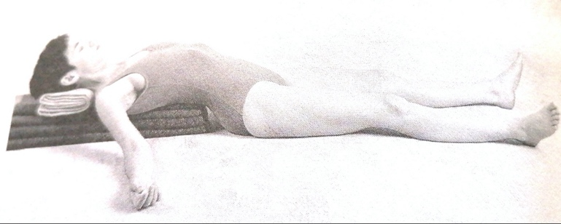
Lie in the effortless rest position where you have folded blankets into a bolster that is about 3 inches high and eight to 10 inches wide and at least three feet long. Lie with your buttocks on the floor and slowly reclined back being careful that your spine is symmetrical along the length of the bolster bend your knees. Lift the pelvis briefly, drawing the buttocks under so that the lower back is long and released. Then extend the legs straight letting them relax about a foot apart. Raise the head with a folded towel until the forehead is slightly higher than the chin.
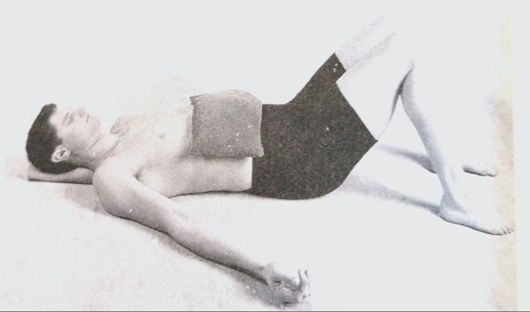
Alternatively, you can lie completely supine on the floor with the legs extended or knee bent. Now place a sandbag or something with a similar weight of around 10lbs, such as a bag of beans or rice, across the base of the ribs, directly under the breasts. If you use beans or rice etc. then see if you make sure the bag is only a third or so full so that it wraps around you rather than feeling like a solid brick. It will cover the area from the middle ribs to the middle of the abdomen above the navel. After you have taken a few moments to relax and check in with your breathing begin to direct your breathing into the area underneath the sandbag.

Rather than lifting the body with muscular effort against the sandbag, imagine that your body is having an easy conversation with sandbag, gradually expanding and making contact all the way around the mid torso. Concentrate your efforts for around 10 breaths and then rest, allowing your breath to breathe you without effort. Then repeat another two sets, resting in between each set. When you are done, take the sandbag off and observe your breathing. How are you breathing now?

Bibliography:
Farhi, Donna, The Breathing Book (1996), Henry Holt & Co: New York, Page 142, 151 & 152

