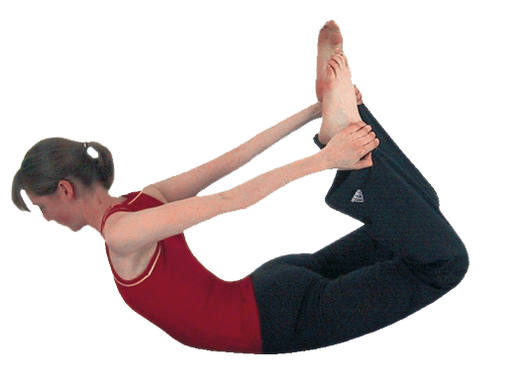**Dhanurasana (Bow pose)**

# *Pronounced dhuh-noor-aah-suh-nuh the word dhanur means bow in Sanskrit*

This prone backbend is called the bow as the shape of the pose resembles that of a bow being drawn.

**1) Teachin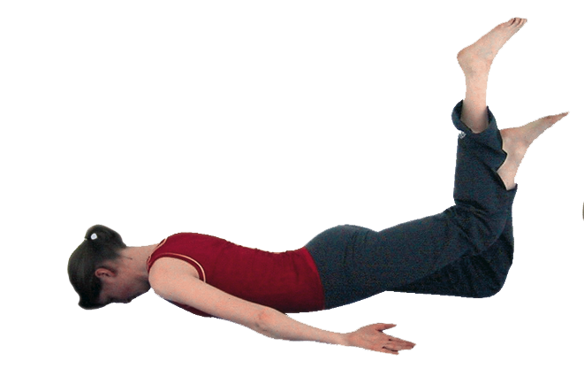g Points:**

* Start in a prone pose

Stage one

* At first we can lift and lower legs only, by trying to take the sole of the raised leg to the ceiling in this way we are learning the action the legs must perform.

Stage two

* Now we can lift both bent legs and the upper body simultaneously without holding at the feet. Some students may wish to stay working at this level.

Stage three

* If all is okay to proceed we now hold behind at the outside of the ankles and keeping legs aligned with the hips we actively lift both legs to the ceiling as we contract the abdominals and **raise the sternum, externally rotating shoulders so that the emphasis is upon lengthening the whole spine**.
* We must ensure the legs are lifting upwards as if extending or straightening the legs rather than towards the buttocks or otherwise we may overly compress knee joints and the lift will be compromised. We must also keep feet active in plantarflexion i.e. pointing toes to ceiling.
* Draw shoulder blades down and retracted opening the chest.
* Keep the front of the pelvis, and/or imagine S1 is pressing down into the ground to maintain openness at the lower back as you extend the spine lifting upwards
* Lengthen the whole spine, keeping the neck long and open, even if chin is lifted
* Stay here using the breath to re-adjust the pose. It is possible that the movement of the breath will create a rocking movement and this is perfectly acceptable,although the intensity of the pose is increased if we stay still breathing into the chest.
* To exit simply release hands and lower the body to the floor and after feeling the effects of the pose adopt a suitable counterpose.

**2) Vulnerable areas:**

Do not overly compress the lumbar and cervical spine, also the knee joints.

**3) Benefits:**

Stimulates and stretches the abdominal organs

Opens chest and shoulders

Rejuvenates the spine (stretching & strengthening)

Strengthens the lungs

Tonifies the sexual and reproductive organs

Alleviate sciatica & simple backache (using softer forms)

#### 4) Good preparation

A series of simpler backbends and twists. Chest & shoulder mobilisers, hip & groin openers, back strengtheners and mobilisers. Poses developing good abdominal control and strength.

**5) Cautions & possible modifications or alternatives**

* Low back conditions if necessary keep to one of the earlier stages or adopt shalabhasana (locust pose)
* Bony hips place padding beneath hips
* Knee problems ensure knees stay aligned, if necessary do not hold feet working with unbound version instead
* Heart conditions and high blood pressure choose softer modification (there is possible pressure upon the deep blood vessels such as the vena cavae)
* Abdominal problems, recent surgery, pregnancy work with vyaghrasana (tiger pose) where can keep raised leg at hip height if needed or bent at knee, toes to ceiling
* Severe spinal disc conditions practice a soft shalabhasana (locust pose) or vyaghrasana (tiger pose)

#### 6) Other simple versions and modifications

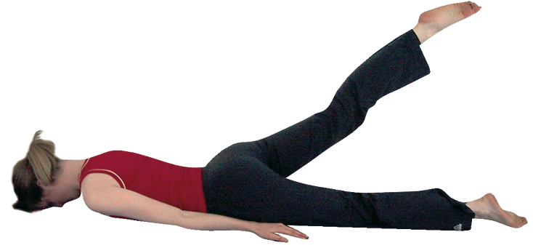***Shalabhasana (locust pose)***

Here we can learn to lift the leg, strengthening hamstrings and releasing hip flexors. This is useful modification and a great preparation for bow.

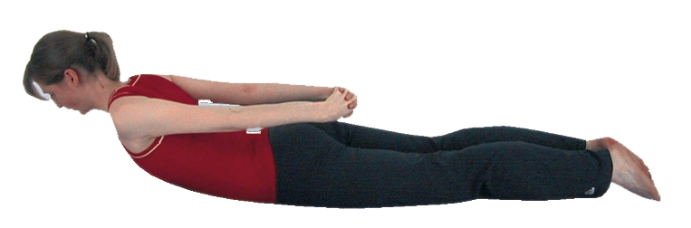***Sarpasana (serpent pose)***

Here we can become proficient at lifting the upper body up using muscular effort only. This is useful modification and a great preparation for bow.

***Wrap a belt around the ankles***

It is possible to extend the reach of the arms by wrapping a belt around the feet, ideally if possible we will wrap one belt around each ankle.

***Allow knees to spread apart***

Ideally the legs will remain aligned with the hips but if necessary we can allow the legs to splay apart.

**7) Variations & Developments**

***Keep thighs to floor***

We can direct the work into the upper body by keeping the thighs to the floor.

###### Hold to the inside of the ankles

This alternative hand position may suit some students very well as it encourages the legs to stay at hip width rather than splaying out to sides***.***

***One legged bow***

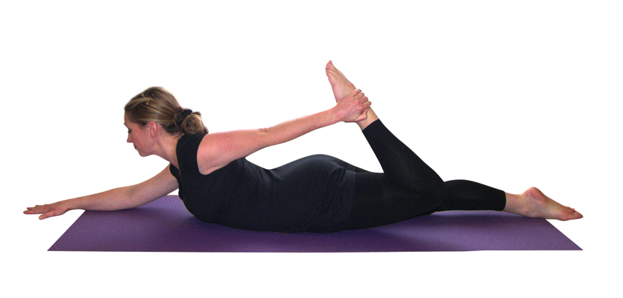We can move into bow where only one leg is raised. To do this the lower arm is extended along the ground in front as we take the other arm to the same side leg. We keep the torso to the ground as the rear leg is raised upwards. Note sometimes the front arm is shown as being place across the area in front of the torso but this can have the effect of compressing the spine so it is much preferable to keep the front arm extended away. This variation requires caution because we are working the spine asymmetrically and so is unhelpful to spinal conditions.

***Palms to feet***

A much stronger pose can be elicited if we place the palms to the soles of the feet, pointing thumbs to big toes. This development certainly requires a much more intense external rotation of the shoulders and great flexibility withi the spine.

#### 8) Counterposes:

#### Flapping fish, gentle lying twist, apanasana, down dog, balasana