**Chakrasana (Wheel pose)**

# :::attachments_16_01_2010 Folder:wheel .tif*Pronounced chuk-raah-suh-nuh the word chakra means wheel in Sanskrit*

This asana is generally called the wheel as the shape of the pose resembles part of circle, although sometimes this asana is also called urdhva dhanurasana meaning upward bow pose. It is a challenging pose because it requires great flexibility as well as strength.

When teaching strong backbends it is very helpful to perform a series of backbends increasing the intensity little by little. So for chakrasana this would certainly be applicable!

**Teaching Points:**

###### Stage one

* 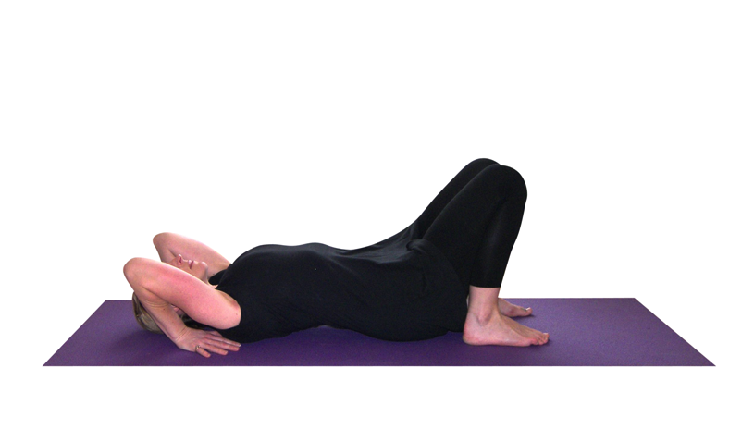Lie supine with feet hip width apart, heels close to the buttocks. Chin tucked in to chest.
* Bending elbows place the hands palms down under the shoulders, fingers pointing towards the feet.
* Keep both elbows pointing upwards and squeeze them inwards. Let the spine be long against the floor.
* Students can stay here working to find this hand placement and drawing elbows inwards.

###### Stage two

* 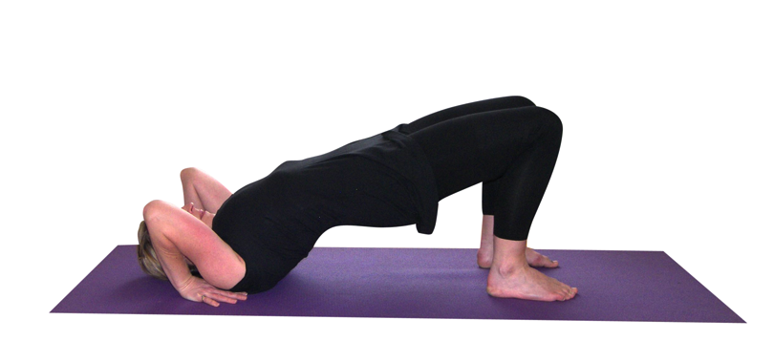If it is possible now lift the hips so there is a straight line between the knees and shoulders. Try to lift the pubic bone higher than the hip bones so that this posterior pelvic tilt will keep the lumbar region of the spine long and open.
* Keep the knees aligned so they do not splay out to sides, if necessary placing more weight into the inner edge of the feet
* Could stay here experiencing the stretch to the thighs and groin.

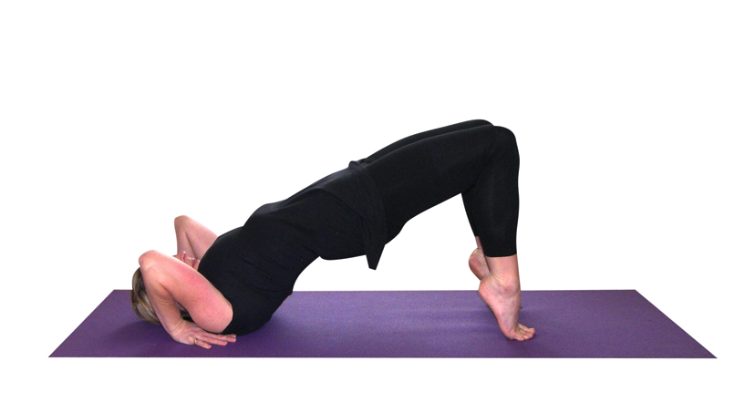Stage three

* Now to continue into the pose lift the hips higher, coming onto toes if necessary.
* Keep the abdomen pressing into the spine drawing the tailbone in the direction of the knees to keep the lower back as open as possible, if needed
* Again, could stay here.

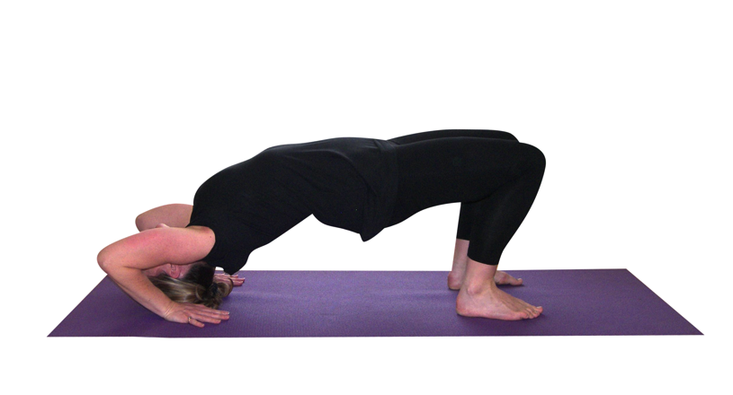Stage four

* Now pressing down into both hands lift on to the crown of the head.
* Keep the elbows tucked in towards the body, the knees aligned with the hips
* Continue to rotate the pelvis beneath by still trying the lift the pubic bone higher than the hip bones, if needed
* Could stay here

Stage five

* 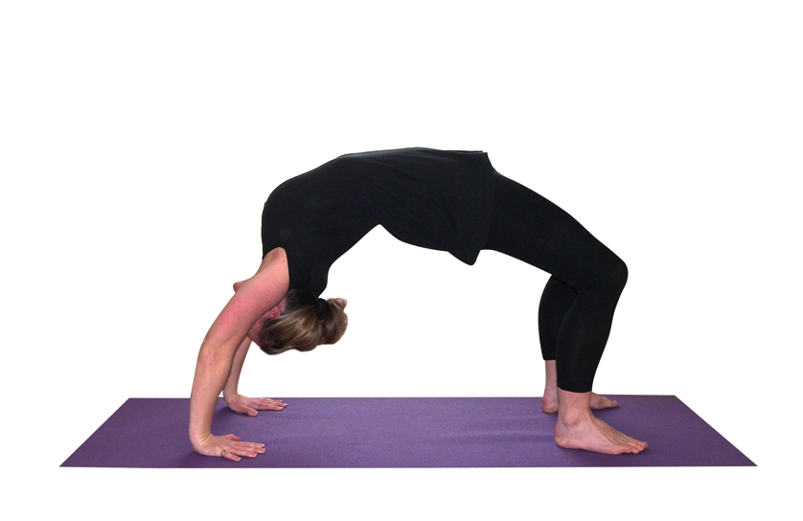To lift into the full pose press down into hands, straightening the arms.
* Lowering heels to the floor if already working on tip toes
* Align armpits above wrists, knees over shins, drawing the shoulder blades into the back and towards the waist.
* Lifting the hips so now the pubic bone and ribs are at the same height
* Keep the neck relaxed
* Walk feet inwards the hands if possible
* Stay here opening the whole front of body experiencing the pose as one continuous curve of energy

To exit

* Bending arms and legs lower head to floor
* Tuck chin into chest and lower down to bridge pose
* Lift arms above the head and curl the spine back down to the floor
* Spend a few moments experiencing the effect of the asana and then move into a suitable counterpose.

**Caution**: Do not overly compress the lumbar and cervical spine and maintain the alignment of knees, elbows and shoulders. Note that some students will be able to work with straighter arms with wrists under shoulders whereas other students will need to work with bent arms and the hands placed further behind, whilst initially this may be due to general stiffness within the shoulder joint it may also be due to structural differences where some students cannot fully flex the arm at the shoulder, meaning this is an acceptable variation.

**Benefits:**

Opens the chest and shoulder girdle

Aids deep breathing by expanding the lungs

Can be helpful for asthmatics

Increases flexibility and strength of spine

Strengthens the wrists, arms, shoulders and legs

Lifts energy

Creates feelings of exhilaration

#### Good preparation

Simpler backbends and twists; chest & shoulder mobilisers; hip & groin openers; back strengtheners and mobilisers; poses developing good abdominal control and strength

**Cautions**

For most conditions and injuries students can simply stay at an earlier stage of the wheel or work with a suitable form of dwi pada pitham or setu bandhasana. These include:

* Shoulder and wrist conditions and injuries
* General low back ache and/or sciatica, disc conditions
* Un-medicated high blood pressure, heart conditions and glaucoma

For pregnancy: cat tilt, soft camel hands to chair seat or similar

#### Simple versions and modifications

**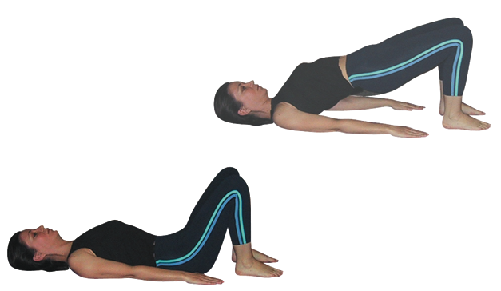Spinal curl**

Stay at an earlier stage of chakrasana or if necessary work with a simple spinal curl. We can in fact introduce any bridge pose that suits the ability of the student as a good modification.

###### Lie over an exercise ball

In the early stages an excellent option is to provide exercise balls where a student sits upon the ball then lowers the upper body backwards placing hands upon the floor. This is great to provide the experience of this backbend whilst providing support and lengthening for the spine.

***Place a belt around the upper arms***

Where a student is ready to lift into the raise wheel pose a belt can initially keep the arms at shoulder width. Although students should not rely upon this in the longer term it can be used in the mid term as students become stronger.

###### :::attachments_16_01_2010 Folder:wheel held.tifStudents to hold teachers ankles

If students hold the teachers ankles it is possible to lift into chakrasana from there and the teacher can hold a belt around the upper back area gently helping to lift the hips. This variation can be used when a student is at the stage of beginning to lift into the raised position. If two people are available that person can stand in front of the feet and place a belt around the buttock region.

***Hands placed against two blocks positioned against a wall***

If we place two blocks upon their sides against the wall it is possible to place the hands upon the flat face of the block. This modification reduces the depth of the backbend and also the angle of the wrists.

#### Developments & Variations

###### One leg lift

From the main pose it is possible to place the weight into one foot and lift the other leg vertically, toes pointing to the ceiling.

***Enter the pose from a standing position***

This development requires great abdominal strength and control.

**Adjustments**

We need to take great care when adjusting for this pose so verbal instruction and perhaps using a student to demonstrate the teaching points is best. However if we notice the feet are not hip width apart we can tap them until they are and if feet are not being made active again we can hold the feet lightly as we instruct students to open the feet and press downwards. We can also check the alignment of the knees and if they are turned inwardly then we can carefully realign them with our hands. Finally if the chest has sunk beneath the shoulders then we can very gently place a hand at the upper back and ask the student to move away from it. It is best not to interfere physically with either the shoulders or the neck since we can inadvertently cause injury.

© S.Beck December 2014