**Bhujangasana (cobra)**

# *Pronounced bhoo-juhn-gaah-suh-nuh the word bhujanga means snake or serpent in Sanskrit.*:cobra.tif

This pose is one of the most basic backbends we can perform although there are many variations we can perform, some of them are very gentle and others are very challenging indeed. For this posture we can imagine we are like a snake where our pubic bone is grounded against the floor and just like a snake uses muscular effort to rise out of the floor, we too rise out of the ground lifting and lengthening the spine.

**Teaching Points:**

* Lie in a prone position, forehead to the floor, placing hands beneath the shoulders, fingers pointing forwards. Keep elbows tucked into the sides of the body, shoulders down away from ears.
* Position legs at hip width apart, toes pointing behind.
* Press the pubic bone down into the floor, keeping both legs active.
* As you exhale/inhale start to lift the chest forwards and upwards, keeping your neck long and open, the spine elongated, shoulder blades flattened to the back and moving down the back, rising up out of the floor keeping hips to the floor
* Do not rely upon the strength of your arms rather utilize the muscles of the front and back of the body, and in the full pose both arms will remain slightly bent so we are not simply hanging off straight arms.
* Once the maximum lift has been reached we stay breathing and relaxing, keeping shoulders down away from shoulders, focusing between the eyebrows at ajna chakra
* To exit we exhale slowly lowering down, feeling all the muscles being released as we lower down.

**Drishti point**: Be aware of the space between the eyebrows, ajna chakra

**Benefits:**

Strengthens & stretches the back

Opens chest & shoulders

Increases circulation within lungs & abdomen

Tones visceral organs & improves digestion

Strengthens abdominal muscles

Gives energy to lower body

Creates feeling of openness

Counteracts low energy states

Softer options help alleviate back pain & sciatica

#### Good preparation

back strengtheners, ankle mobilisers, chest openers, shoulder mobilisers, spinal mobilisers (twists)

**Important teaching notes**

It is very important we do not compromise the integrity of the spine so we must instruct students to ensure they experience the limitations of the posture at the front of the body rather than at the back of the body.

Students must also learn that we must avoid compressing the lumbar area of the spine which is a natural 'v' shape, meaning we must maintain the extension through the whole length of the spinal column rather than directing the back bend into the lumbar region; this includes the neck where we must not overly compress the cervical vertebrae by lifting your chin, it being much better to keep the neck long and in a neutral position. Remember how this placement of the neck engages the hyoid bone which in turn engages the muscles along the front of the body supporting the back. Later you may wish to lift your chin and allow your head to drop when your neck muscles are strong and mobile enough.

**Contra-indications & possible modifications**

* For back conditions such as disc injuries, sacroiliac problems and sciatica, gentle backbends are generally therapeutic so we must offer gentler versions when the rest of the class is working more intensely.
* For spondylosis where the discs have degenerated or thinned then backbends can aggravate the condition so we must proceed carefully starting with soft supported backbend such the fish where a roll is place under the thoracic region and slowly move towards more active backbends.
* Abdominal conditions may need softer versions or an alternative such as working with majrasana (cat) or hamsa (seated swan).
* For pregnancy avoid backbends.
* For headaches, heart conditions or unmedicated high blood pressure work only with softer versions.
* Where the hips bones dig into the ground we can also place some padding across this area.

**Note:** a great modification for cobra is where a rolled mat or blanket is placed beneath the pelvis because this ensures the lower back is kept lengthened.

#### Simple versions and modifications

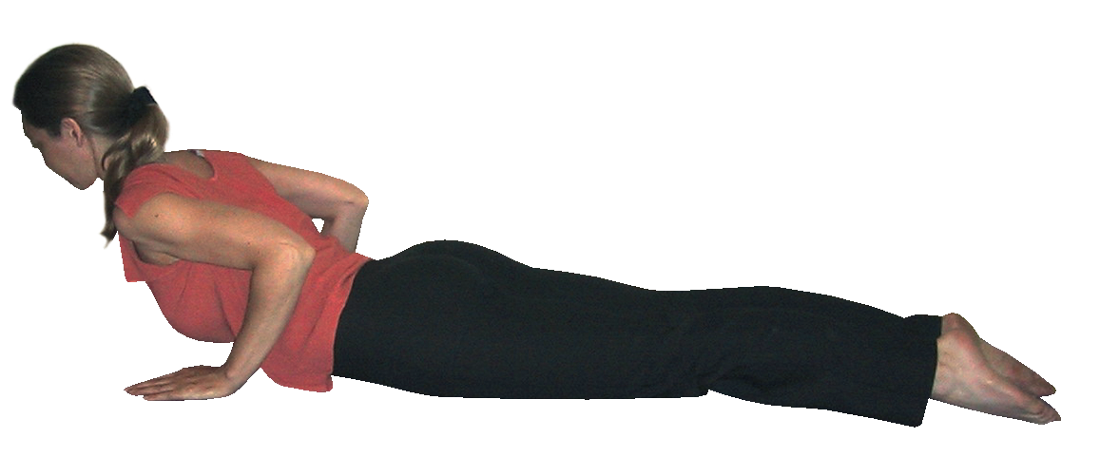It is often best to begin the journey into the cobra by working with the softer modifications where we are encouraged to lift the chest and extend the back without the use of arms. This means the back and abdominal muscles will be the primary muscles used so you can gradually strengthen and stretch them with integrity. Later use the arms to aid your lift but always remember not to use the arm muscles as the primary force since you will find you are simply pushing into the lower back or hanging off your shoulders.

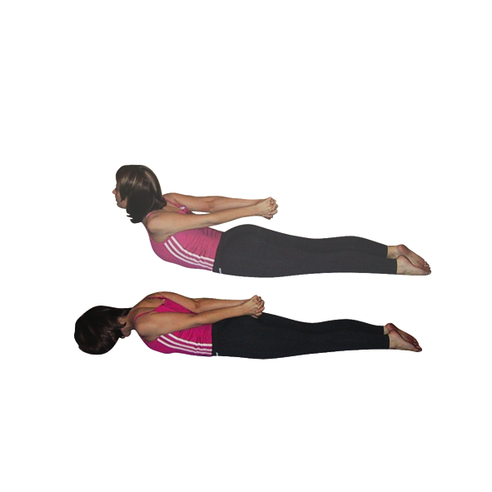

***Sarpasana (serpent)***

We can perform this version of cobra which helps to draw back shoulders and open the chest. It also helps us to really engage the muscles of the front and the back of the torso.

###### Sphinx

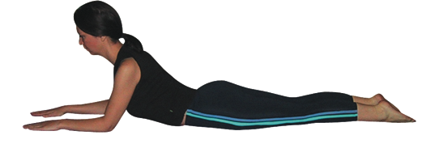This is an extremely useful version of bhujangasana that can be used whenever a student requires a softer version. Here elbows are placed beneath shoulders with forearms to the floor so that the backbend is diminished. We must still keep the tailbone dropping downwards.

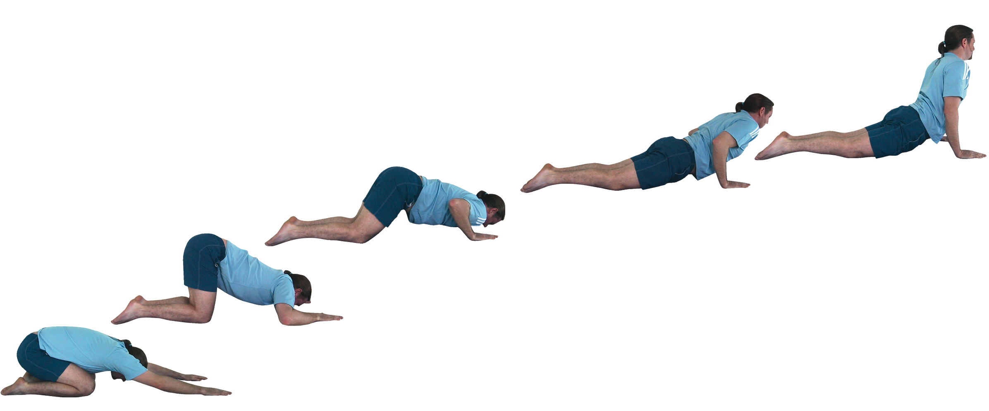

**Developments & Variations**

#### *Tiryaka bhugansana*

*Striking cobra*

To work with striking cobra we follow the poses as illustrated. We must keep the elbows tucked in against the body and the buttocks are raised until we slide the chest between the hands, planting the hips as the legs are straightened, rising up into cobra.

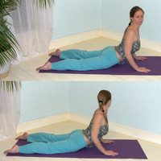**Head turning cobra**

Here we move into cobra then as we exhale we turn the head to one side, inhaling to centre and exhaling we turn the head in the opposite direction.

#### *Cobra twist*

We can make this turning movement more intense by moving into a gentle twist.

#### *Legs raised cobra*

We can make cobra more intense by bending both knees and pointing the toes of both feet to towards the ceiling or even if flexible enough, take the feet to the back of the head. However this variation is contraindicated for most students because most students have structural limitations to make this pose an impossibility without overly compressing the spinal column. Remember we must always ensure students become aware of where the resistance is, for this pose if it is experienced within the back of the body then bone has met bone.

#### Adjustments

To assist students into cobra we often have to lessen the intensity of the pose, especially if when asked the student indicates they can feel discomfort within the lower back. We can lightly tap hands to feet of the feet when they are not aligned with the front of foot to the floor. We can also place hands lightly upon shoulders to encourage them to relax away from the ears, and gently draw them open into external rotation. We may also place a hand lightly upon the back of the neck drawing the hand lightly up the neck to encourage students to lengthen the neck. If shoulders are splayed we can also draw them lightly back so they aligned with the shoulders.