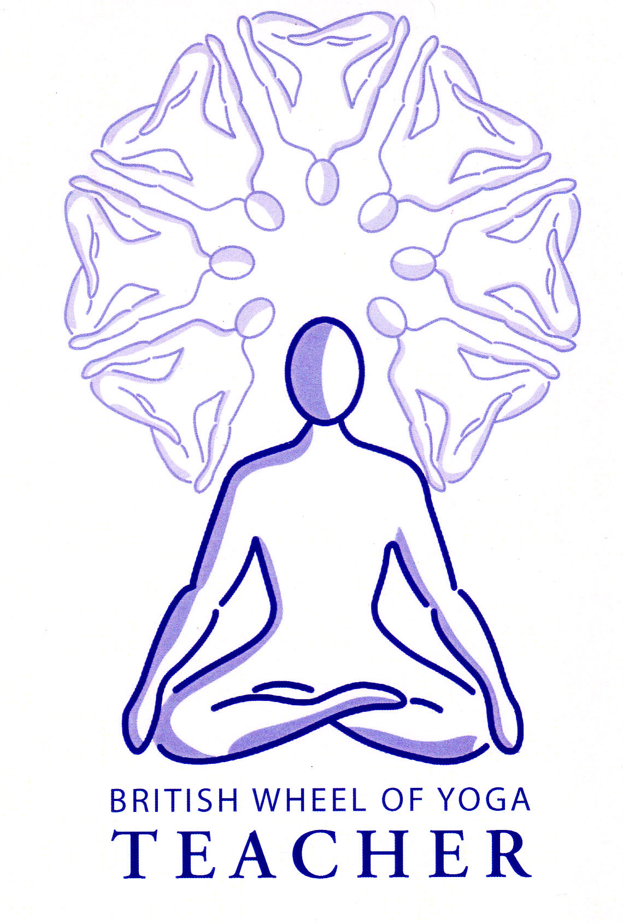
An Introduction to

Mudras and Bandhas

In Western yogic literature there is a vast amount of material dealing with asana but very little regarding mudras and bandhas, indeed mudras are often dismissed as merely finger exercises and bandhas are often ignored altogether.

Yet in both the Hatha Yoga Pradipika and the Gheranda Samhita we can see the importance of M & B for Hatha Yoga as a whole chapter is devoted to this subject with more detail and instruction given to M & B than given to other subjects such as pranayama, dharana etc.

If we look at all the ancient traditional yogic sources we can discern some 58 classical mudras used in the earlier stages of hatha yoga, i.e. those associated with kriyas, asana, pranayama, pratyahara and still others suggested for the ‘higher’ practices of dharana and dhyana. If we look at tantra and yantra we can uncover some 729 classical mudras.

Yet mudras and bandhas are an essential part of an advanced practice and are a fundamental part of the physiological process where enlightenment, or an expansion of consciousness, occurs through the physical practices of Hatha Yoga. Indeed the path of hatha yoga, when practiced intensely, is considered to be a faster route than the path of Classical Yoga, where the focus is upon meditation, and it is said that enlightenment is possible within one lifetime.

As we have previously noted hatha yoga utilizes kriyas, asana and pranayama to cleanse, lighten and stabilize the physical body, promote the free flow of prana and build focus within the mind and in conjunction with this mudras and bandhas add the necessary elements of finesse. They can be used independently, with asana, with pranayama and during practices of dharana and dhyana.

- In the Hatha Yoga Pradipika we find 10 mudras, which includes the bandhas, which are seen as a specialized form of mudra.

- In the Gherandha Samhita we can find 25 mudras, which again include the bandhas.

Mudra

Mudra translates as ‘seal’.

They are gestures or positions of parts of the body or the whole body. We often know of Hasta Mudras or Hand Seals but there are many others.

They are used to direct prana and are methods of sealing particular concentrations of awareness within the body. They can be used to stimulate and express introverted awareness i.e. they can change how we are feeling or thinking or express how we are feeling or thinking.

For the latter think of how a board director places his fingers in a pyramid shape when he is expressing him/herself – this is Hakini Mudra where tips of all fingers are pressed together to create increased concentration, deepened respiration, mental powers are increased and access to both hemispheres of the brain is possible.

They are traditionally used in many other societies and traditional Indian dance uses them, especially within kathakali where whole stories are told with eye, hand and other types of mudras.

We can find mudras in all spiritual & religious societies for instance: -

- Early Christian sects - seven seals of John the Divine in his Apocalypse, The Book of Revelations
- In Aramaic texts Jesus and his followers are said to have practised yogic techniques. There is even a theory that Lazarus was actually using kali mudra which makes the body lifeless, this being the mudra used when yogis are buried alive
- Zen and Buddhism
- Sufis of Islam – 15 mudras described as physical & mental attributes
- Indian Jains - 73 gestures in Mudra Vichara

Most mudras used in other religious/spiritual schools are the same as those used in Yoga.

Bandhas

Bandha translates as “binding, lock, restraint”

They are specialized forms of mudras where there are muscular contractions of sphincter muscles in the alimentary canal. They are also used to redirect prana but in addition they build up ‘pranic pressure’ by blocking the flow of energy by means of locks.

There are many individual benefits to be derived from the practice of the bandhas but we can sum up the effect of bandhas as a whole as a ‘pressure cooker effect’.

e.g. Water boils at 100 degrees and if we increase the pressure it boils at
a higher temperature so a casserole is cooked in ten minutes rather
than an hour

So whilst ordinary pranayama gives us energy and controls prana if we increase pressure by applying the bandhas this is quicker and more effective. Just as a pressure cooker has a valve to prevent the release of steam so the bandhas prevent the release of prana.

However remember that a faulty or misused pressure cooker may explode and deposit its contents all over the kitchen!!!

So how do the bandhas work? Well they create internal ‘pranic pressure’ by blocking the flow of prana directly affecting the movement of the vayus where the application of jalandhara bandha, the neck lock, and mula bandha, the root lock, direct prana to the solar plexus region.

- Jalandhara Bandha, the neck lock blocks prana vayu preventing it from escaping upwards.

- Mula Bandha, the base lock, blocks apana vayu preventing it from escaping downwards.

- As the pressure builds, prana vayu and apana vayu are forced together, stimulating samana vayu, the ‘fire’ vayu.

- Uddiyana bandha, the abdominal lock, is applied to further stimulate samana vayu.

Hence the bandhas lock the vayus within the body, creating great heat as prana accelerates. This creates a powerful chain reaction at the base of spine causing kundalini to awaken and the Shakti to rise through the Chakras, opening each in turn, where she journeys upwards to the crown chakra in the process of self-realisation. As prana flows upwards through the sushumna, nadi it pierces the granthis, the psychic knots, although initially it may only rise partially.

As prana travels beyond duality, i.e. beyond the ajna chakra and moves to sahasrara chakra, the crown chakra the yogi becomes filled with wisdom and no longer identifies with the changing world of form. He is now in the world, but not of the world. He sees himself as he is, consciousness itself – SAT CHIT ANANDA i.e. Being-Consciousness-Joy.

In this way it is said we have gone beyond the ceaseless antagonistic flow of these prana and apana vayus which symbolize the material world of opposites, and the aging process with their twin poles of birth and death.

Remember for the hatha yogi self-realization is a physiological possibility!

Performing the Bandhas

Jalandhara Bandha ‘The Chin Lock”

“jal “= throat “dhara” = supporting

Method
Sit comfortably with your spine erect. Place hands on knees, arms straight. Inhale, hold the breath, drop the chin forwards and down onto the jugular notch, continue to retain the breath, lift the head, exhale. Ensure that you draw your shoulder blades together and keep your chest open. Can also swallow first to release neck tension and lengthen neck.

Benefits for Jalandhara Bandha (cervical contraction)
It stretches the neck, pulling the spinal cord and thus the brain. This has subtle effects on the pituitary and pineal glands while the forward flexion of the neck affects the thyroid, parathyroid and thymus glands. Jalandhara bandha at the same time stimulates the parasympathetic spinal area in the medulla oblongata (situated at the bottom of the brain and the top of the spinal cord) regulating heart rate, respiration, blood pressure etc. Finally, it also compresses the carotid sinuses, which help in lowering the blood pressure. By reducing sympathetic activity, one achieves a sense of rest, relaxation and general wellbeing.

JB also encourages pratyahara where the brain does not receive sensory information from the body. It also inhibits the flow of information from the parasympathetic and sympathetic nervous systems to the Adhares, or life centres of the body. These include the toes, ankle, knees, thighs, perineum, generative organs, navel, heart, neck, throat, palate, nose, eyebrow centre, forehead centre, skull and the opening of the sushumna nadi. It is therefore an excellent prelude to meditation.

Esoterically JB places pressure on the nadis preventing the cooling energy of the moon plexus from flowing down from the brain dispersing the hot energy of the heart and abdominal plexi, this allows prana and apana to unite (often called nectar in the classic texts).

Precautions & Prohibitions
There are many when we are also practicing breath retention, such as high blood pressure, heart conditions or pregnancy, or any other contraindications where breath retention is unadvised. There should be no pain felt in the neck. Do not hold for more than 10 beats without also performing mula bandha. If short-necked roll a scarf under the chin to supply the pressure. When practiced without breath retention there are no cautions, rather we will find that it is a relaxing practice. (See benefits of JB at the end of the handout.

See HYP Ch3 v70 to 72
Asana Pranayama Mudra Bandha, Bihar School, p326 to 328

Mula Bandha “The Root Lock”

Method
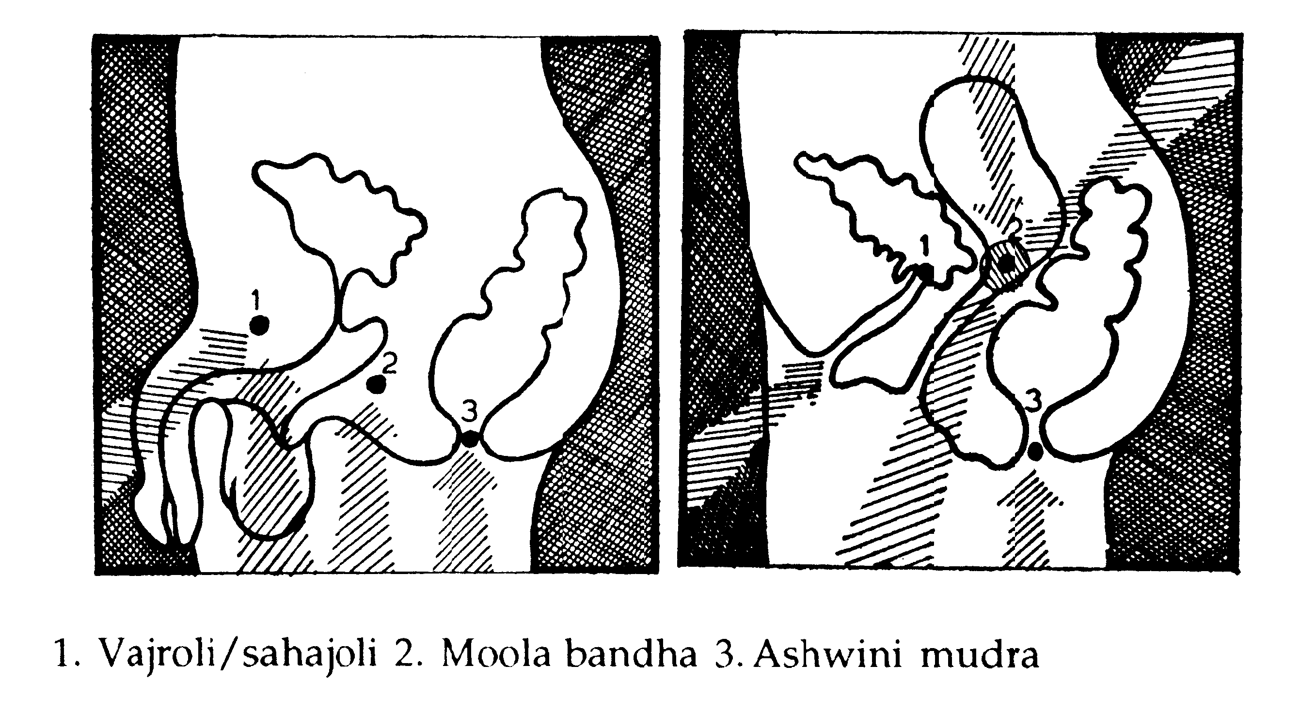
Practice general techniques to strengthen the pelvic floor first. Contract the rectal muscles repeatedly (Aswini Mudra). Contract the muscles around the pubis repeatedly (Yoni Mudra). Aim to isolate one movement from the other then finally when some control is experienced, practice the muscle lift into Mula Bandha on the central point, not the front or back. For men MB is located at the perineum whereas for women it is at the entrance of the cervix. Everyone can lie down with knees bent to practice pelvis rolling to locate the point in the perineum. Performing the cat or shoulderstand can help you to locate this point.

Benefits of Mula Bandha (perineal contraction)
This stimulates both the sensory-motor and the autonomic nervous systems in the pelvic region. When mula bandha is performed, pelvic stimulation activates parasympathetic fibres emerging from the spinal cord. Parasympathetic fibres emerge from the cervical (neck) and sacral (pelvic) areas only, while sympathetic fibres emerge from the thoracic and lumbar areas only.

MB increases the blood supply, removes toxins, tones muscles, strengthens vagina and anal sphincter muscles, prevents prolapse of the uterus or bladder and is good for piles.

Esoterically it helps to control prana, helping the union of prana and apana, and is responsible for the awakening of kundalini.

Precautions & Prohibitions
As for jalandhara bandha, and we can also practice it without breath retention with natural breathing with no contraindications. It is an excellent practice for the elderly when done without retention.

See HYP Ch3 v61 to 63
Asana Pranayama Mudra Bandha, Bihar School, p329 to 328

Maha Mudra I “The Great Seal”

This is a simpler option that can be used first

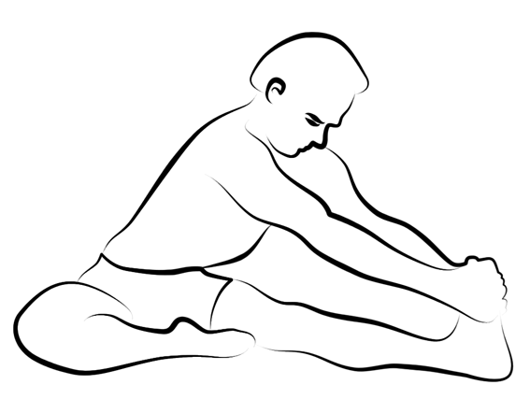
Method
Sit in Janusirsasana (head to knee pose), right leg straight, left foot against the perineum or vagina. Alter the position by keeping the torso erect, spine long, but angle forward to 45 degrees. Hold the right big toe with index finger or loop the foot with a belt. Arms are straight. Inhale, hold your breath with JB & MB for a comfortable length of time. Release JB & MB then breathe out. Work for several rounds then practice on the other side. It is possible to also rotate awareness between muladhara, vishuddhi and ajna chakras whilst performing the A.K. or we can simply engage shambhavi mudra.

Precautions & Prohibitions
As for JB and MB in relation to breath retention.

Uddiyana Bandha “Flying Upwards”

Method
This is easier to learn standing although for pranayama purposes it is performed in a cross legged asana. Inhale, swoosh out forcefully through the mouth. Hold the breath, adopt JB and pull up Uddiyana, which will in effect pull up the pelvic floor into MB. Slowly release MB, UB, JB and then breathe in. Find your own level for retention.

However you need to first teach the pelvic tilt, increased abdominal strength and control, increased body awareness and it should be taught after the other two bandhas. It would usually be taught in the second to third year of very regular attendance of yoga classes and only sooner if the class is fit and enthusiastic.

One simple version I have encountered to help us find UB is to sit on a chair or cushion, planting the tailbone down, growing out of the pelvis. Take a deep breath in whilst opening the chest and exhale out through the mouth, leaning forwards placing hands on the floor drawing the belly back towards the spine as you lift the chest, spreading the ribs away from the spine. Keep shoulders down and simply pause for as long as is comfortable then relaxing the abdomen inhale. After a short while you may experience a kind of a suction action when you are pausing on the exhalation, where the flow of prana and apana are reversed and UB is activated.

To locate where the effect is felt, lie on the floor, inhale raising arms behind, swoosh the air out and there will be an involuntary deep hollow experienced at the edge of the lower front of the ribs. This would be safe for all, except those with hiatus hernia, abdominal problems or pregnancy.

Benefits for Uddiyana bandha (abdominal contraction)
This bandha compresses the digestive organs, adrenal glands, kidneys, and most importantly the solar plexus. The ‘brain-in-the-stomach’ is squeezed and in return a flood of energy is generated in the abdomen and chest. The energy has healing qualities and is experienced consciously as beneficial, enhancing our feeling of wellbeing. Uddiyana bandha tones the sympathetic nervous system so that it does not function in inappropriate situations, thus avoiding the effects of stress and anxiety.

UB exercises the diaphragm, massages all internal organs improving the functioning of the liver, pancreas, kidneys etc., it stimulates metabolism, releases toxins, stimulates the circulatory system and gives energy. It normalizes the adrenals so gives energy or is calming as it balances.

Esoterically it helps to increase and distribute the pranic flow throughout the body, helps to unite prana and apana, break the granthis and assists the movement of prana through sushumna nadi.

Precautions & Prohibitions
This should only be performed by the fit & healthy; there are many prohibitions as UB works deeply on the whole abdominal region and creates heat inside, also all prohibitions associated with breath retention also apply as this practice can only be done on a BK. Prohibitions include menstruation, pregnancy, high blood pressure, abdominal surgery and urinary problems.

See HYP Ch3 v55 to 63
Asana Pranayama Mudra Bandha, Bihar School, p331 to 333

Maha Mudra II “The Great Seal”

Sometimes called ‘traya bandha’ the three bandhas

Method
Only practice this is you are confident with the previous practice. Sit as before. Inhale, swoosh the air out, then adopt MB, UB & JB. Focus on energy rising up the sushumna, then finally on the ajna chakra (eyebrow chakra). It can be done with eyes open (Shambavi Mudra) or closed. Then release JB, UB & MB and inhale. Practice on both sides.

Purpose
This mudra directs awareness inwardly. Gives a feeling of strength and being positive. In yogic terms it stimulates the shakti and draws it up powerfully.

Precautions & Prohibitions
As for JB, UB and MB. It is only for those who are healthy and experienced. However it is self-limiting and can sometimes be practiced in a very moderate way for the physical & psychological benefits. We can also practice without the focus upon the ajna chakra.

Maha Bandha / Traya bandha

As above but seated crosslegged.
See HYP Ch3 v19 to 22

Please Note
You can find many variations for all of these practices. We need to be disciplined in working through each stage slowly. These instructions are really the “bare bones”. You can build on them over time if you decide to go for intensive Ashram type training.

The General Benefits of Bandhas
The performance of bandhas leads to a general massaging effect of the deeper muscles and internal organs. Increased blood supply to these areas aids in general purification of the body. Bandhas stimulate and balance the endocrine glands; as these glands are intimately related to the chakras this influences every aspect of our organism, revitalizing it with life-sustaining energy and balancing mental and emotional functioning.

The performance of bandhas has been experimentally shown to reinforce all parasympathetic activities on the body, which includes a decrease in heart rate, respiration and blood pressure (where blood pressure is already normal), and a general sense of rest and relaxation. Sympathetic nervous stimulation also occurs but at a subdued level. The overall effect of stimulating both the parasympathetic and sympathetic nervous systems is to rebalance these two major components of nervous activity in the body. This has very definite repercussions on the hypothalamus (responsible for the complete endocrine system), which relays its information to the whole limbic (emotional) system and the cerebral cortex (outer layer of the brain).

More specifically as we perform the bandhas in conjunction with pranayama they affect the whole body as follows:-

- They harmonize the efficient functioning of the endocrine system: jalandhara directly influences the pituitary, pineal, thyroid, parathyroid and thymus: uddiyana directly influences the adrenals and pancreas: mula directly influences the gonads and the perineal body/cervix (which are said to be vestigial endocrine glands). All bandhas have an indirect effect on the pituitary, pineal and brain.
- As a result of the direct effect of the bandhas on the endocrine glands, certain biorhythms in the body are also regulated. For example both mula and uddiyana bandhas are extremely useful in stabilizing menstrual periods.
- All bandhas, when performed correctly, lower respiration rate inducing calmness and relaxation for instance blood pressure is decreased and heart rate is lessened.
- Alpha brainwave production, an index of profound relaxation, is increased, indicating slowing of nervous activity.
- Sympathetic activity in the body is decreased, a further index of relaxation.
- Confused and/or crossed neuronal circuits in the brain are reordered, in effect ‘retraining’ the brain.
- The digestive system is toned, massaged and revitalized via pressure on the internal organs.
- Harmony in the cavity of the uro-gential system occurs as a result of reflex action via the nervous system.
- There are very many physiological and psychological benefits!!

For more information also see:

Swami Buddhananda Saraswati, Mula Bandha the Master Key, 1984, Bihar School of Yoga
Swami Muktibodhananda Saraswati, Hatha Yoga Pradipika, 1985, Bihar School of Yoga
Swami Satyananda Saraswati, Asana, Pranayama, Mudra, Bandha, 1969, Bihar School of Yoga

© Sarah Beck August 2014

