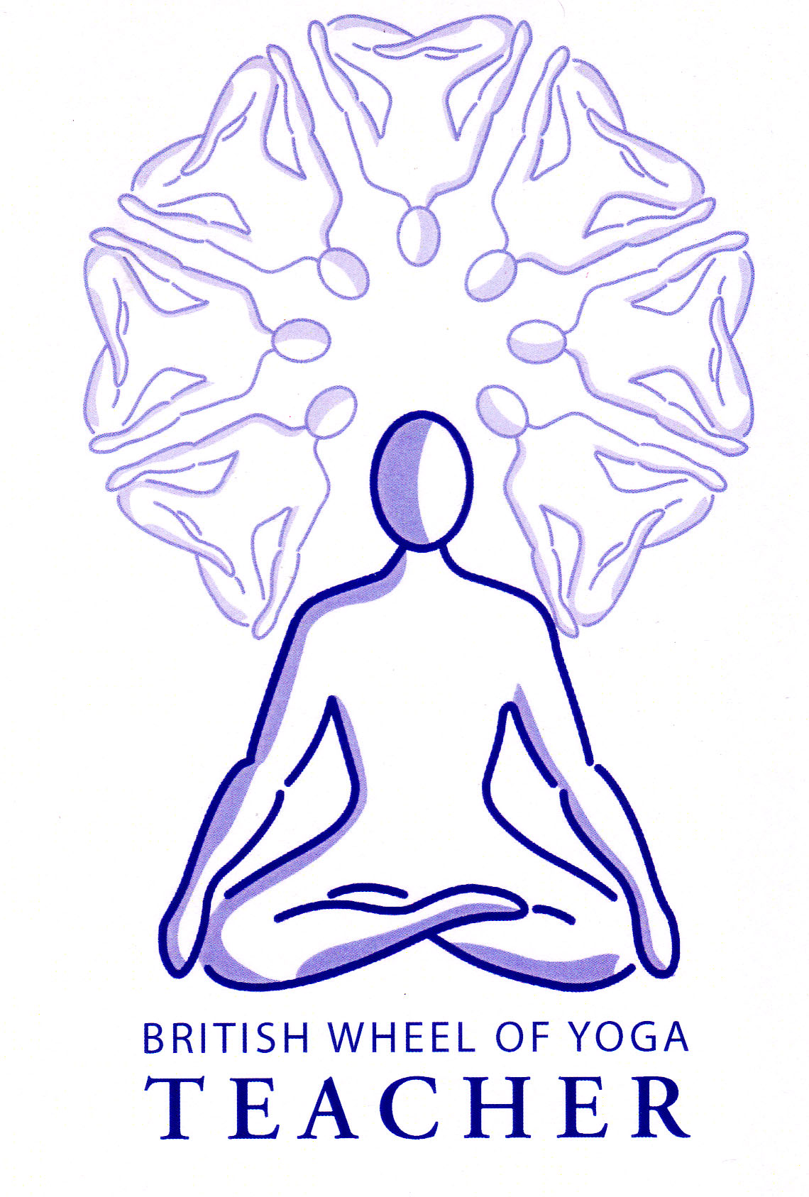**Bakasana (Crane pose)**

# *Pronounced buhk-aah-suh-nuh the word baka means crane in Sanskrit.*

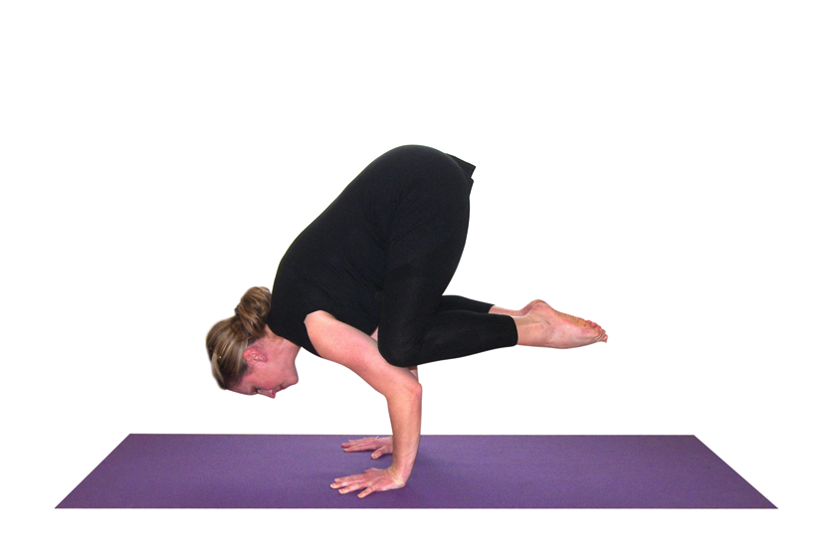

This arm balance is called crane pose because the shape is reminiscent of the crane, the tall wading bird to be seen in river estuaries and the like.

**Teaching Points:**

**Note:** whenever practicing an arm balance such as bakasana we must ensure we are not working on a soft carpeted floor because this can mean we over-extend the wrists as the wrists sink beneath the level of the fingers. Also some students will find it helps to claw at the ground rather than keeping the hands perfectly flat.

* Start in a squatting position placing hands shoulder width apart, middle fingers facing forwards. Let elbows be bent.
* Place the feet close together coming on tips of toes as the knees are positioned upon the outside of the upper arms as close to the armpits as possible.
* Press the shins against the upper arms, keeping elbows tucked in against the body.
* Now very slowly bring the body weight forwards as the chin is lifted slightly.
* Keep the feet touching at the inner edges and actively point the feet, let the abdomen be hollow and the back rounded.
* Balance here using the positioning of the head to help, oftentimes if we look down then all is lost so simply look up a little working as if the head and buttocks are two ends of a scale.

**Drishti point**: Be aware of tip of nose

**Benefits:**

Strengthens the shoulder girdle, arms and wrists

Stretches the lower back

Strengthens the abdominal muscles

Develops good concentration

Promotes good balance

Instills feelings of confidence, conquering fear

#### Good preparation

Hip mobilisers, shoulder and arm strengtheners.

This is an interesting asana because there is flexion of the spine and abduction of scapulae, and it is often challenging to lift the head whilst keeping the thoracic spine flexed and the scapulae abducted. Many muscles are working through isometric contraction, meaning it is very strengthening.

**Contra-indications & possible modifications**

* For carpal tunnel syndrome can omit the pose or simply place a little weight into wrists 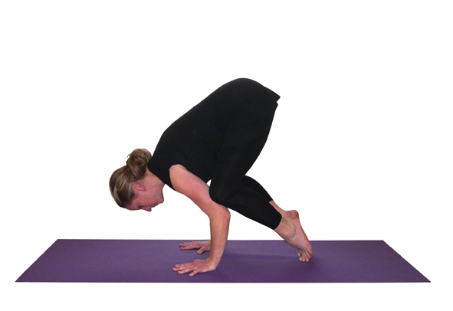without lifting feet.
* For osteoporosis again we can omit the pose or simply place a little weight into wrists without lifting feet.
* For both conditions and stiff wrists it may be helpful to place a wedge beneath the hands to alleviate pressure upon the wrists by reducing the angle between arms and hands.

#### Simple versions and modifications

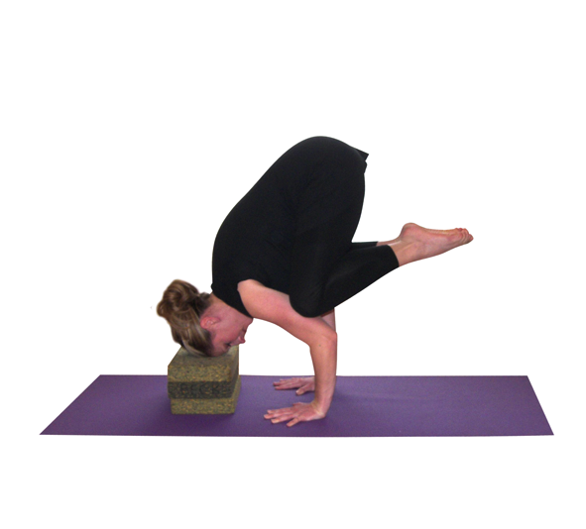***Blocks stacked beneath the forehead***

A good intermediary option to assist in balance and confidence is to place a number of blocks beneath the forehead. The height of the blocks will need to be determined according to the height of the student.

***Blocks stacked beneath the feet***

It is possible to assist the lift by placing blocks beneath the feet although this is not ideal because it means the student does not as yet have enough strength and co-ordination to lift of their own accord so it may be better to work without them, building strength.

**Developments & Variations**

***Extend arms***

We can develop the pose by straightening arms

***Extending one leg behind***

We can develop this pose significantly by bending the elbows a little more and straightening one leg behind.

***Moving from crane to headstand***

A very good development for those who are ready is to lower from crane into headstand, perhaps returning to crane after working with headstand!

**Adjustments**

We need to scan the room to check the hands are being placed at shoulder width and if necessary move students’ hands to the correct position. If elbows are splayed we touch them lightly and ask students to squeeze them against the body.

© S Beck 2012