# A picture containing text Description automatically generatedThe Background of the Bhagavad Gita

# “The Song of the Lord”

The Gita is an extraordinary text. It is concerned with **how we can live in the world and at the same time stay linked to the spiritual force, as well with exploring our own spiritual development.**

“The Vedic Dharma is verily twofold, characterized by Pravritti (social action) and Nirvritti (inward contemplation), designed to promote order in the world; this two-fold dharma has in view the true social welfare and spiritual emancipation of all beings”

Sri Shankaracharya (788 to 820 CE)

The date of the Gita is **circa 300BCE**, usually being placed between C5th and C2nd BCE. It was written in the period following the Upanishads when there was a great development of devotional religion within India. This era is usually referred to as the **Pre-Classical** **Epic Period** where we find two very famous epic poems, the Ramayanaand the **Mahabharata**. The latter was of encyclopedic length and contains within it the Gita, one of the most striking of Indian Scriptures. Most scholars attribute authorship of the Mahabarata, and the Gita, to **Vyasa**, although Vyasa can simply mean ‘author’ and so ultimately the true authorship is unknown. It is also suggested that the Gita may have been written alone as an Upanishad and later inserted within the Mahabharata and certainly it is different from the other parts of the Mahabharata although the same characters can be found in both. Whilst conventionally only the Vedas and the Upanishads are known as being Shruti, i.e. direct revelation, as Easwaran in his introduction to the Gita says on page 18 “In the literal sense the Gita too is shruti, owing its authority not to other scriptures but to the fact that it set down the direct mystical experience of a single author.”

It is important to note the Gita is **generally known as a Vedantic text** because there is an overall sense of Monism where all is ultimately One; although we find that the Gita **also contains many concepts and terminology from dualistic Samkhyan Philosophy,** such as the the concept of the Gunas, Sattva, Rajas and Tamas. So whilst there are two underlying philosophies embedded ithin the Gita ultimately this is not of consequence for the reader because the Gita is foremost a practical handbook on how we may best live in this world.

[For more information (optional): the Gita combines two rather different philosophies i.e. Monism where all is considered to be One and Samkhya where there is a distinct separation of Spirit and Nature, i.e. Purusha and Prakriti, where any manifestation, including our body, mind and senses, is considered to be Prakriti. These views however are not necessarily contradictory, rather two viewpoints of the same mountain, each viewpoint possessing it’s own value. Do not get wrapped up in this however as it is a finer point for now.]

Interestingly the Gita can also be seen as a **synthesis of different paths of yoga** and some authorities tell us at the time of its conception the Gita was written as a way of unifying all of the different yogic traditions.

The words Bhagavad Gita mean ‘**The Song of the Lord’** and it is comprised of approximately 700 couplets or verses within 18 chapters.

As we read the Gita we find it is more poetic in style than the concise style of the Sutras nor is it written in such a logical or systemic style as the Sutras; however it is actually more expansive on many of the same aspects and for this reason is always held that yoga teachers and serious students of yoga must study the Bhagavad Gita, and it will help them to more fully understand Patanjali’s Yoga Sutras.

Some students of yoga certainly seem to prefer the Sutras since they appear to be less overtly religious and as such can be taken as a more general scientific work on human development yet we must remember that although Lord Krishna, an important Hindu God, is at the heart of the Gita we need not worship Krishna personally or even accept him as an avatar to appreciate the teachings of the Gita. This is because the Gita gives spiritual truths that transcend any one religion and very importantly when we look closely at the Gita we can quickly realize that the text takes the form of a conversation between Prince Arjuna and Lord Krishna which can be seen as a **beautiful metaphor of the internal conversation we all have between our lower and higher selves, i.e. the struggle we all have for self-mastery, so rather than being a religious text it can be seen as a spiritual text.**

## The Setting of the Bhagavad Gita

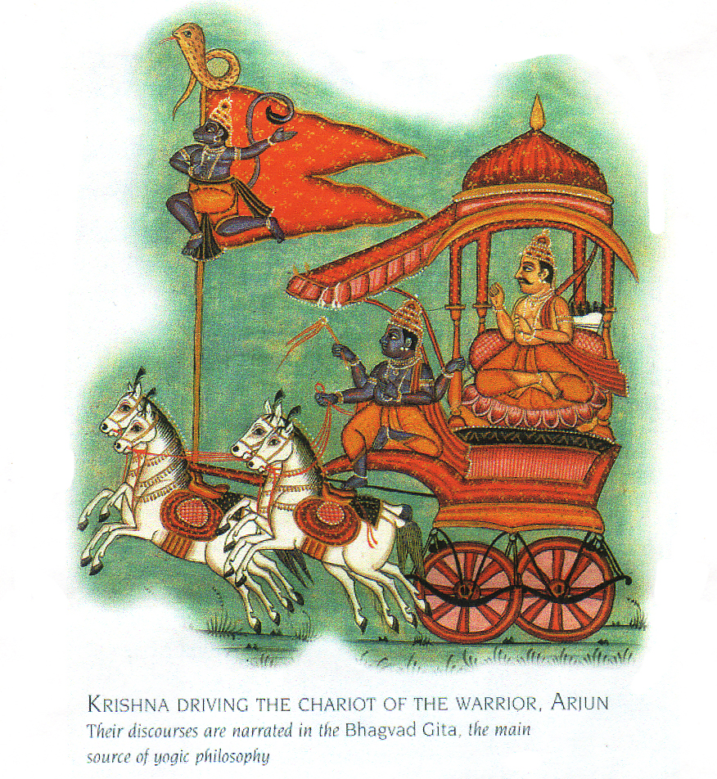

The setting of the Gita is a very dramatic one as it is a battleground at **Kurushetra,** near Dehli which is now a place of pilgrimage.

A little more of the background of the battle may help us to set the scene.

**King Pandu had died** so his brother, Dhritarashtra succeeded him. He continued to rule the kingdom educating both his own 100 sons, the Kauravas, and the five sons of King Pandu, the Pandavas. Dhritarashtra eventually decided that he would split the kingdom between the Pandavas and Kauravas but the Kauravas were highly jealous of the noble and pious sons of Pandu and sought to murder the Pandavas.

Without success finally the eldest Kaurava, Duryodhana, challenged the eldest Pandava, Yudhisththira, to a game of dice and Yudhisththira possessing a weakness for gambling finally gambled his family’s half of the kingdom! He lost the bet and it was only Dhritarashtra, their uncle, who intervened and eventually was persuaded to allow one more game of dice. Again Yudhishsthira lost (a certain amount of cheating is mentioned!) and this time the Pandavas were exiled for one year. However once the year was over and they returned claiming just one village for each member of the family the Kauravas refused and the long time feud became all out war.

So the battle lines were drawn at **Kurushetra,** near Dehli. Each side looked to Lord Krishna for help, being offered the choice of either Krishna’s army or Krishna himself; the Kauravas chose the assistance of the army and the Pandavas the help of Krishna himself.

At the start of the battle the Gita takes the form of the conversation between Prince Arjuna, of the Pandavas, and his charioteer Krishna. They talk whilst sitting in a chariot situated between the two sides because as the decisive battle with the enemy, the Kauravas, is about to start Arjuna is reluctant to fight because he sees that many of his relatives, teachers and friends are amongst those he is expected to kill. It is at this point he seeks advice from his charioteer Krishna.

Lord Krishna, who is considered to be an incarnation of the god Vishnu, one aspect of the Supreme Brahman, is disguised as Arjuna’s charioteer and offers Arjuna comfort, advice and spiritual teaching. In particular Krishna instructs Arjuna in the **general moral and spiritual principles which should govern the life of a yogi, especially one who is still fulfilling his life and duties in the world as well as practicing yoga.**

We can easily become involved with asking questions about the morality of fighting and war but when we look carefully **we must realize that we actually considering the battle between the forces of darkness and light within every heart.** In fact the Gita needs to be read as an **internal dialogue** rather than an external dialogue where an individual is asking questions regarding his/her own life. We are exploring the nature of action, searching for the meaning of life and addressing the aims that we may work towards.

It is said that the battle went on for 18 days and that the Pandavas were victorious. Yudhishthira, the eldest son of Pandu, became ruler and went on to reign for 36 years.

## The Bhagavad Gita as a Synthesis

In particular the Gita highlights the fact that we are all individuals and must choose a path to enlightenment that suits our own temperament telling us that **all paths lead to God.** The Gita is famous for outlining four primary paths of yoga:

* Karma Yoga (yoga of work or service)
* Bhakti Yoga (yoga of devotion)
* Jnana Yoga (yoga of knowledge)
* Raja Yoga (yoga of meditation)

The Gita outlines the fundamental nature of each path and gives the common features amongst them. It is very clear that **no path has ultimate supremacy** but that each can lead us to the goal of Self-Realization. Indeed by following a particular path this will inevitably lead us to the other paths so for instance the yogi who follows the path of devotion finds awareness and wisdom grow as the by products of love, and the yogi who follows the path of wisdom will find love as a by product as awareness expands. Primarily each path is seeking to helps us ovecome the supremacy of the ego so that there can be an eventual shift from individuality to universality.

## The Universality of the Gita

The Gita has a very wide appeal and whilst the average Hindu may know little of Brahma, the creator God, they all can tell us something of Lord Krishna, in fact it is sometimes stated that the introduction of Krishna within the Gita was a pivotal choice whereby the concept of God was personified. Krishna has been moulded in the original form of Vishnu, as an affable Avatar or reincarnation of God, and for the first time we are given concrete guidelines for living. The text is often considered to be smriti meaning it outlines received wisdom.

The Gita is one of the most widely read spiritual texts in the world, becoming accessible to the West during the 18th Century. Gandhi is well known for having held the Gita in the highest esteem, considering it to contain the answers to every problem that life could offer. He called the Gita ‘Mother’ and often said that it nourished him with it’s love, comforted him when he was down-hearted, strengthened him when he felt weak and lovingly chastised him when he had gone astray!

“To me the Gita became an infallible guide of conduct. It became my dictionary of daily reference. Just as I turned to the English dictionary for the meaning of English words that I did not understand, I turned to this dictionary of conduct for a ready solution of all my troubles and trials.”

M.K.Gandhi (1948, p233)

The Gita has always been used as a source of inspiration with many seekers meditating daily upon its teachings.

“When we concentrate completely upon the verses of the Gita we gradually become so focused that we go beyond the words and thoughts and become absorbed in the living truth that underlies them, the sap of life that runs through all creation. And what we meditate on with that kind of absorption, we become”

Eknath Easwaran (1985, p19)

The Gita is absolutely non-sectarian and does not seek to create a Hindu, a Jew or a Christian. As such it can be considered to be a poem that seeks to give comprehensive advice regarding how we can best live in this world and also achieve Self-Realization; it’s core is spirituality within living rather than religiosity. And you could say that although written in antiquity it is as relevant today as it was at the time of writing.

Very significantly for us it tells us we do not need to leave the world and its attendant responsibilities to achieve internal freedom and peace. The mundane and spiritual can co-exist and be cultivated together.

Bibliography

Easwaran, Eknath (1st Edition 1985), The Bhagavad Gita, Penguin Arkana, London p19

Gandhi, Mahatma, (1948) Autobiography: The Story of My Experiments with Truth, Courier Corporation: US p233

© Sarah Beck April 2022