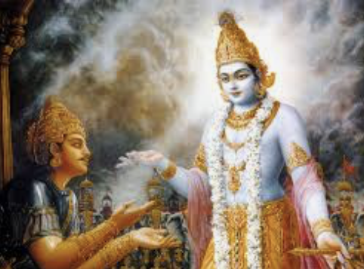

The Bhagavad Gita

The Bhagavad Gita is a collection of verses containing the conversation between Lord Krishna and Prince Arjuna just before Arjuna is to commence battle. The Gita, as it is popularly known, is a part of the Hindu epic, Mahabharata, where it is almost as if time stops as Lord Krishna and Prince Arjuna discuss the nature of life and examine how life can be best lived.

“Actions do not cling to me because I am not attached to their results.
Those who understand this and practice it live in freedom.

Knowing this truth, aspirants desiring liberation in ancient times engaged in action.
You too can do the same, pursuing an active life in the manner of these ancient sages.”

Chapter Four v14 & v15

A CHRONOLOGICAL PERSPECTIVE ON CLASSICAL YOGA TEXTS
(Please note the dates given will vary according to different authorities)

VEDIC ERA
6500 – 900 B.C.E. | Indus-Saraswati Civilization, in cities such as Mehrgarh and later (3000 B.C.E) within satellite cities, such as Mohenjo-Daro along the Indus River.
4000 to 2000 B.C.E. | Rig Veda, Sama Veda, Yajur Veda & Atharva Veda
2600 to 1500 | Brahmanas, ritual texts full of metaphor, based on the Vedas. Also the Aranyakas which were forest teachings where orthodox Brahmins chose to live a life of solitude, moving away from the hustle & bustle of life, to perform their rituals etc. This was the first time we find the ‘sannyasin’ living a life of renunciation. The forest teachings prepared the ground for the later Upanishads and subsequent ascetic traditions of Yoga.
1500 to 1200 B.C.E. | The invasion of the Sanskrit speaking Indo-Aryan tribes – now refuted by many scholars. They are now thought to have peacefully settled long before then.
1450 B.C.E. | The Great Bharata War forming the basis of the later Bhagavad Gita
1000 – 900 B.C.E. | With the drying up of the great Saraswati River there was a movement away from the Indus- Saraswati region to populate the fertile regions of the Ganges in the west.

PRE CLASSICAL ERA
700 to 600 B.C.E | Brihadaranyaka, Chandogya, Taittriya, Aitareya, Kausitari Upanishads
600 to 400 B.C.E | Kena, Katha, Isa, Svetasvatara, Mundaka Upanishads
500 to 300 B.C.E. | Bhagavad Gita (Part of the Epic Mahabharata)
400 to 300 B.C.E. | Maitri, Mandukya, Prasna Upanishads
563 to 483 B.C.E. | Buddhism (200 B.C.E to 400 C.E. was the height of Buddhism in India)

CLASSICAL ERA
300 B.C.E to 300 C.E. | Patanjali’s Yoga Sutras (often given as 150 – 200 C.E.)

POST CLASSICAL ERA
200 C.E. | Brahma Sutras
400 C.E. | Rise of Tantra
1400 C.E. | Hatha Yoga Pradipika
1650 C.E. | Gherandha Samhita (another Hatha Yoga Text)
1760 C.E. | Beginning of British Raj in India
1862 to 1902 C.E. | Swami Vivekananda comes to the West and begins the dissemination of Yoga in Europe and America

Regarding dating texts and authorship: -
It is interesting to note for Indian texts it is extremely difficult to accurately date them because Indians consider them to be eternal truths, which have always been available to us, so dates were rarely recorded. Also, the authorship of these texts is often questionable because the author is simply seen as having transcribed that given to them by a higher consciousness (Sruti: directly revealed), so sometimes we see the same name given several centuries later or the authorship is simply anonymously called ‘the author’!

There are two definitive lineages: 1) Brahmanic Lineage accepting the wisdom of the Vedas but not the authority of the Brahmin Priests: Upanishads & Bhagavad Gita 2) Sramanic Lineage rejecting the Vedas and the authority of the Brahmin Priests: Buddhism and Classical Yoga of Patanjali’s Yoga Sutras.

