**Ardha Chandrasana (half moon pose)**

# *Pronounced ar-dhuh-hcuhn-draah-suh-nuh the word ‘ardha’ means half and ‘chandra’ means moon in Sanskrit.*

This pose is usually performed from trikonasana (triangle pose) and some authorities state that the name of half moon is derived from the movement of the back leg as it lifts from the floor upwards.

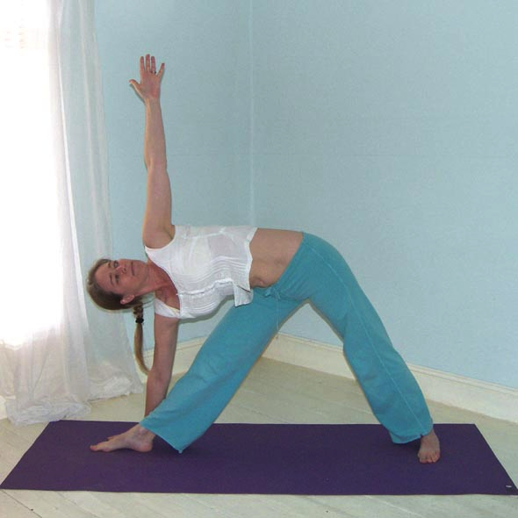**Teaching Points:**

* Start in trikonasana (triangle pose), right foot leading.
* Now looking down bend the right knee as you place the right hand around one foot in front of the right foot. You may need to simultaneously bring the left leg a little closer if necessary
* Continue to look downwards as the right leg is straightened and the left leg is raised upwards. It is possible to stay here.
* 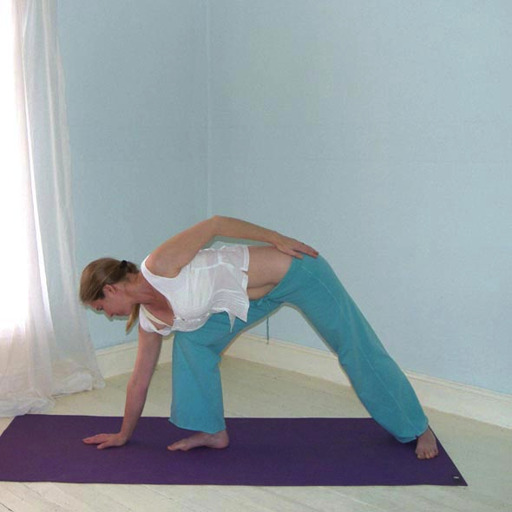Now draw the top shoulder backwards as the top hip is rotated backwards, opening the chest and groin respectively. Keep the back long and spacious. Could stay here.
* If possible now lift the left arm vertically energetically lifting out of the lower arm into the upper arm, keeping both shoulders open. Could stay here.
* 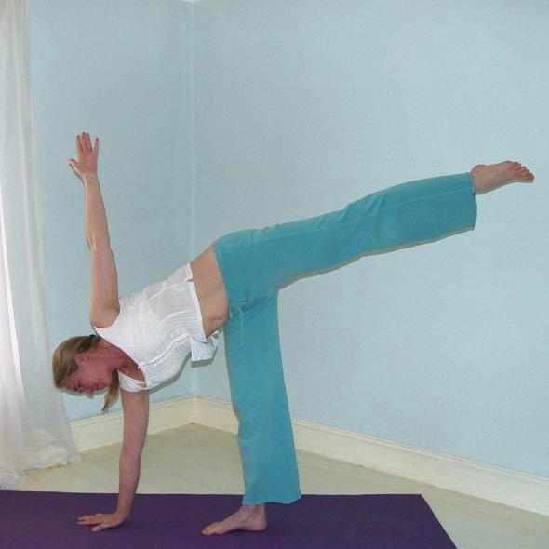To complete slowly rotate the head to look upwards at the upper thumb.
* Stay here extending outwards from the centre of the body into each of the limbs, maintaining space within all joints as you reach outwards.
* To exit slowly bend the right knee, lowering the left leg to the floor, coming to a standing position.
* Now work to the other side.

Note that sometimes students move the lower foot but it must be kept aligned at 90º, pointing towards the lead hand, i.e. towards the short end of the mat, so the knee remains correctly positioned.

**Benefits:**

Intensely tones and strengthens legs

Especially strengthens the hip abductors

Strengthens and frees hips

Strengthens the knee joints

Strengthens ankles

Opens chest and shoulders muscles

Invigorates, lifting energy levels

Gives confidence & enthusiasm

#### Good preparation

Hip and shoulder mobilisers; abdominal, back, shoulder and abductor strengtheners

**Contra-indications & possible modifications**

* For pregnancy use modified versions by placing lower hand on blocks, back against the wall or work in kneeling position
* For heart conditions and high blood pressure keep the upper arm to the side and do not work with strain, coming out as soon as necessary
* For balance problems work against a wall or against the hip of a partner
* For hamstring and groin injury work gently, avoiding opening at the hips as intensely, if necessary placing lower hand on blocks and keeping top hip down
* For neck problems keep the head looking downwards or forwards
* Avoid hyper-extending the lower knee, keeping the knee aligned with the ankle and hip joints.

#### Simple versions and modifications

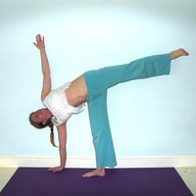

#### *Place back to the wall*

Try to ease the whole of the back of the body against the wall, working to roll the top hip backwards.

#### *Place a block(s) beneath the lower hand*

This is a very useful modification and for some students the proportion of the length of legs, arms and back will mean it will always be necessary.

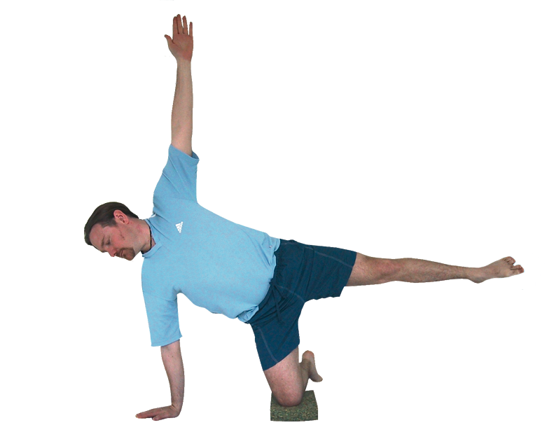

#### *Bend the lower leg*

For some students working with the lower leg bent will be a good modification, this especially true for those who are weak or have hamstring or groin injuries.

**Developments & Variations**

The main development is work alone without support and look upwards. It is surprising looking upwards makes posture so much more challenging!

**Adjustments**

We must scan the room to check all students have the correct foot placement, and that the lower ankle is positioned below the hips, helping students to find this where necessary. We can help students into this posture by standing behind them, looking towards the head so the side of our hip is against their buttocks. The student can enter the pose with the support you are offering and once they have entered the full pose we can place a hand upon the top hip and gently draw it back, increasing the external rotation at the hip. It is also useful to work gently with the top hip when students are practicing against a wall.