### Anatomical Terms of Movement Worksheet

For the following asana name the anatomical term of movement and joint articulation as shown in the example below. This should be for the full pose shown in the photos below. Please note **there may be more than one movement** **occuring at a particular joint**. At this point you are not being asked to give all possible movements possible for each asana, just those as indicated. Please refer to your handouts on ‘Major Joints of the Body’ and ‘Pictoral Summary of Anatomical Movements’, and on occasion it may help you to physically practice the asana to better determine what movement is occuring at each joint.



For example:

**1. Utkatasana (Fierce Pose / Armchair Squat)**

**a) Movement at ankles**

* Dorsiflexion (talus articulates with tibia and fibula)

**b) Movement at knees**

* Flexion of legs at knees (femur articulating with the tibia)

**c) Movement at hips**

* Flexion of legs at hips (femur articulating with the acetabulum of the hips)

**d) Movement at spinal vertebrae**

* Extension with possible slight hyperextension (vertebrae articulating with each other)

**e) Movement at shoulders:**

* Flexion (through elevation of arms) at the shoulders (humerus articulates with the glenoid cavity of the scapula)
* 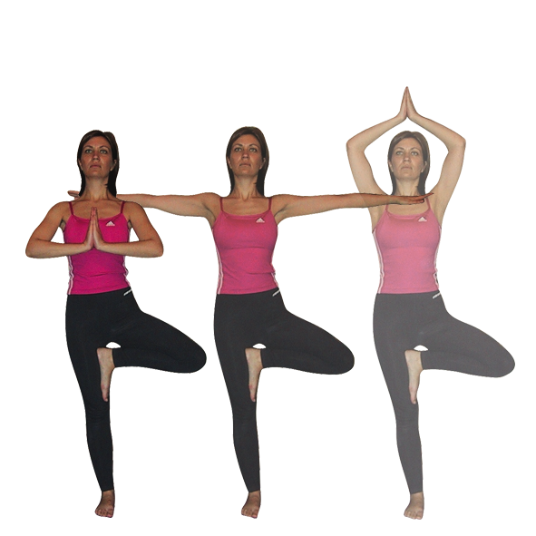External rotation of arms at shoulders (humerus articulates with the glenoid cavity of the scapula)

**f) Movement at elbows:**

* Partial pronation (radius articulating with the ulna)
* Extension (ulna articulating with humerus)

**g) Movement of hands at wrists:**

* Extension (carpals articulating with radius)

**2. Vrkasana (Tree Pose) in full version:**

1. **Movement at left knee**
2. **Movement at left hip**
3. **Movement at shoulders**
4. **Movement at spine:**
5. **Movement at the elbows:**
6. **Movement at wrists**

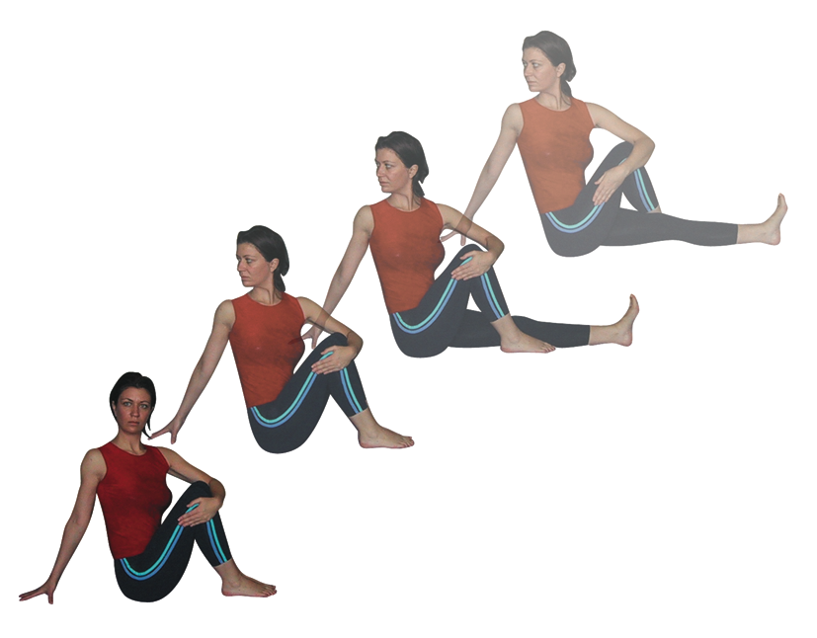**For Homestudy:**

Remember refer to your Major Joint Handout to see what is possible at each joint and what the articulation is, and other handouts may also be useful. Do try the pose if it is helpful to determine what is happening!

3. **For Marichyasana, Sage Twist Pose (Full Pose)**

1. Movement at vertebral column
2. Movement at right hip
3. Movement at right knee
4. Movement at left ankle



4. F**or Salamba Sarvangasana, Supported Shoulderstand**

1. Movement at cervical vertebrae
2. Movement at lumbar and thoracic vertebrae
3. Movement at shoulders
4. Movement at elbows
5. Movement at knees
6. Movement at ankles

5. **For Ustrasana, Camel Pose**

1. Movement at ankles
2. Movement at knees
3. Movement at the hips
4. Movement at vertebral column
5. Movement at shoulders
6. Movement at elbows

Please email your answers to me at [sarahdevayoga@gmail.com](mailto:sarahdevayoga@gmail.com) before our next meeting.