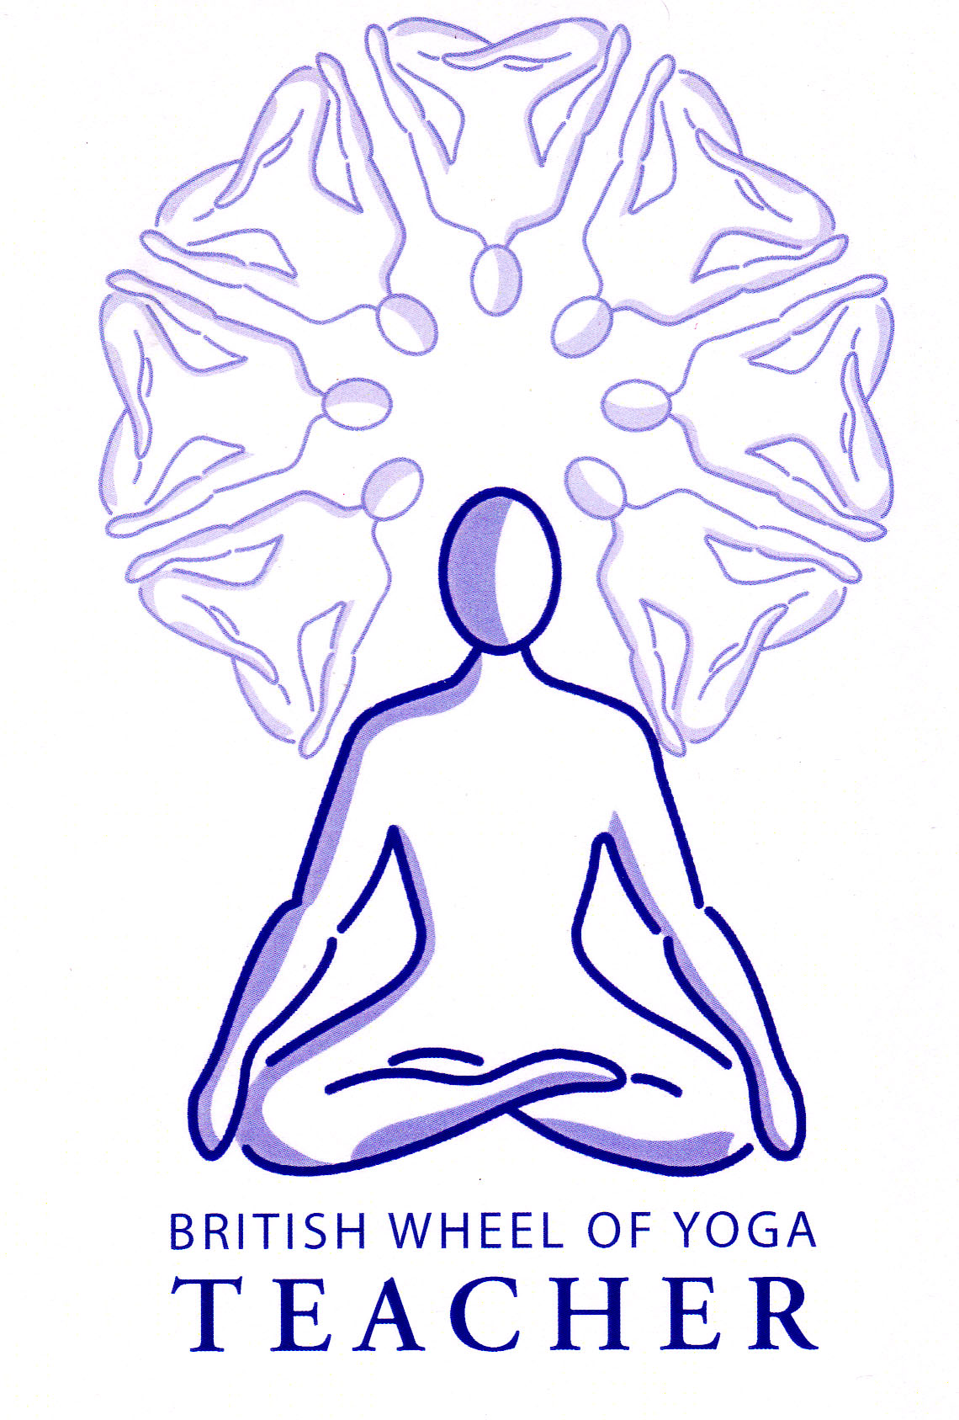**Assignment 6.3 Teaching of Pranayama, Kriya, Mudra Bandha**

**Formal Guidelines:**

Student teachers will within their peer group take a **maximum of twenty minutes** to teach a pranayama, with or without prolonged retention but observing all four stages of breathing and either a kriya, mudra or bandha. The teaching will be followed by group discussion and evaluation. A lesson plan will be submitted by the student teacher to the tutor for approval in advance as negotiated between tutor and student teacher. The plan will contain all information required in the proforma format for lesson plans and will be assessed according to the criteria set out in the front sheet for assessment of lesson plans. The teaching session will include the following elements:

1. Settling the students into practice including comfort in posture and opening breath awareness; attention to any environmental factors which may affect practice
2. Teaching the chosen pranayama and kriya, mudra or bandha, including explanation, teaching points, preparation for and building up to the practice aids and modified practice as appropriate to the chosen techniques, areas for caution.
3. Gradual return from practice.

Student teachers will demonstrate:

1. Clarity of instruction and explanation.
2. Knowledge and understanding of the chosen techniques through their explanation and teaching points.
3. The ability to present information in a logical order and to build explanation and guidance step by step in a way suitable for students **new to the technique.**
4. The ability to observe students, offer individual attention if needed and to pace their teaching according the needs of students and nature of the practice.

The aims and learning outcomes of the session need not be verbally stated but should be clear from the teaching. **The teaching itself should reflect how the student would teach in a class teaching situation**. Any practical benefits stated should be realistic in terms of western science. Any esoteric benefits stated should be supported by reference to source yoga texts.

The teaching should be followed by a feedback session involving tutor and peers.

*Note: if any previous experience of a particular technique or important piece of knowledge is expected then you can add this to the level of experience box in the header sheet.*

**Allocations:**

Please see which teaching practice you have been assigned and note that in a future home study sheet you will be reminded to start your lesson plan, having one month to email me a first lesson plan. Then you will have another month to make any final adjustments to the plan as well practicing/teaching the technique.

Do not be concerned if we have not as yet covered your technique in class, as this will always be done in good time at our future meetings.

|  |  |  |  |  |
| --- | --- | --- | --- | --- |
|  | **Teach in:** | **Technique** | **Meeting to start plan:** | **Name** |
| 1. | Meeting 3 | Explanation of use of ratio  Intro to Ujjayi (1:0:1:0)  & Chin Mudra at the close | 1 | Lucy |
| 2. | Meeting 4 | Reiteration of use of ratio  Ujjayi (1:0:2:0)  & Dhyana Mudra at the close | 2 | Alison |
| 3. | Meeting 4 | Vishnu Mudra (for nadi sodhana)  Nadi Sodhana (1:0:1:0)  Inhale: Left & Exhale: Left x12  Inhale: Right & Exhale: Right x12  Gyana Mudra at the close | 2 | Michelle |
| 4. | Meeting 5 | Intro to Kapalabhati (kriya)  Nadi Sodhana (1:0:1:0)  Inhale: Right & Exhale: Left  Inhale Left & Exhale; Right x24 | 3 | Amanda |
| 5. | Meeting 6 | Kapalabhati (kriya)  Nadi Sodhana (1:0:1:0)  Inhale: Right & Exhale: Left  Inhale Left & Exhale; Right x12 | 4 | Lisette |
| 6. | Meeting 6 | Intro to Mula Bandha & Jalandhara Bandha  Ujjayi (1:1:1:0)  With MB & JB on AK | 4 | Nicky |
| 7. | Meeting 7 | Mula Bandha & Jalandhara Bandha reiterated  Nadi Sodhana (1:1:1:0)  With MB & JB on AK | 5 | Gill |
| 8. | Meeting 7 | On Exhale Brahmari (fingers to ears)  Intro to Yoni Mudra (aka Shanmukti)  Brahmari & Yoni Mudra | 5 | Hajnal |
| 9. | Meeting 7 | Sitkari/Shitali & chin mudra  Tratakem (kriya) | 5 | Brigid |
| 10 | Meeting 8 | Bhastrika (1:0:1:0)  Viparita Karani Mudra | 6 | Sylvie |
| 11 | Meeting 8 | Bhastrika (both nostrils no ratio)  Sitkari/Shitali & chin mudra (1:1:1:0) with Mula Bandha & Jalandhara Bandha | 6 | Angela |
| 12 | Meeting 8 | Ujjayi (1:1:1:1)  Shambhavi Mudra at the close | 6 | Antonia |
| 13 | Meeting 9 | Uddiyana Bandha  Ujjayi 1:0:1:1 JB, MB, UB on BK | 7 | Gail |
| 14 | Meeting 9 | Nadi Sodhana 1:1:1:1  Bhoochari Mudra at the close | 7 | Jill |
| 15 | Meeting 10 | Nadi Sodhana (1:0:1:0)  Bhastrika alternate nostrils and then both nostrils MB & JB on the AK | 8 | Rod |
| 16 | Meeting 10 | Nadi Sodhana (1:0:1:0)  Bhastrika alternate nostrils and then both nostrils MB & JB & UB on the BK | 8 | Donna |
| 17 | Meeting 10 | Yoga Mudra  1:1:1:1 | 8 | Callie |
| 18 | Meeting 11 | Maha Mudra I  1:1:1:0 MB JB & Shambhavi Mudra on AK | 9 | Katie |
| 19 | Meeting 11 | Maha Mudra II  1:0:1:1 & MB, JB, UB & Shambhavi Mudra on BK | 9 | Helen |
| 20 | Meeting 12 | Maha Mudra II  1:0:1:1 & MB, JB, UB & Shambhavi Mudra on BK | 10 | Howard |

**Remember when teaching:**

* Always attune to the breath first & resume natural breathing between rounds as relevant.
* Always stage the practices
* If a student is holding kumbhaka (breath retention) for more than 10 counts both Jalandhara Bandha & Mula Bandha are always needed
* Always provide an anchor so the mind will stay focused