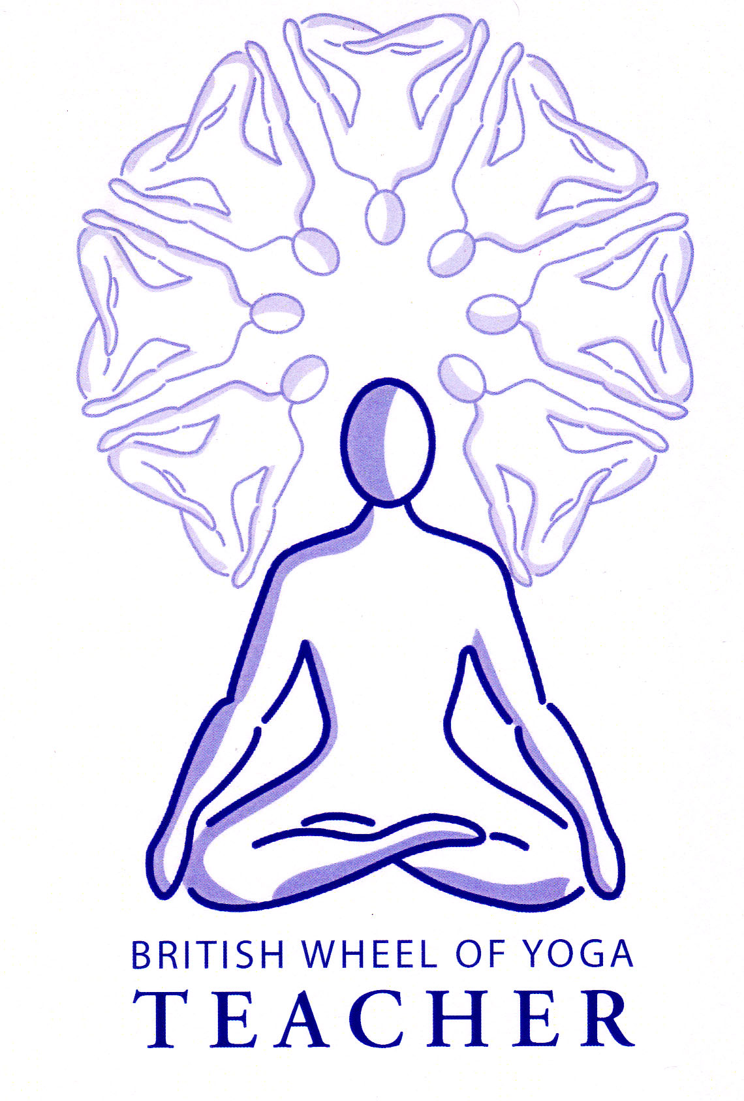**Assignment 6.2: The Hatha Yoga Pradipika.**

**a) Explain the purpose of hatha yoga as described in Hatha Yoga Pradipika (HYP) and give a brief summary of the content of the four chapters.**

**b) Discuss one of the following topics (include references to the HYP where appropriate):**

* **Shatkarma - kapalabhati, trataka, nauli, jivashodhana and jalaneti.**

**Explain how you would introduce kriya into your teaching.**

* **Pranayama – Nadi Sodhana, Ujjayi, Surya Bhedana, Sitali, Sitkari, Bhastrika, and Bhramari.**

**Explain how you would introduce and teach pranayama to a mixed ability class.**

* **Mudra as described in HYP. Explain how you would introduce mudra into your class teaching.**
* **Bandha - Mula Bandha, Uddiyana Bandha, and Jalandhara Bandha. Explain how you would introduce bandha into your class teaching.**

Guideline word count 2000 to 3000 words Suggested weighting is 40/60. (i.e. if 2000 words then split is 800/1200 or if 3000 words then split is 1200/1800).

Written work may include tabular or diagrammatic representations.

Written work must contain quotations from the Hatha Yoga Pradipika and be explained by reference to informed modern practical texts or commentary. Answers should distinguish between what was written in the original text and what constitutes modern interpretation.

--------------------------------------------------------------------------------------------------------------------------------------

**\*Please copy and paste the full question at the start of your assignment**

Specific assessment criteria against which the assignment will be marked are set out on the assignment front sheet (AFS) 6.2 which can be found on the website [www.yoga-ayurveda.co.uk](http://www.yoga-ayurveda.co.uk) (password Shanti)

--------------------------------------------------------------------------------------------------------------------------------------

**Guidance Notes for Part a)**

Here you will need to outline how Hatha Yoga is focused upon harmonizing our physiological/pranic system (Sun& Moon) rather than focusing on the mind and meditation, or ethical observances.

You will need to give an overview of what is contained within the chapters of the HYP and to help with this you can refer to the index of the HYP & also it’s introduction, plus you have a course handout outlining the four chapters.

Please ensure you outline all the main practices, which together constitute the practice of Hatha Yoga (i.e. shatkarma, asana, pranayama, mudra & bandha) and give a succinct description of their specific purpose; here I suggest you initially discuss their everyday overall benefits then later see if you can link all of the practices together as the overall system of Hatha Yoga leading to our awakening to our full potential culminating in the awakening of kundalini.

**Guidance Notes for Part b)**

Only choose one topic to explore

**Initially provide an overview of your chosen topic** remembering to give at least two direct quotations from the HYP, preferably give several references and quotes, to include those from the actual text and also the commentary. For each quote please also make sure you comment upon it to show your analytical skills.

**Then with regards to the different techniques listed for your chosen topic:**

* Give an explanation of the purpose of each technique including some of the most significant benefits i.e. why it would be practiced
* Describe the cautions involved
* Provide a succinct overview of the basic technique

Note for Mudras where no specific techniques are given here you can divide them into the different types, as discussed, such as kaya (body), chaksu (eyes), hasta (hands) etc. giving some examples of each but ensure that you make reference to the ten mudras given in the HYP and show you are aware that Bandhas are a specialised form of Mudra although please do not focus upon these if you are discussing mudras.

**Introduction and teaching of your topic - remember to include the following points:**

* You will need to emphasize how our teaching should be **student orientated** so we always aim to meet students’ needs with each group having a different character, for instance a group of older students in a daytime class, stressed NHS workers in an after work class, gym class with very mixed ability and experience, private class with a very experienced and motivated group etc.
* How there will be **gradual development** over time in terms of both theory and practice, building up to more complex practices, and that we will seek to avoid overwhelming students with too much information
* Very significantly that there will be **use of differentiation** so all students will have something to do that suits their interest, ability, level of experience etc. meaning **staging, modifications, aids and alternatives are always made available.**
* Try to always make theory & practice as **relevant as possible**
* Use **different teaching methods** to teach the practices & convey some accompanying theory, giving some examples. Such as
  + Presentation at start, end etc.
  + Demonstration, one to one or whole group, practicing alongside
  + Physical Adjustment
  + Small verbal asides during centering, during practice, during rest times – give benefits, interesting facts, rationale for practice
  + Visual notes or images e.g. on white board, poster etc.
  + Handouts to refer to or read at leisure
  + Discussion and/or sharing with pairs, small groups, whole group

More specifically for each topic:

**Shatkarma/Kriya:** Here you will certainly need to highlight which would be part of a regular class, which could be introduced on a special situation or given for use at home. Also what theory might accompany the teaching with some examples of when & how this might be introduced. Here some knowledge concerning the Doshas could be taught, plus the idea that by cleansing the body prana flows more freely, and the mind is cleared (mind/body link as being the two sides of the same coin).

**Pranayama:** Here you will need to show you understand the need to establish a foundation of good basic breathing skills, explaining why, and how in a very mixed experience group how these can be also taught alongside pranayama when needed. Also how you would always seek to include differentiation so that we always establish natural breathing, then the technique without ratio, then ratio, completing with natural breathing and self-reflection, with all students staying at the stage required. Highlight the need to take care with ratio, especially kumbhaka, and also the need to very gradually develop student’s experience over time. Always stress the positive to be gained by staying with the most appropriate stage, rather than focusing upon the negative!

**Mudra:** Here you will need to refer to our class notes as well as the HYP and consider how you might introduce the theory behind the mudras, emphasizing the need to avoid overwhelming students by giving little pieces of theory until perhaps you spend a little longer exploring them in more detail. Determine which kinds of mudras you might introduce initially giving examples of how these could be taught and then go on to explain more complex mudras that can be taught to more experienced intermediate and advanced students.

**Bandha:** Here you will need to determine the different ways you could teach MB, JB and UB, outlining which you would teach first and ways you would introduce them and incorporate them into your classes. Also how you can gradually build them up into the more complex whole body mudras such as Maha Mudra I.

This assignment must be completed and marked by 11th February 2018 at the very latest as we then start Part 3.