**Navasana (Boat pose)**

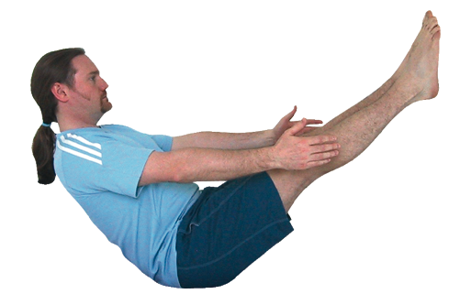

# *Pronounced naah-vaah-suh-nuh the word nava means boat in Sanskrit*

This balance is called the boat as the shape of the pose resembles that of a boat balanced within the water.

**Teaching Points:**

*Stage one*

* Start in dandasana (staff pose) bending both knees, draw the knees in towards the chest. Place hands either side of the buttocks leaning backwards a little with a straight spine. Ensure you are sitting upon your sitting bones. Lift the heels from the floor, keeping knees bent. You could stay here is necessary with hands lightly touching the floor either side of thighs.

Stage two

* Now if possible slowly lift both arms extending them forwards at shoulder height, palms facing. Could stay here with knees bent engaging the abdominal muscles, chest open, shoulders relaxed down away from ears.

Stage three

* If possible now straighten both legs keeping the chest open and the spine lengthened. You could stay here. Remember to continue to breathe as fully as possible keeping the body relaxed and strong.
* To exit simply lower feet and arms and enter a suitable counterpose such as a soft forward bend or baddha konasana (cobbler pose).

**Caution:**

Keep on the sitting bones rather than rolling under on to the sacrum. Do not allow the spine to round, any collapsing of the spine means we need to take a modification until enough strength has been built up.

**Drishti point**: Be aware of tips of toes

**Benefits:**

Strengthens the back and abdominals

Strengthens the thighs

Tones visceral organs

Improves digestion

Increases concentration & confidence

Increases balance

Lifts energy

#### Good preparation

Poses developing good abdominal control and strength, back strengtheners, thigh strengtheners, hip flexor strengtheners, hamstring stretches

**Cautions & possible modifications**

* Abdominal complaints keep feet to floor and perhaps simply lean backwards a little whilst holding behind the thighs. Alternatively work as below in one leg lift from dandasana.
* Pregnancy to avoid this pose, taking an alternative instead

#### Simple versions and modifications

###### :boat mod 1.tifHold beneath legs To assist the stay in boat hold beneath thighs.

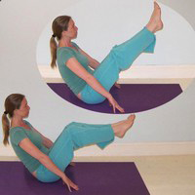***Hands to floor***

Here we can modify the pose by keeping fingertips to the floor.

###### :attachments_11_12_2009 Folder:bow-to-ear-staight_resized.tifOne leg lift from dandasana

We can keep one leg aligned along the floor and practice lifting the other leg first to a bent position and then to an extended position. This is a good preparation for moving into boat and enables students to have a sense of how it feels to lengthen the hamstrings when seated. It is a good modification to use when a student must not overly engage the abdominals.

**Developments & Variations**

###### :attachments_11_12_2009 Folder:bound-boat_resized.tifBound boat

Here we can take hold of big toes with the index fingers and initially keep both legs bent. When we are ready we can straighten both legs whilst maintaining balance.

###### :attachments_11_12_2009 Folder:boat-lift_resized.tifDynamic Boat

It is possible to lift into boat from a supine position where the hands are placed beneath the lower back, palms face downwards. When we are ready to lift we press down into hands and forearms lifting the upper and lower body simultaneously. We can then keep the hands to the floor or lift them to shoulder height. We can lift and lower several times if wished. This is also a good transition to be used in a practice when we moving from lying to seated poses.

###### Feet placed upon a chair or exercise ball

A good variation is to keep both hands to the floor and place the heels of both feet upon a chair seat or an exercise ball. This helps to build strength within the thigh, back and abdominal muscles.

#### Adjustments

We can kneel behind a student who allows the back to round and very gently place a knee against the back as we support the shoulders with our hands. The student can keep the knees bent and simply lift the feet a little way off the floor. This gives the student an excellent opportunity to experience the pose correctly. It may also be helpful to hold the weight of the legs a little when a student has extended the legs but feels the legs to be trembling. Ideally however in both situations the students will work alone and gradually develop their strength with practice!